Luke Rivard
Dr. Matthew Kay
FURSCA Paper

Introduction
The goal of this project was to find the elements of Irish Traditional Music (ITM) essential for composers trying to emulate its style. I attempted to draw conclusions about ITM’s idiomatic parts through an analysis of three pieces from each of the following genres: jigs, slip jigs, reels, hornpipes, songs/airs, waltzes, and polkas. I looked for commonalities between examples of each.

Research and Methodology
I used the Albion College library and internet to research the background of ITM. I contacted an Irish band, Celtic Jams, and interviewed some of their members. Their piano/accordion/harp/concertina player, Cathy Foster, gave me research of her own. I was able to ask Cathy Foster and her husband, Dave Foster, about their lived experience with ITM. They invited me to play music with them in a session after the interview. Selections from Alan Merriam’s ten functions of music helped to frame the ethnomusicological parts of my research . I used the functions of emotional expression and communication. I also explored the aural learning tradition of ITM by transcribing the Irish waltz, “Inisheer,” and comparing my results to transcriptions available online.
I did a quantitative analysis of seventy-six Irish tunes from The Grand Irish Songbook published by the Hal-Leonard Corporation; the factors considered were meter, presence of an anacrusis, tonality, form, phrase length, and phrase structure. Additionally, I took a closer look at three of each of the genres previously listed to find commonalities between them. I focused on patterns that I noticed visually and aurally. For the transcription of “Inisheer,” I looped small sections of a recording I found on YouTube until I could sing that section, learned to play the notes with my flute, wrote the notes out on staff paper, and compared it to an available transcription. This exercise helped me to understand the process of transcriptions and highlighted the drawbacks of musical notation in an aural tradition.

Results

The results for the different Irish song types and dances will be discussed with the use of musical set theory. All the chromatic notes are assigned a number. “C” is 0, “C#” is 1, “D” is 2, and so on (see table 1). I transposed the idioms so “C” is the tonal center, where pieces are in a non-major mode, accidentals have been added to retain the tonal center. Some examples may seem out-of-place on their own, but it is up to the composer to add context before or after the set in a way that makes musical sense.
Musical set theory has historically been used to analyze post-tonal works, however, I found it helpful when analyzing intervallic relationships idiomatic of ITM. Using numbers helped reveal commonalities across tunes and genres. Below is a chart of the numbers that I used and what note of the chromatic scale they refer to.
Table 1.
Note | Number
C | 0
C#/Db | 1
D | 2
D#/Eb | 3
E | 4
F | 5
F#/Gb | 6
G | 7
G#/Ab | 8
A | 9
A#/Bb | t
B | e

The sets in the examples below are separate and are not continuations of musical thought. Sets that are directly next to each other are often from a different tune.

- Jigs
Jigs are a common dance in Ireland that are in 6/8 meter. They are conjunct, without accidentals, and employ mainly the intervals of 2nds, 3rds, and 4ths. Their most common rhythms are running 8th notes, quarter notes with an 8th note, and a dotted quarter note. The tonic note appeared before the final beat in the jigs I looked at. This often looks like 400-0.

Figure 1. Tonic note appearing before final beat motif.
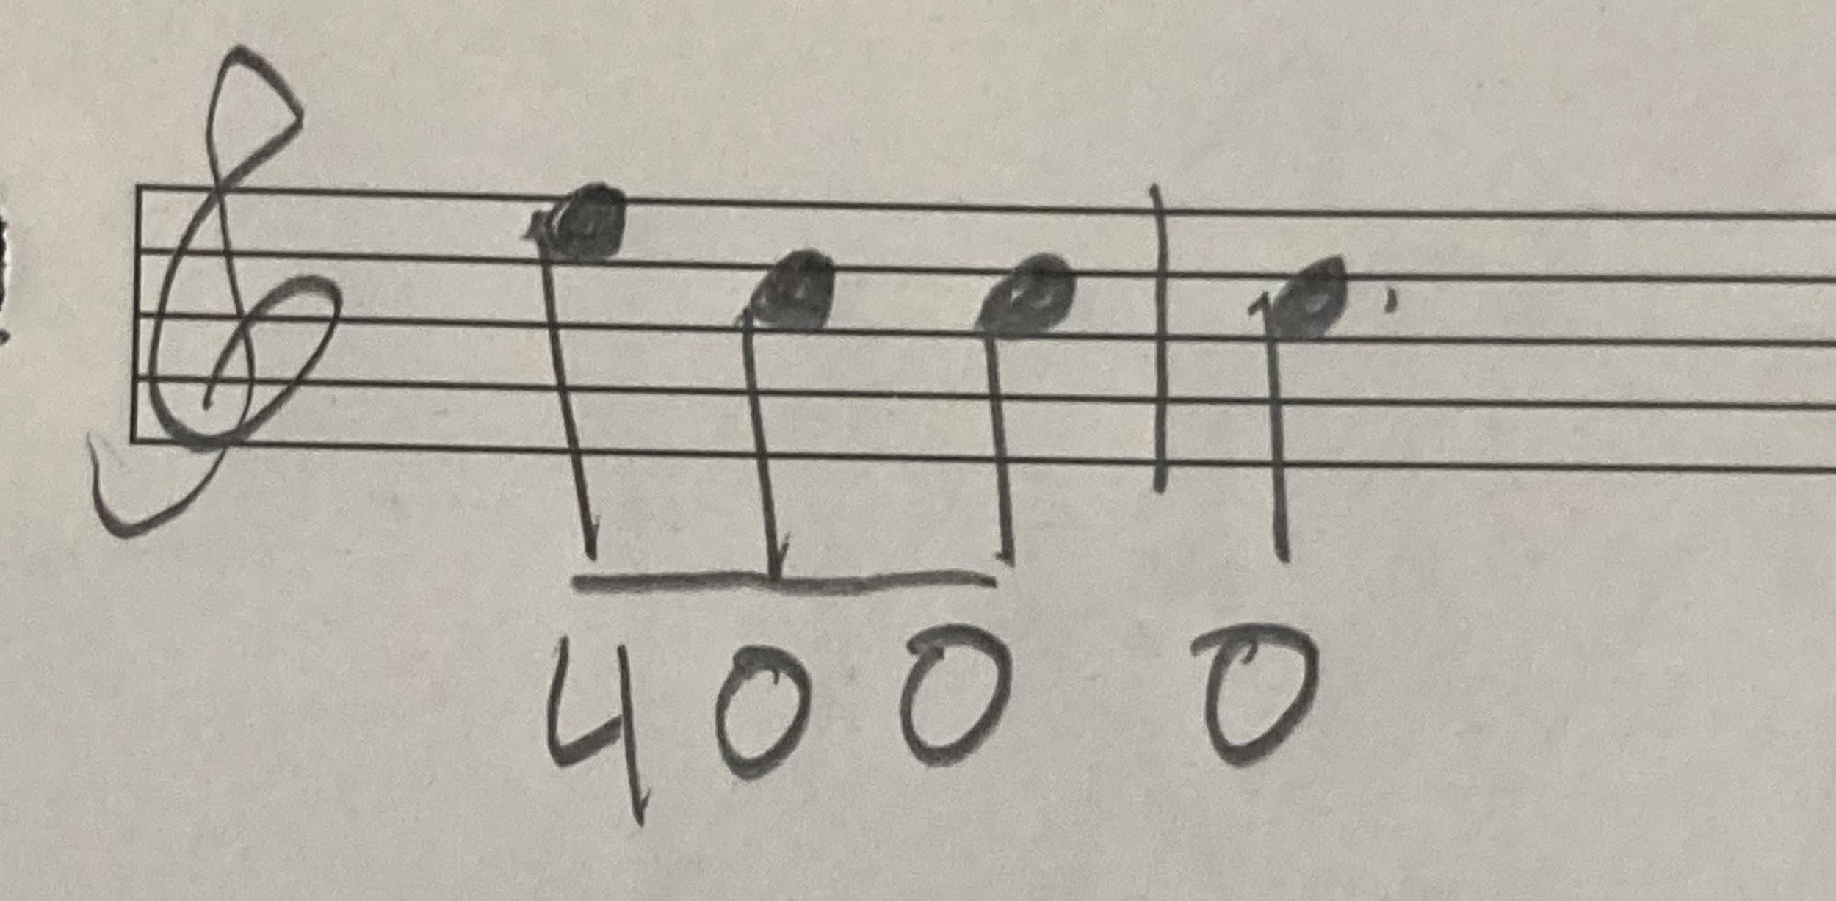
There are three idioms that I found for jigs. The first is made up of triplet sets where one pitch is repeated twice with a different pitch in between them. Examples of this are 020, 909, 242, and 202. The interval of the non-repeated pitch from the repeated pitch is typically a major 3rd or smaller.

Figure 2. Jig repeated note separated motif.
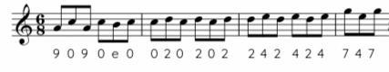
The next triplet idiom has two pitches that are repeated after a different first pitch. Examples of this are 977, 077, 044, 944, 700, and 400. This interval between the first and second pitch tends to stay within a perfect 4th. Some tunes have larger intervals with this idiom. This idiom often is used to lengthen melodic motion while keeping true to the rhythmic motive of running 8ths.
Figure 3. Jig repeated note not separated motif.
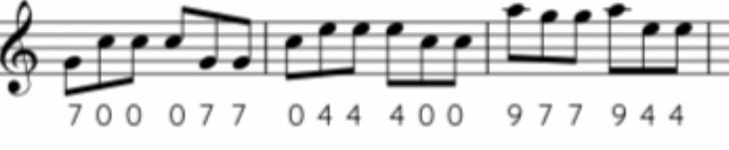
The third idiom spans across a perfect 4th comprised of a major 2nd and minor 3rd.
This can be seen in 974, 742, 42e, and 209.

Figure 4. Jig perfect 4th motif.
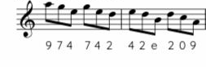

- Reels
Reels are an Irish dance in 4/4 meter. Reels are usually conjunct, without accidentals, and the main intervals are 2nds, 3rds, 4ths, and 5ths. The main rhythms are running 8ths and a quarter note with two 8th notes. The tonic note does not always arrive before the final beat.
The three main idioms found in jigs can also be found in reels, but there are four-note sets instead of three with the exception of the perfect fourth idiom. The first idiom consists of a set with two repeated pitches separated by one or two other pitches. Examples include 979e, 9e09, 5425, 4574, etc (see fig. 5). These sets are usually made up of stepwise motion and skips. Sometimes larger leaps take place, and they often take place where pitches skip or leap above a pitch returns to the same pitch multiple times (see fig. 6). These are less common than stepwise motion and skips, but they are still part of this idiom.

Figure 5. Reel repeated note separated motif.
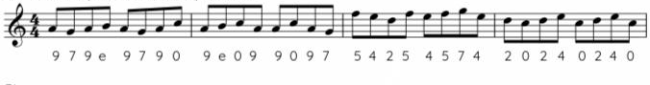

Figure 6. Reel note leapt back to motif.
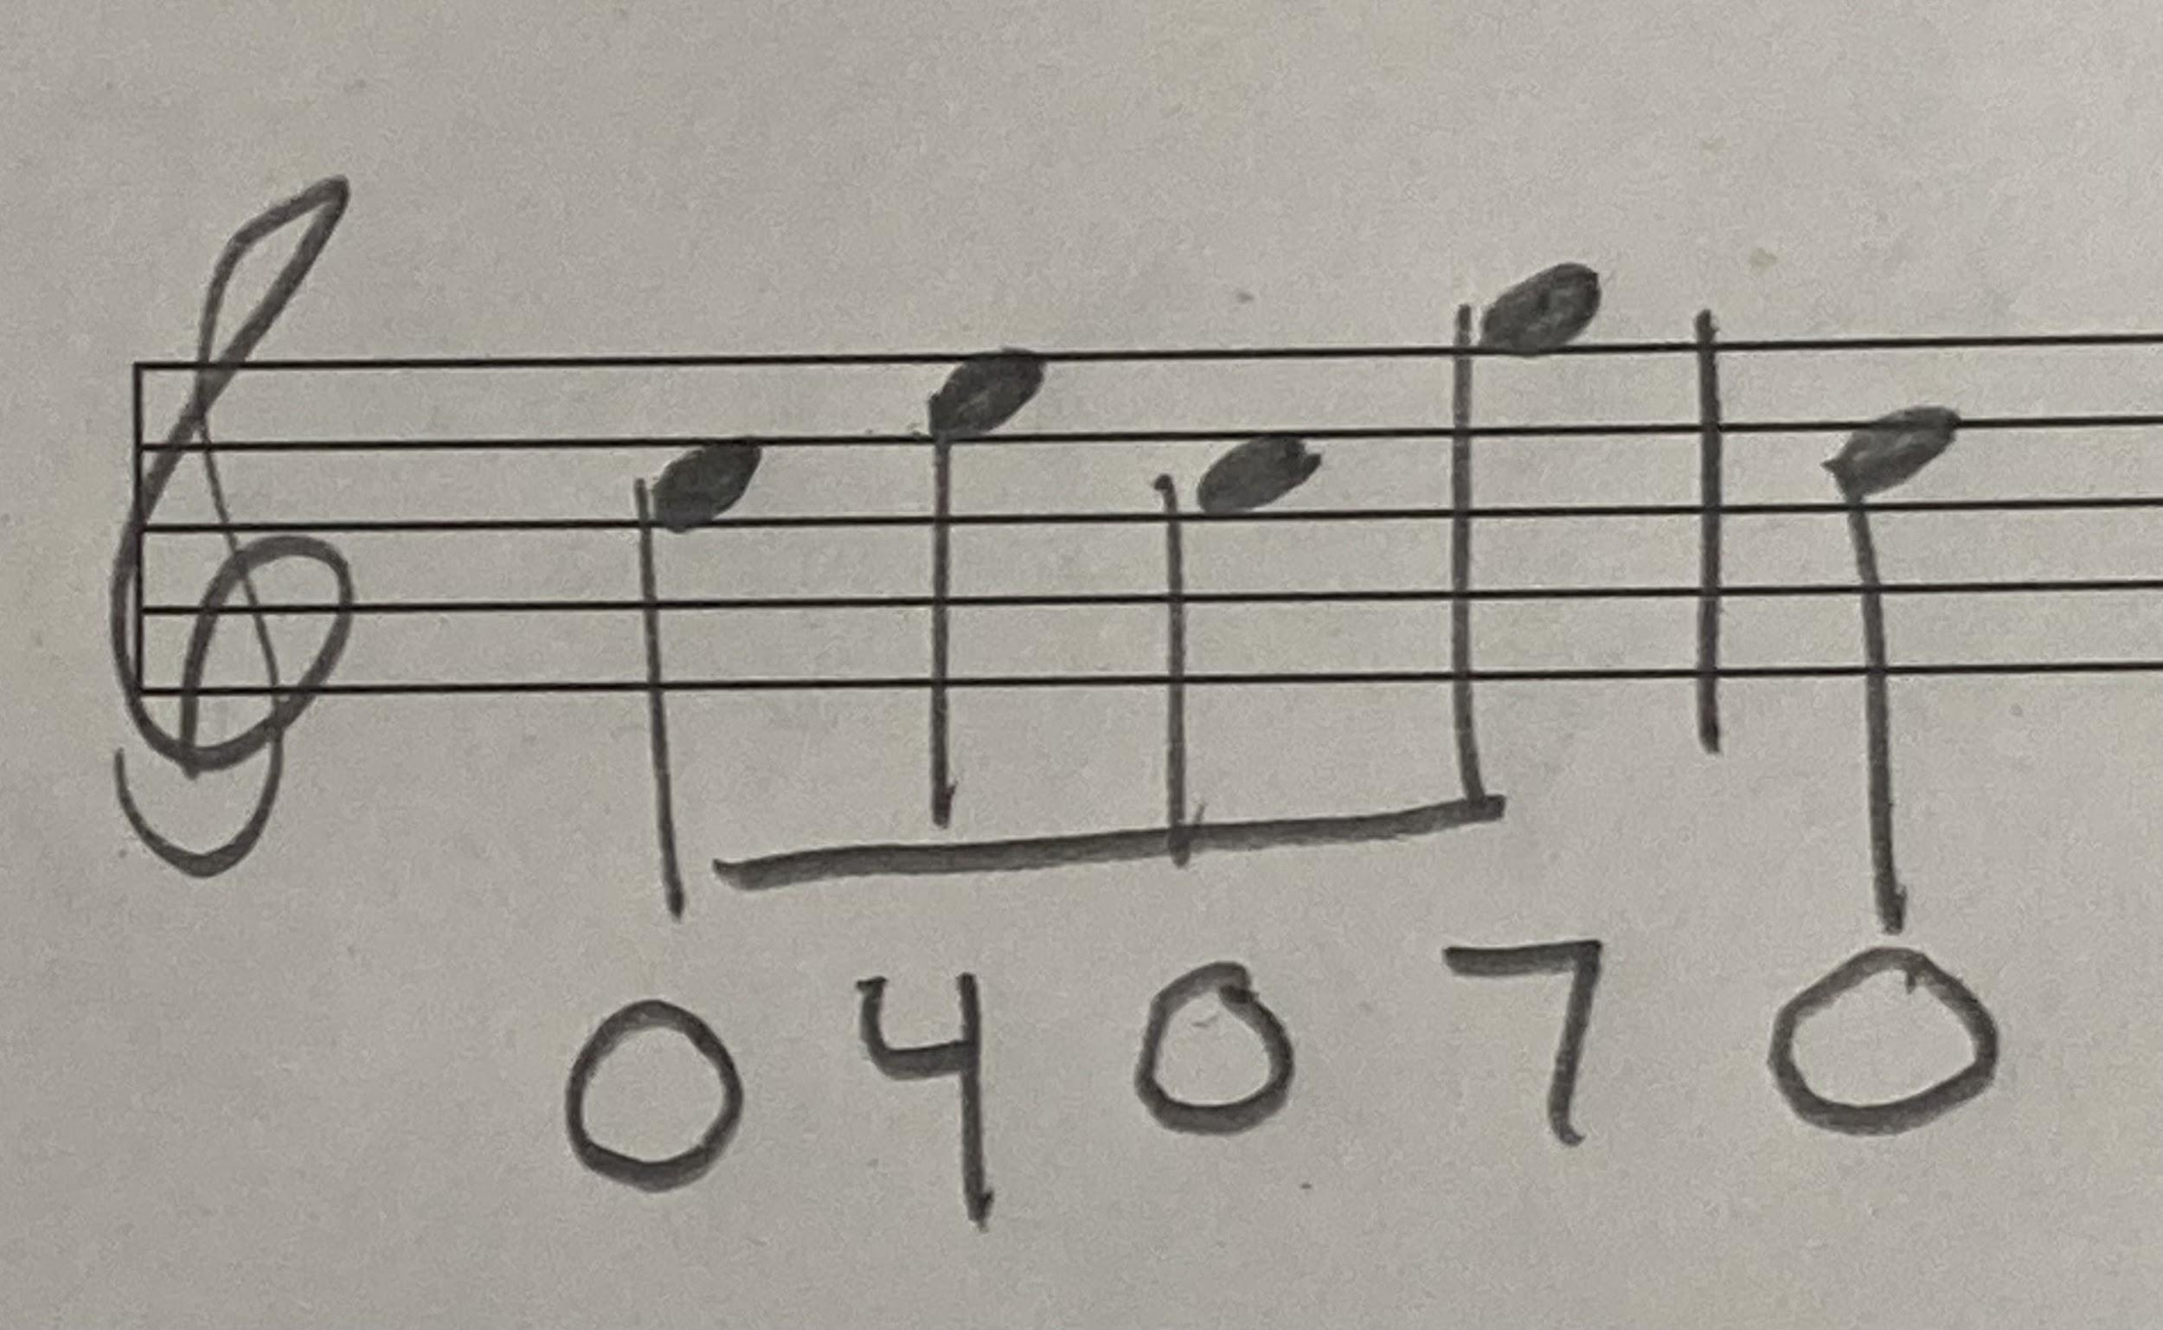
.

The second idiom is a set that has two repeated pitches that are not separated. This includes 4779 and 4997. The examples I used for these have sets with larger leaps than seen in the jigs, but the leaps typically are not larger than a perfect 5th.

Figure 7. Reel repeated note not separated motif.
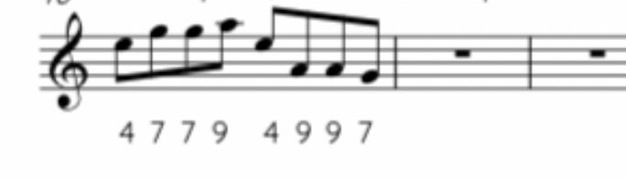
The third idiom is sets of pitches that span a perfect 4th made up of a major 2nd and a minor third, such as 40e. These often, like the second set in the example listed below, take place in the middle of larger sets, sometimes even across barlines. The skip often happens on the 4th or 7th scale degree.

Figure 8. Reel perfect 4th motif.
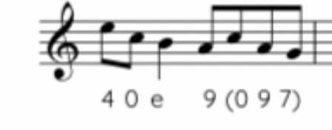
- Slip Jigs
Slip jigs are an Irish dance in 9/8 time. They are often played faster than jigs. The melodies are conjunct, without accidentals, and the main intervals used are 2nds, 3rds, 4ths, and 5ths. The most common rhythm in the slip jigs is a quarter note with an 8th note. It is less common to see running 8th-note sets like in regular jigs. In my selected tunes, the tonic note does not arrive before the ending beat.
There are three idioms that I found with slip jigs. The first idiom is a set of three or four notes with a repeated pitch that is separated by another pitch. The examples I found are 7030, 3707, 25t5, 757, and 404. The sets of four usually consist of two of the common quarter note and 8th note pairs. These groups are often 2nds or 3rds. Caution should be used if using this idiom with larger intervals for they do not resemble traditional Irish slip jigs and can be tricky for players using instruments associated with ITM. However, players using modern instruments will have no trouble.

Figure 9. Slip jig repeated note separated motif.
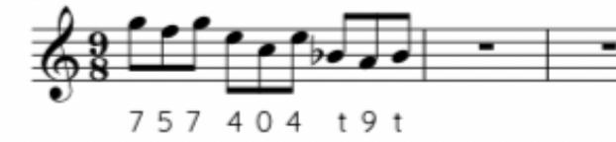
The next idiom is sets of three pitches that are scalar or have a skip in downward motion. Examples of this are 320, 20t, and 532. This idiom often relates to the perfect 4th motive when the set has a minor 3rd and major 2nd.

Figure 10. Slip jig scalar and 3rds motif.
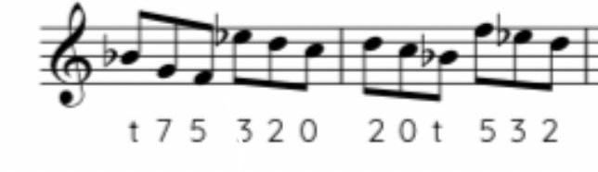
The third idiom is a perfect 4th comprised of a minor 3rd and major 2nd. The examples that I found in slip jigs are t75 and 0t7. This example, compared to the examples from the reels and hornpipes, skips a different scale degree. These examples skip the 6th scale degree. This was caused by the non-major modes of some of the tunes the examples are from.
Figure 11. Slip jig perfect 4th motif.
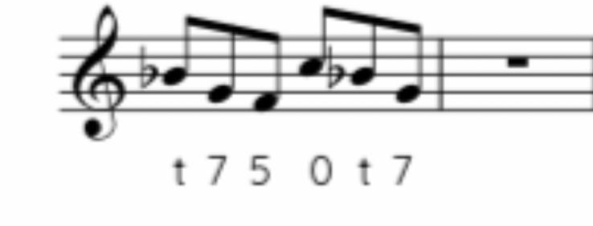

- Hornpipes
Hornpipes are a dance in 4/4 time. These dances are usually conjunct, rarely have accidentals, and the most common intervals are 2nds, 3rds, and 4ths. The most common rhythm is running 8th-note sets; some examples used quarter notes to break up phrases. The tonic note does not arrive before the final beat in my selected tunes.
I noticed two idioms with reels. The first idiom is a set of four notes with one repeated pitch that is separated by different pitches. Some examples of this are 0t02, 3235, and 0230. This idiom uses stepwise motion and skips. Just like reels, there are instances where there are larger leaps above a pitch that gets repeated three or more times (see Figure 6).

Figure 12. Hornpipe repeated note separated motif.
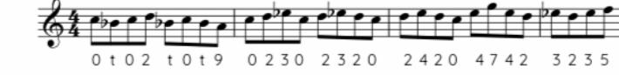
The second idiom is a set of notes that contain a perfect 4th within them. Some examples of this are 9740, 2097, and 9747 (the perfect 4th interval is underlined in these examples). The examples in the hornpipes often skip the 4th scale degree or the 7th scale degree.

Figure 13. Hornpipe perfect 4th motive
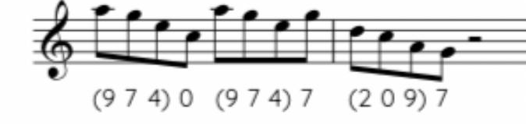

- Polkas
Polkas are a dance in 2/4 time. They are conjunct, have no accidentals, and the most common intervals are 2nds, 3rds, and 4ths. The most common rhythm is sets of two 8th notes with four 16th notes following them. It is also common to see an 8th note with two 16th notes. The tonic note arrived before the final beat in all the tunes I examined.
The first idiom is a set of four notes with a repeated pitch separated by a different pitch. Some examples found in the polkas are 9e09, t9t0, and t757. This idiom usually stays within the intervallic limits of 2nds and 3rds.

Figure 14. Polka repeated note separated motif.
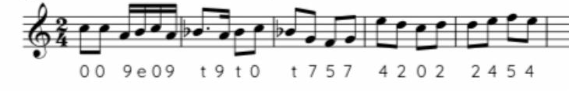
Another idiom is a set with repeated notes that are next to each other. Some examples are 4002, 7002, and 4227. These typically stay within 2nds and 3rds.

Figure 15. Polka repeated note not separated motif.
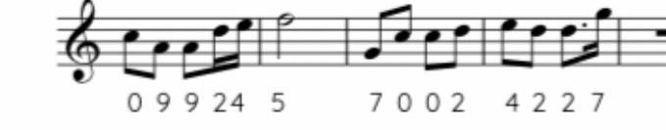
The final idiom occurs at the end of polkas. The final measures had two tonic quarter notes in every polka I used. Some polkas end differently, but it is an idiomatic motif.
Figure 16. Polka ending motif.
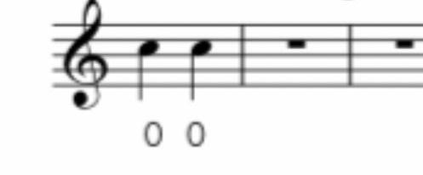

- Slides
Slides are a dance in 12/8 time; they are related to the jig. Slides are usually conjunct, have no accidentals, and their main intervals are 2nds and 3rds. The main rhythms are running 8ths and a quarter note with an 8th note. The tonic note usually does not come before the final beat.
The first idiom is a set of three notes with a repeated pitch that is separated by a different pitch. Some examples are 202, 242, and 909. These sets stay within a 2nd or 3rd; there are rarely large leaps used in sets like this.

Figure 17. Slide repeated note separated motif.
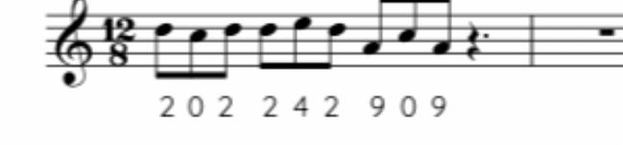
Another idiom is a set of notes with a repeated pitch not separated by different pitches. Examples would be 400 and 200. Sets such as these can be used in a composition for intensity and drive, and this can be especially true if there are multiple instruments contributing to this intervallic and rhythmic motive. This idiom is usually conjunct.

Figure 18. Slide repeated note not separated motif.
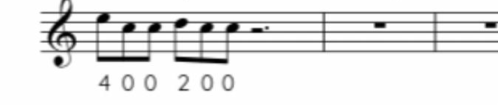

The third idiom is a set that consists of a perfect 4th with a minor 3rd and major 2nd. Some examples from these pieces would be 790, and 974. The scale degree mainly avoided in these examples is the 4th.
Figure 19. Slide perfect 4th motif.
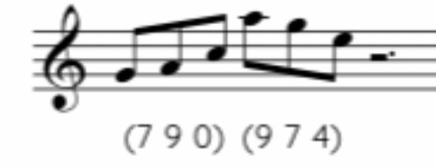
The last idiom for slides is similar to the final idiom for polkas. The second half of the last measures of these pieces were made up of two tonic dotted quarter notes (in fig. 20, there are rests for the first two beats of the measure, but there are normally notes that lead to the final two tonic notes.)

Figure 20. Slide ending motif.
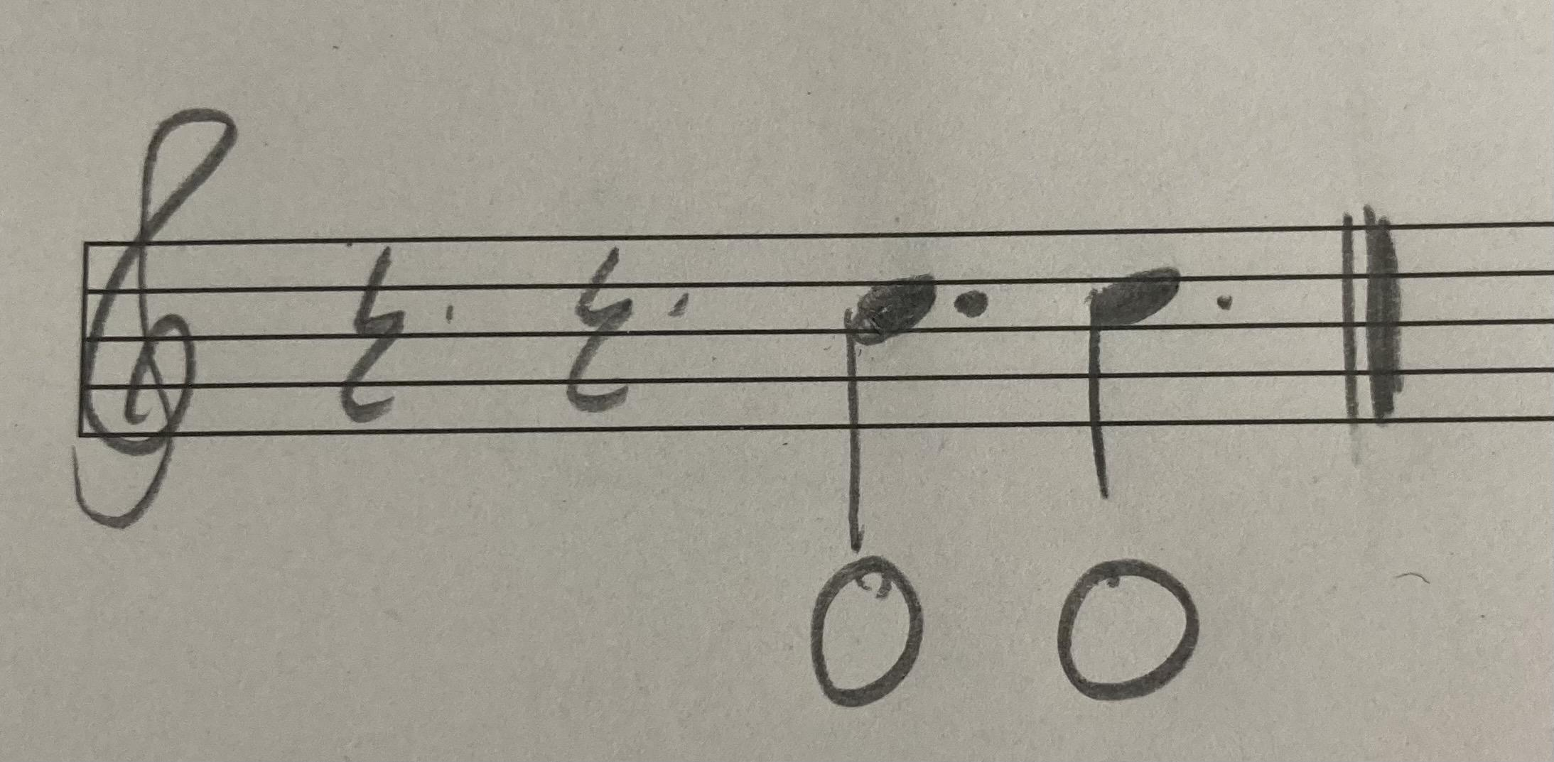

- Waltzes
Waltzes are dances in 3/4 that are not specific to Ireland. All the waltzes I looked at, have an anacrusis, are conjunct, are without accidentals, and the most common intervals are 2nds, 3rds, and 4ths. The most common rhythm was a dotted quarter note, 8th note, and quarter note as a group. There were also groups with three 8th notes and a dotted quarter note.
A common idiom that I found is a set of notes that has a repeated pitch separated by other pitches. This includes 979e0, 20247, 2474, and 9e97. This idiom is a lot broader in application than in the other dances, but that is because the waltzes that I used are also songs or airs. The songs and airs tend to be freer rhythmically than dance tunes.

Figure 21. Waltz repeated note separated motif.
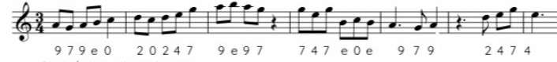

- Songs/Airs
Songs and airs are sung and are usually meant to be listened to rather than danced to. These songs often have an anacrusis. In my analysis of seventy-six songs, 88.2% of them had an anacrusis while another 3.9% contained an anacrusis between phrases but not at the start (see fig. 22). Songs are normally conjunct, have no accidentals, and the most common intervals are 2nds, 3rds, and 6ths. Many songs also have the tonic note arriving before the final beat. Phrase structure is also important; 96.1% of the songs I analyzed had phrases made up of two, four, or eight measures. 3.9% of songs had an irregular phrase length of three or five measures (see fig. 23).
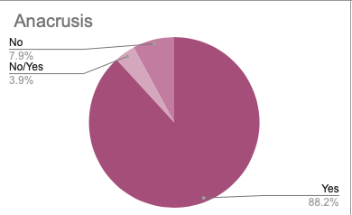
Figure 22. Presence of an anacrusis in songs and airs.

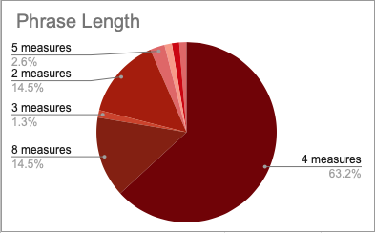
Figure 23. Phrase length in songs and airs.

The first idiom is repeating notes in a line. This is likely used as a storytelling technique because songs/airs are mainly used for telling histories, stories, and memories. This storytelling technique is a possible explanation for the anacrusis being of importance in preparing the beginning of the text.

Figure 24. Song and air repeated note motif.
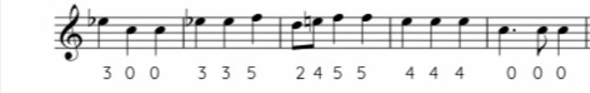
Another idiom is repeated pitches in a set with different pitches between them. Some examples are 9757, t757, and 4240. This often takes place on a larger rhythmic scale than in dance music.
Figure 25. Song and air repeated note separated motif.
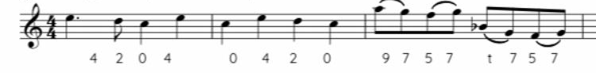

- Form
The form of dance tunes is more predictable than for songs and airs. Dance tunes almost always follow a simple AB pattern. In practice, the sections are both eight measures long and are repeated. The two repeated sections are then repeated two more times for a total of three times the tune is played through. When written out, it looks like AABB AABB AABB. Songs usually have a short intro and then an A section. Some have a chorus and some have a refrain.
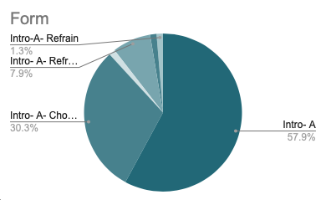
Figure 26. Form of songs and airs.
- Lombardic Rhythm
There are specific examples of rhythms for each genre in their sections, but Lombardic rhythm and a varied version of it are applicable across the tune types. Lombardic rhythm is where there is a 16th note followed by a dotted 8th note. There is a variation that sounds similar with an 8th note followed by a quarter note in 6/8, 9/8, and 12/8 meters. This rhythm is often used in the repeated section of tunes as a means of varying the melody.

Figure 27. Lombardic rhythm and variation
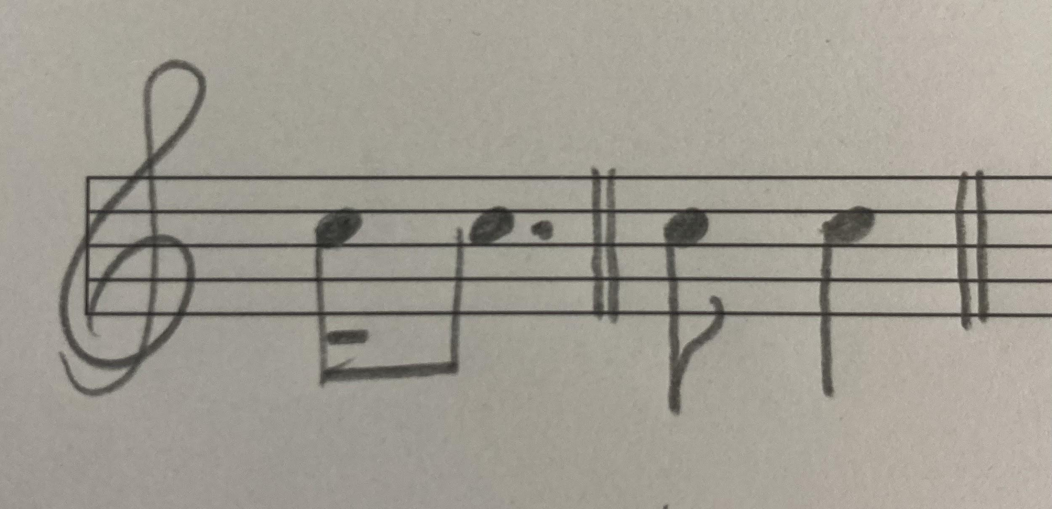

- Harmony
The usual harmony in ITM varies based on the mode of the tune. For major keys, the chord progression follows a I - IV - V - I progression. Minor and dorian modes follow a i - bVII - i progression. An example is Dmin - C maj - D min. For mixolydian the most common progression is I - bVII - I. This would look like Dmaj - Cmaj - Dmaj. The dominant section comes from the major chord a whole step beneath the tonic note in the minor, dorian, and mixolydian modes. There are exceptions to these progressions.
In traditional tunes, harmony never should be more interesting than, or draw focus away from, the melody. The harmony and harmonic rhythm are melodically driven. This idea manifests sociologically with musicians whose role is harmonic accompaniment being viewed at a lower status within the session.

- Ornamentation
Ornamentation, or the embellishing of a note, is a device that can be used in enhancing an Irish sound. Ornaments take place on the instruments that are responsible for the melody. Some examples include fiddle, flute, whistle, and pipes. The notation that is used for ornaments in transcriptions of ITM is the same as the standard notation, but the execution is different. When there is a single grace note, the sound sounds similar to a flick to the grace note; it is a swifter sound than the grace notes heard by classically-trained musicians. These are called cuts (grace note is above the note) or tips (grace note is below the note).
Figure 28. Cut and Tip example.
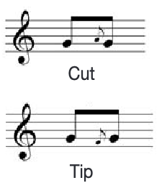
Another ornament, the roll, combines a cut with a tip respectively. In my listening, I have observed that cuts, tips, and rolls are often on repeated notes like written in the examples.
Figure 29. Roll example.
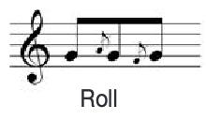
The final ornament I will draw attention to is the triplet. Instead of playing a quarter note, a player will play three of the same note or three notes in upward or downward motion. There are other ornaments, but these are the most common.
Figure 30. Triplet example.
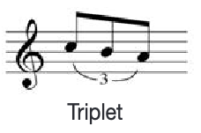

- Notes on Composition
When composing music with Irish idioms, it is worth noting that these idioms can be found in other genres and musical periods. For example, idioms with sets of four notes where there is a pitch repeated and Lombardic rhythm are often found in Baroque music.

Figure 31. Measures 13-15 of J.C. Naudot’s Sonata No. 2, IV. Gayment.
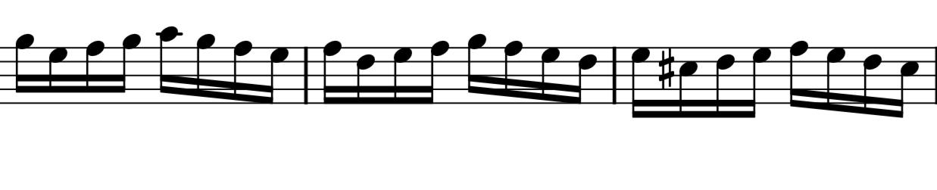
Figure 32. Telemann’s 1st Fantasia for Solo Flute.
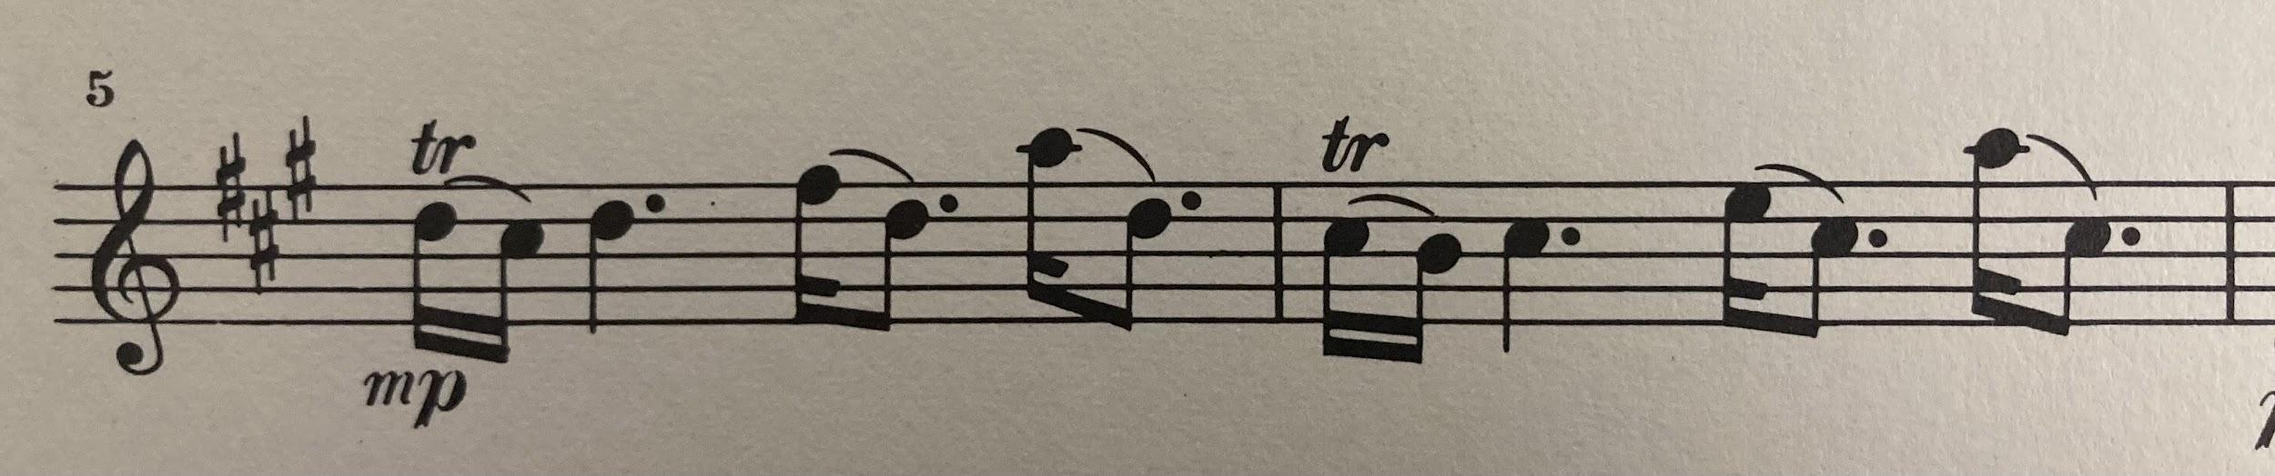

The best way to prevent these idioms losing their “Irishness” in a composition is by listening to a wide variety of Irish tunes. There are many recordings of Irish tunes of all types, and these are a valuable resource when composing.

- Modernizing ITM
How can this research help the modern composer? There is potential for ITM and other folk music to be modernized and reach the contemporary audience in a thrilling and engaging way. I applied what I learned from analyzing Irish dance tunes by writing a suite for a double wind quintet. The double wind quintet consists of two of the following instruments: flutes, oboes, clarinets, bassoons, and french horns. Instead of writing a jig in the regular 6/8 meter, I composed it in an irregular 7/8 meter, using the Irish idiomatic Lombardic rhythm, but with syncopation across the beat, creating a fresh interpretation of the traditional Irish rhythms. Rather than a simple chordal accompaniment, I made the accompaniment more interesting by antiphonal question and answer motives and canonic textures. I applied my classical training along with what I have learned from studying ITM to create my own personal voice to compose an Irish suite that could be performed in recital halls.

Conclusions

The importance of this research is specific to composers. It can be used for applying an Irish sound to a film score, a concert work, or a video game score. There is a strong tradition of using folk music in compositions for concert works or film/game scores, such as the works of Bartók, and the film score of Titanic. This research will help composers to create “Irishness” by using folk techniques in their musical compositions.
My plans for dissemination are the Elkin Isaac Research Symposium, a lecture-recital at a music major meeting, and as a resource in my thesis where I will be writing an Irish-inspired piece.
This experience has made a difference in my life because it has opened my eyes to a realm of the music world that was previously unfamiliar to me. I had never done composition research before this, which has been incredibly helpful in writing my own music. Doing research on a genre that is important to my journey as a musician has been rewarding and challenging. I have learned different styles of playing my own instrument, different compositional techniques, and about the field of ethnomusicology. This experience has also helped me prepare for graduate school.

To the Hyde Fellows in Student Research,
Thank you for giving me the opportunity to participate in Albion’s FURSCA program this summer. This summer provided many benefits that will greatly influence my future education and research endeavors. Thank you!

Bibliography

Adler, Samuel. The Study of Orchestration. 1st ed. New York: W. W. Norton & Company, Inc., 1982

Ahern, Pat et al. The Companion to Irish Traditional Music. Edited by Vallely Fintan. New York, NY: New York University Press, 1999

Baker, David. How To Learn Tunes: The Quick and Easy Method for Remembering Melodies and Chord Changes. New Albany, IN: Jamey Aebersold Jazz, 1997

Goff, Angela. “The Ulster Cycle: Cultural Significance for Irish Composers.” Estudios irlandeses 2, no. 12 (2017). https://www.proquest.com/docview/2116436675?accountid=8252&pq-origsite=primo&parentSessionId=6fitUkHIjpgHYog4pzczV9OhWjfplTM7xV75Jt%2Fc1DA%3D (accessed May 27th, 2022): 47–61.

The Grand Irish Songbook. Milwaukee, WI: Hal Leonard Corporation, 2006

Krassen, Miles. O’Neill’s Music of Ireland: New and Revised. New York, NY: Oak Publications, 1976

Köküer, Münevver, Islah Ali-MacLachlan, Daithí Kearney, and Peter Jančovič. “Curating and Annotating a Collection of Traditional Irish Flute Recordings to Facilitate Stylistic Analysis.” International journal on digital libraries 20, no. 1 (2019). https://web.s.ebscohost.com/ehost/pdfviewer/pdfviewer?vid=0&sid=662f404a-b632-44fb-a39f-631c9149a048%40redis (accessed May 27, 2022): 107-121.

Laoire, Lillis O. “Towards an Aesthetics of Gaelic Song Performance.” Folk life 54, no. 1 (2016). https://web.p.ebscohost.com/ehost/pdfviewer/pdfviewer?vid=0&sid=8e2a253b-49c9-4290-b832-1304b837db7d%40redis (accessed May 27th, 2022): 49–67.

Merriam, Alan. “Uses and Functions.” In The Anthropology of Music, 219-223. Evanston, IL: Northwestern University Press, 1964

Owens, Thomas. Bebop. New York, NY: Oxford University Press, 1995

Pendlebury, Celia. “Tune Families and Tune Histories: Melodic Resemblances in British and Irish Folk Tunes.” Folk music journal 11, no. 5 (2020). https://web.s.ebscohost.com/ehost/pdfviewer/pdfviewer?vid=0&sid=db8ea294-bbc5-41ec-8a2d-62925ed223db%40redis (accessed May 27th, 2022): 67–95.

The Session. A community website dedicated to Irish traditional music.https://thesession.org
(accessed July 16, 2022).
Appendix 1.
Charts of ITM genres.

The first chart is a quantitative analysis of seventy-six Irish songs and airs from The Grand Irish Songbook. The categories show the following information for each song: name, genre, meter, presence of an anacrusis, tonality, form, phrase length, and phrase structure. The next eight charts are a brief quantitative analysis of three tunes from each of the genres that I looked at. Their categories are name, meter, presence of an anacrusis, tonality, largest leap, conjunct vs. disjunct, frequent intervals, presence of accidentals, main rhythms, and presence of tonic note before the final beat.

Table 2. Song and air analysis
Name | Genre | Meter | Anacrusis | Tonality | Form | Phrase Length | Phrase Structure
Arthur McBride (4) | Ballad | 3/4 | Yes | Major | Intro- A | 4 measures | abcd - eb'c'f
The Banks of Claudy (7) | Air | 3/4 | Yes | Mixolydian | Intro- A | 8 measures | abba
Avondale (10) | Slow Air | 4/4 | Yes | Major | Intro- A | 3 measures | abcd
The Banks of My Own Lovely Lee (12) | Slow Air | 3/4 | Yes | Major | Intro- A | 8 measures | aabcc'
Banna Strand (16) | Lament | 3/4 | Yes | MIxolydian | Intro- A | 8 measures | abbc
The Bard of Armagh (24) | Ballad | 3/4 | Yes | Major | Intro- A | 8 measures | aa'
The Bold Tenant Farmer (31) | Jig | 6/8 | Yes | Minor (no raised 7th) | Intro- A | 4 measures | aa'ba'
The Bonny Boy (34) | Air | 2/2 | Yes | Major | Intro- A | 8 measures | abb'c
Boston Burgular (40) | Ballad | 4/4 | Yes | Major | Intro- A | 4 measures | aa'ab
The Boys of Fairhill (45) | Reel | 4/4 | Yes | Major | Intro- A | 2 measures | aba'b'
The Boys from County Armagh (46) | Waltz | 3/4 | Yes | Major | Intro- A- Chorus | 4 measures | ababa'b'ab/cdefcdag
Brennan on the Moor (50) | Ballad | 2/4 | Yes | Major | Intro- A- Chorus | 4 measures | abbc/de
A Bunch of Thyme (52) | Slow Air | 4/4 | Yes | Major | Intro- A | 4 measures | abca
Butcher Boy (54) | Slow Air | 4/4 | Yes | Major | Intro- A (intro repeats) | 2 measures | abcd
Carrickfergus (56) | Slow Air | 4/4 | Yes | Major | Intro- A | 4 measures | aa'aa'bb'aa'
Cliffs of Doneen (59) | Air | 3/4 | Yes | Major | Intro- A | 5 measures | abb'c
Castle of Dromore (62) | Jig | 6/8 | Yes | Major | Intro- A- Chorus | 4 measures | abc/d
Cockles and Mussels (64) | Air | 3/4 | Yes | Major/Maybe Pentatonic | Intro- A- Chorus | 4 measures | abab'/ab'
Come Back to Erin (66) | Slow Air | 4/4 | No/Yes | Major | Intro- A- Chorus | 2 measures | abab'a'a''a'''a''''/abac
Easy and Slow (69) | Slow Air | 3/4 | Yes | Major | Intro- A- Chorus | 4 measures | aba'b'/cdd'b''
Come to the Bower (72) | Reel | 2/4 | Yes | Major | Intro- A- Refrain | 4 measures | aa'bb'/a''
The Croppy Boy (74) | Waltz | 3/4 | Yes | Major | Intro- A | 4 measures | abcb'
Danny Boy (78) | Air | 4/4 | Yes | Major | Intro- A | 2 measures | aa'aa''a'''a''''a'''''a''''''
Dicey Riley (80) | Reel | 2/4 | Yes | Major | Intro- A | 4 measures | aa'a''a'''
Do You Want Your Old Lobby (82) | Waltz | 3/4 | Yes | Major | Intro- A- Chorus | 8 measures | aa'ba'/a''a'''
Down By the Sally Gardens (86) | Slow Air | 4/4 | Yes | Major | Intro- A | 4 measures | aaba
The Enniskillen Dragoon (88) | Air | 2/2 | Yes | Major | Intro- A | 4 measures | abb'a
FIddler's Green (90) | Waltz | 3/4 | Yes | Major | Intro- A- Chorus | 4 measures | aa'bc/db'b''a'
The Foggy Dew (96) | Slow Air | 3/4 | No/Yes | Minor (no raised 7th) | Intro- A | 4 measures | ababcdab
Follow Me Up To Carlow (98) | Jig | 6/8 | No | Dorian | Intro- A- Chorus | 8 measures | aa/bb
The Galway Shawl (101) | Air | 3/4 | Yes | Major | Intro- A | 4 measures | aa'ba''aa'b'
The Galway Races (104) | Reel | 4/4 | Yes | Major | Intro- A- Refrain | 2 measures | aa'ba'/c
Green Grow the Rashes, O (106) | Reel | 4/4 | Yes | Minor (no raised 7th) | Intro- A- Chorus | 2 measures | aa'a''a'''
Henry My Son (108) | Slow Air | 2/4 | No/Yes | Major | Intro- A- Refrain | 4 measures | aa'a''/bc
High Germany (110) | Slow Air | 4/4 | Yes | Minor | Intro- A | 4 measures | abb'a'
The Hills of Kerry (117) | Air | 3/4 | Yes | Major | Intro- A | 8 measures | aba'
The Holy Ground (120) | Air | 2/2 | Yes | Major | Intro- A- Chorus | 4 measures | aabcabc'a'/bca
The Humour Is On Me Now (124) | Jig | 6/8 | Yes | Major | Intro- A | 4 measures | aa'aa''
Isn't It Grand Boys (135) | Air | 3/4 | No | Major | Intro- A- Chorus | 8 measures | aba'b'
I'll Tell Me Ma (138) | Air | 4/4 | Yes | Major | Intro- A | 4 measures | aabb'
I'm a Rover and Seldom Sober (140) | Air | 3/4 | Yes | Major | Intro- Refrain- A | 4 measures | ab/ab
The Irish Rover (142) | Air | 4/4 | Yes | Major | Intro- A | 4 measures | aa'ba''
James Connolly (144) | Ballad | 3/4 | Yes | Major | Intro- A | 8 measures | aa'
Johnny I Hardly Knew Ye (146) | Jig | 6/8 | Yes | MInor | Intro- A | 8 measures | ab
Johnson's Motor Car (148) | Air | 2/4 | Yes | Major | Intro- A | 4 measures | aa'a'a''
The Jolly Beggarman (150) | Air | 4/4 | Yes | Major | Intro- A- Chorus | 4 measures | abab/a'b'
Kelly of Killane (153) | Air | 4/4 | Yes | Major | Intro- A | 4 measures | ababa'a''ab'
The Juice of the Barley (158) | Air | 3/4 | Yes | Major | Intro- A- Chorus | 4 measures | aaa'b/a''a'''
The Kerry Recruit (160) | Waltz | 3/4 | Yes | Major | Intro- A | 4 measures | aa'aa'
Lanigan's Ball (162) | Jig | 6/8 | Yes | Minor | Intro- A- Chorus | 4 measures | aa'a''a'''/bb'b''b'
Lark in the Morning (168) | Jig | 6/8 | Yes | Minor (no raised 7th) | Intro- A | 4 measures | abcb
Leaving of Liverpool (172) | Sea Shanty | 2/2 | Yes | Major | Intro- A- Chorus | 4 measures | aa'a''a'''/ba''''ca'''''
The Little Beggarman (174) | Jig | 6/8 | Yes | Major | Intro- A- Chorus | 4 measures | abcb'/dbd'b'
Lowlands Low (186) | Air | 4/4 | No | Major | Intro-A- Refrain | 2 measures | aba'c/dc
The Meeting of the Waters (190) | Slow Air | 3/4 | Yes | Major | Intro- A | 4 measures | abba'a
Mrs. McGrath (204) | Air | 2/4 | Yes | Major | Intro- A- Chorus | 4 measures | ab/cc'
The Nightingale (216) | Slow Air | 3/4 | Yes | Major | Intro- A- Chorus | 4 measures | aa'a'a/aa'a'a
Oft in the Stilly Night (224) | Jig | 6/8 | No | Major | Intro- A- Chorus | 4 measures | aabbaa'
Old Maid in the Garret (226) | Air | 4/4 | Yes | Major | Intro- A- Refrain | 4 measures | abb'c/de
The Old Orange Flute (228) | Jig | 6/8 | Yes | Major | Intro- A | 4-4-4-2-2 measures | aba'a''a'''
The Old Woman From Wexford (230) | Jig | 6/8 | Yes | Major | Intro- A- Refrain | 2 measures | aba'b'/a''b''
The Parting Glass (234) | Air | 4/4 | Yes | Minor | Intro- A | 4 measures | aa'ba'
The Patriot Game (236) | Waltz | 3/4 | Yes | Major | Intro- A | 6 measures | abba
The Queen of Connemara (244) | Jig | 6/8 | Yes | Major | Intro- A- Refrain | 4 measures | aa'bc/de
The Rising of the Moon (248) | Air | 4/4 | No | Minor | Intro- A | 2 measures | abaca'dc
The Rocks of Bawn (251) | Waltz | 3/4 | Yes | Major | Intro- A | 4 measures | aa'bcbc'da'
The Rose of Mooncoin (264) | Air | 3/4 | Yes | Major | Intro- A- Chorus | 4 measures | aa'aa''aa'aa''
Slievenamon (274) | Jig | 6/8 | Yes | Major | Intro- A | 4 measures | ababcda'b
Sally Brown (277) | Air | 4/4 | No | Major | Intro- A | 2 measures | abcd
Sam Hall (278) | Air | 4/4 | Yes | Major | Intro- A | 4 measures | aaa'aa
Skibbereen (280) | Air | 4/4 | Yes | Major | Intro- A | 4 measures | aa'ba'
Spancil Hill (284) | Jig | 6/8 | Yes | Minor | Intro- A | 4 measures | abba
The Spanish Lady (286) | Air | 4/4 | Yes | Major | Intro- A- Chorus | 4 measures | aabb'/aa
Sweet Carnlough Bay (290) | Air | 3/4 | Yes | MIxolydian | Intro- A | 5 measures | abab
The Town of Ballybay (295) | Jig | 6/8 | Yes | Major | Intro- A- Chorus | 2 measures | aa'abccc'a'/aa'ab'
The West's Awake (304) | Air | 3/4 | Yes | Major | Intro- A | 3-3-3-3-4 measures | aa'a''a'''b

Table 3. Jig analysis
Title | Meter | Anacrusis? | Tonality | Largest Leap | Conjunct or Disjunct | Frequent Intervals | Accidentals | Main Rhythms (More to Less) | Arrival on Tonic Before Final Beat
The Kesh Jig | 6/8 | Yes | Major | 4th | Conjucnt | 2nds, 3rds | Yes | Running 8ths / dotted quarter/ quarter-eighth | Yes
The Lark in the Morning | 6/8 | No | Major | 4th | Conjunct | 2nds, 3rds | No | Running 8ths/ quarter-eighth | Yes
The Lilting Banshee | 6/8 | No | Dorian | 5th | Conjunct | 2nds, 3rds, 4ths, 5ths | No | Running 8ths / dotted quarter/ quarter-eighth | Yes

Table 4. Reel analysis
Title | Meter | Anacrusis | Tonality | Largest Leap | Conjunct or Disjunct | Frequent Intervals | Accidentals | Main Rhythms (More to Less) | Arrival on Tonic Before Final Beat
Drowsy Maggie | 4/4 | No | Dorian | Minor 7th | Mostly Conjunct | 2nds, 3rds, 5ths | No | Running 8ths/ quarter + 2 eighths/ quarter | No
The Maid Behind the Bar | 4/4 | No | Major | 4th | Conjunct | 2nds, 3rds, 5ths | No | Running 8ths/ quarter + 2 eighths/ half note | No
The Banshee | 4/4 | No | Mixolydian | 4th | Conjunct | 2nds, 3rds, 4ths | No | Running 8ths/ quarters | Yes

Table 5. Slip jig analysis
Title | Meter | Anacrusis | Tonality | Largest Leap | Conjunct or Disjunct | Frequent Intervals | Accidentals | Main Rhythms (More to Less) | Arrival on Tonic Before Final Beat
The Butterfly | 9/8 | No | Minor | 5th | Conjunct | 2nds, 3rds, 5ths | No | Quarter + 8th/ Dotted Quarter/ three 8ths | No
A Fig For A Kiss | 9/8 | No | Dorian | 5th | Conjunct | 2nds, 3rds, 5ths | No | Quarter + 8th/ three 8ths/ two 16ths + two 8ths | No
The Foxhunter | 9/8 | No | Major | 8th | Conjunct | 2nds, 3rds, 4ths | No | Quarter + 8th/ three 8ths | No

Table 6. Hornpipe analysis
Title | Meter | Anacrusis | Tonality | Largest Leap | Conjunct or Disjunct | Frequent Intervals | Accidentals | Main Rhythms (More to Less) | Arrival on Tonic Before Final Beat
King of the Fairies | 4/4 | Yes | Dorian | 5th | Conjunct | 2nds, 3rds, 4ths | Yes | Running 8ths/ Dotted quarter + eighth/ quarter/ half note | No
The Boys of Bluehill | 4/4 | Yes | Major | 5th | Conjunct | 2nds, 3rds | No | Running 8ths/ 8th triplet set/ quarter | No
Off to California | 4/4 | No | Major | 4th | Conjunct | 2nds, 3rds | No | Running 8ths/ quarters/ half | No

Table 7. Polka analysis
Title | Meter | Anacrusis | Tonality | Largest Leap | Conjunct or Disjunct | Frequent Intervals | Accidentals | Main Rhythms (More to Less) | Arrival on Tonic Before Final Beat
John Ryan's | 2/4 | No, Yes in B section | Major | 6th | Conjunct | 2nds, 3rds | No | Two 8ths + four 16ths/ One 8th + two 16ths | Yes
The Ballydesmond | 2/4 | No | Dorian | 6th | Conjunct | 2nds, 3rds | No | Running 8ths/ dotted 8th & one 16th + two 8ths/ quarter | Yes
Maggie in the Woods | 2/4 | Yes | Major | 4th | Conjunct | 2nds, 3rds, 4ths | No | Two 8ths + four 16ths/ dotted 8th & one 16th + two 8ths | Yes

Table 8. Slide analysis
Title | Meter | Anacrusis | Tonality | Largest Leap | Conjunct or Disjunct | Frequent Intervals | Accidentals | Main Rhythms (More to Less) | Arrival on Tonic Before Final Beat
Merrily Kissed the Quaker | 12/8 | Yes | Major | 6th | Conjunct | 2nds, 3rds | No | Running 8ths/ quarter + eighth | Yes
Denis Murphy's Slide | 12/8 | No | Major | 6th | Conjunct | 2nds, 3rds | No | Quarter + eighth/ three eighths/ quarter + eighth + dotted quarter | Yes
Star Above the Garter | 12/8 | No | Mixolydian | 6th | Conjunct | 2nds, 3rds | No | Quarter + eighth/ three eighths | Yes

Table 9. Waltz analysis
Title | Meter | Anacrusis | Tonality | Largest Leap | Conjunct or Disjunct | Frequent Intervals | Accidentals | Main Rhythms (More to Less) | Arrival on Tonic Before Final Beat
Sí Beag Sí Mór | 3/4 | Yes | Major | 10th | Both | 2nds, 3rds, 4ths, 6ths | No | half + quarter/ quarter + two 8ths + quarter/ four 8ths + 1 quarter | Yes
Inisheer | 3/4 | Yes | Major | 8th | Conjunct | 2nds, 3rds | No | three 8ths + dotted quarter/ one 8th + two 16ths + one 8th + dotted quarter | No
The South WInd | 3/4 | Yes | Major | 8th | Conjunct | 2nds, 3rds, 4ths | No | dotted quarter + eighth + quarter/ 3 quarters | No

Table 10. Song and air analysis
Title | Meter | Anacrusis | Tonality | Largest Leap | Conjunct or Disjunct | Frequent Intervals | Accidentals | Main Rhythms (More to Less) | Arrival on Tonic Before Final Beat
The Parting Glass | 4/4 + 6/4 | Yes | Minor | 6th | Conjunct | 2nds, 3rds | No | 3 quarters + two 8ths/ 2 slurred 8ths + 2 slurred 8ths | Yes
The Dawning of the Day | 4/2 | `Yes | Major | 6th | Conjunct | 2nds, 3rds, 6ths | No | 3 half + 2 quarter | Yes
Mo Ghile Mear | 4/4 | No | Mixolydian | 4th | Conjunct | 2nds, 3rds | No | dotted quarter + eighth/ eighth + quarter + eighth | No

Appendix 2.
Scores of a traditional and modernized reel.

In this appendix, I have a score of a reel that in the traditional style and a rough draft of a modernized version, both of which I wrote. I used the idioms that I found in reels, and attempted to put them together in a way that makes musical sense while still remaining true to the style of ITM. I then used this traditional version as the basis for the piece for double wind quintet. After the reel examples, there are examples of a traditional jig that I wrote and a work-in-progress of a modernized version of it.

Figure 33. Original reel in traditional style.
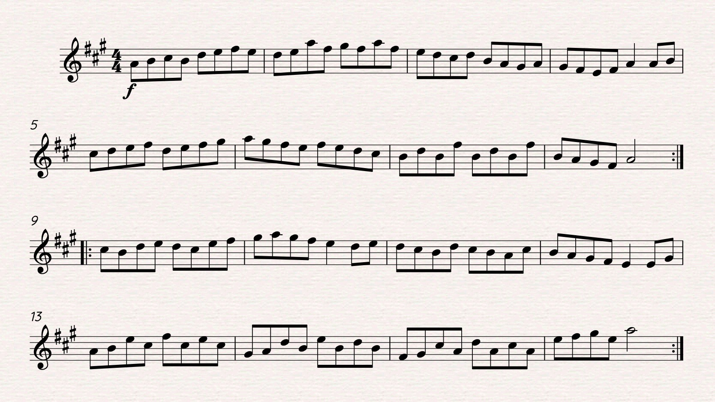

Figure 34. Original reel in modernized style.
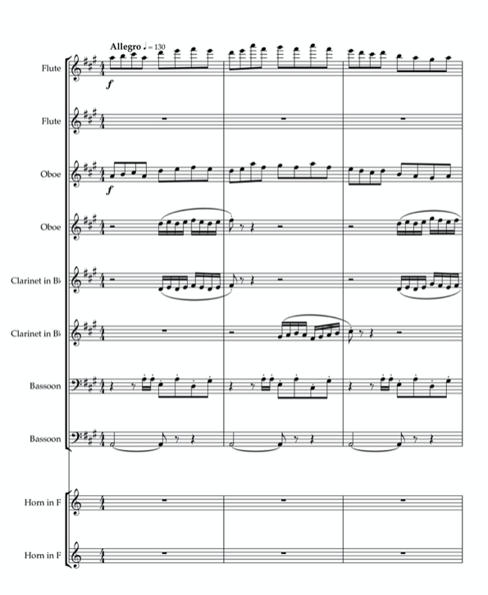
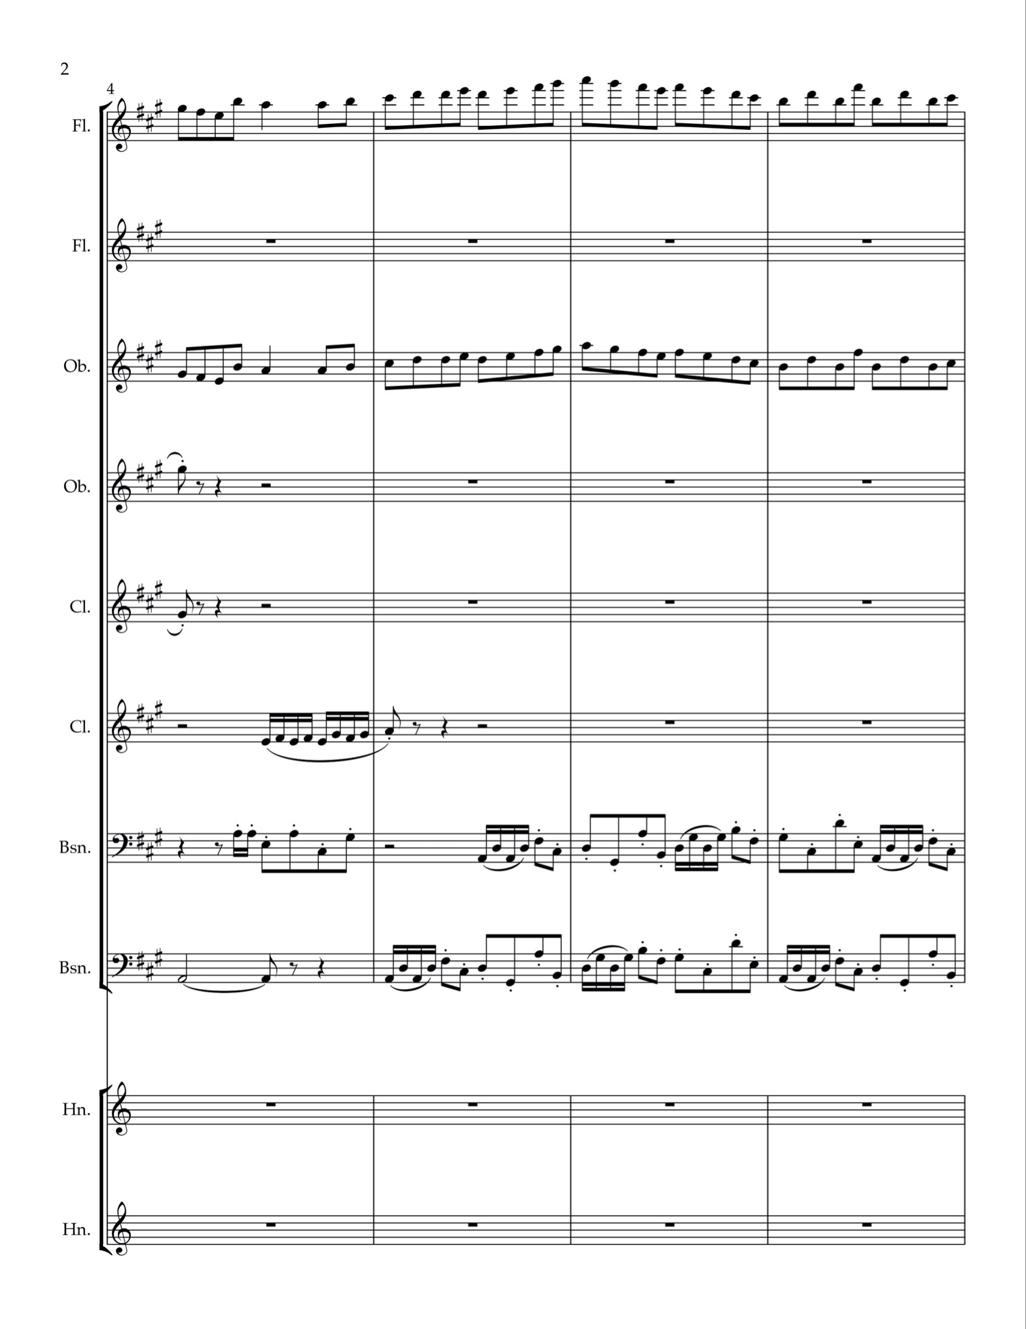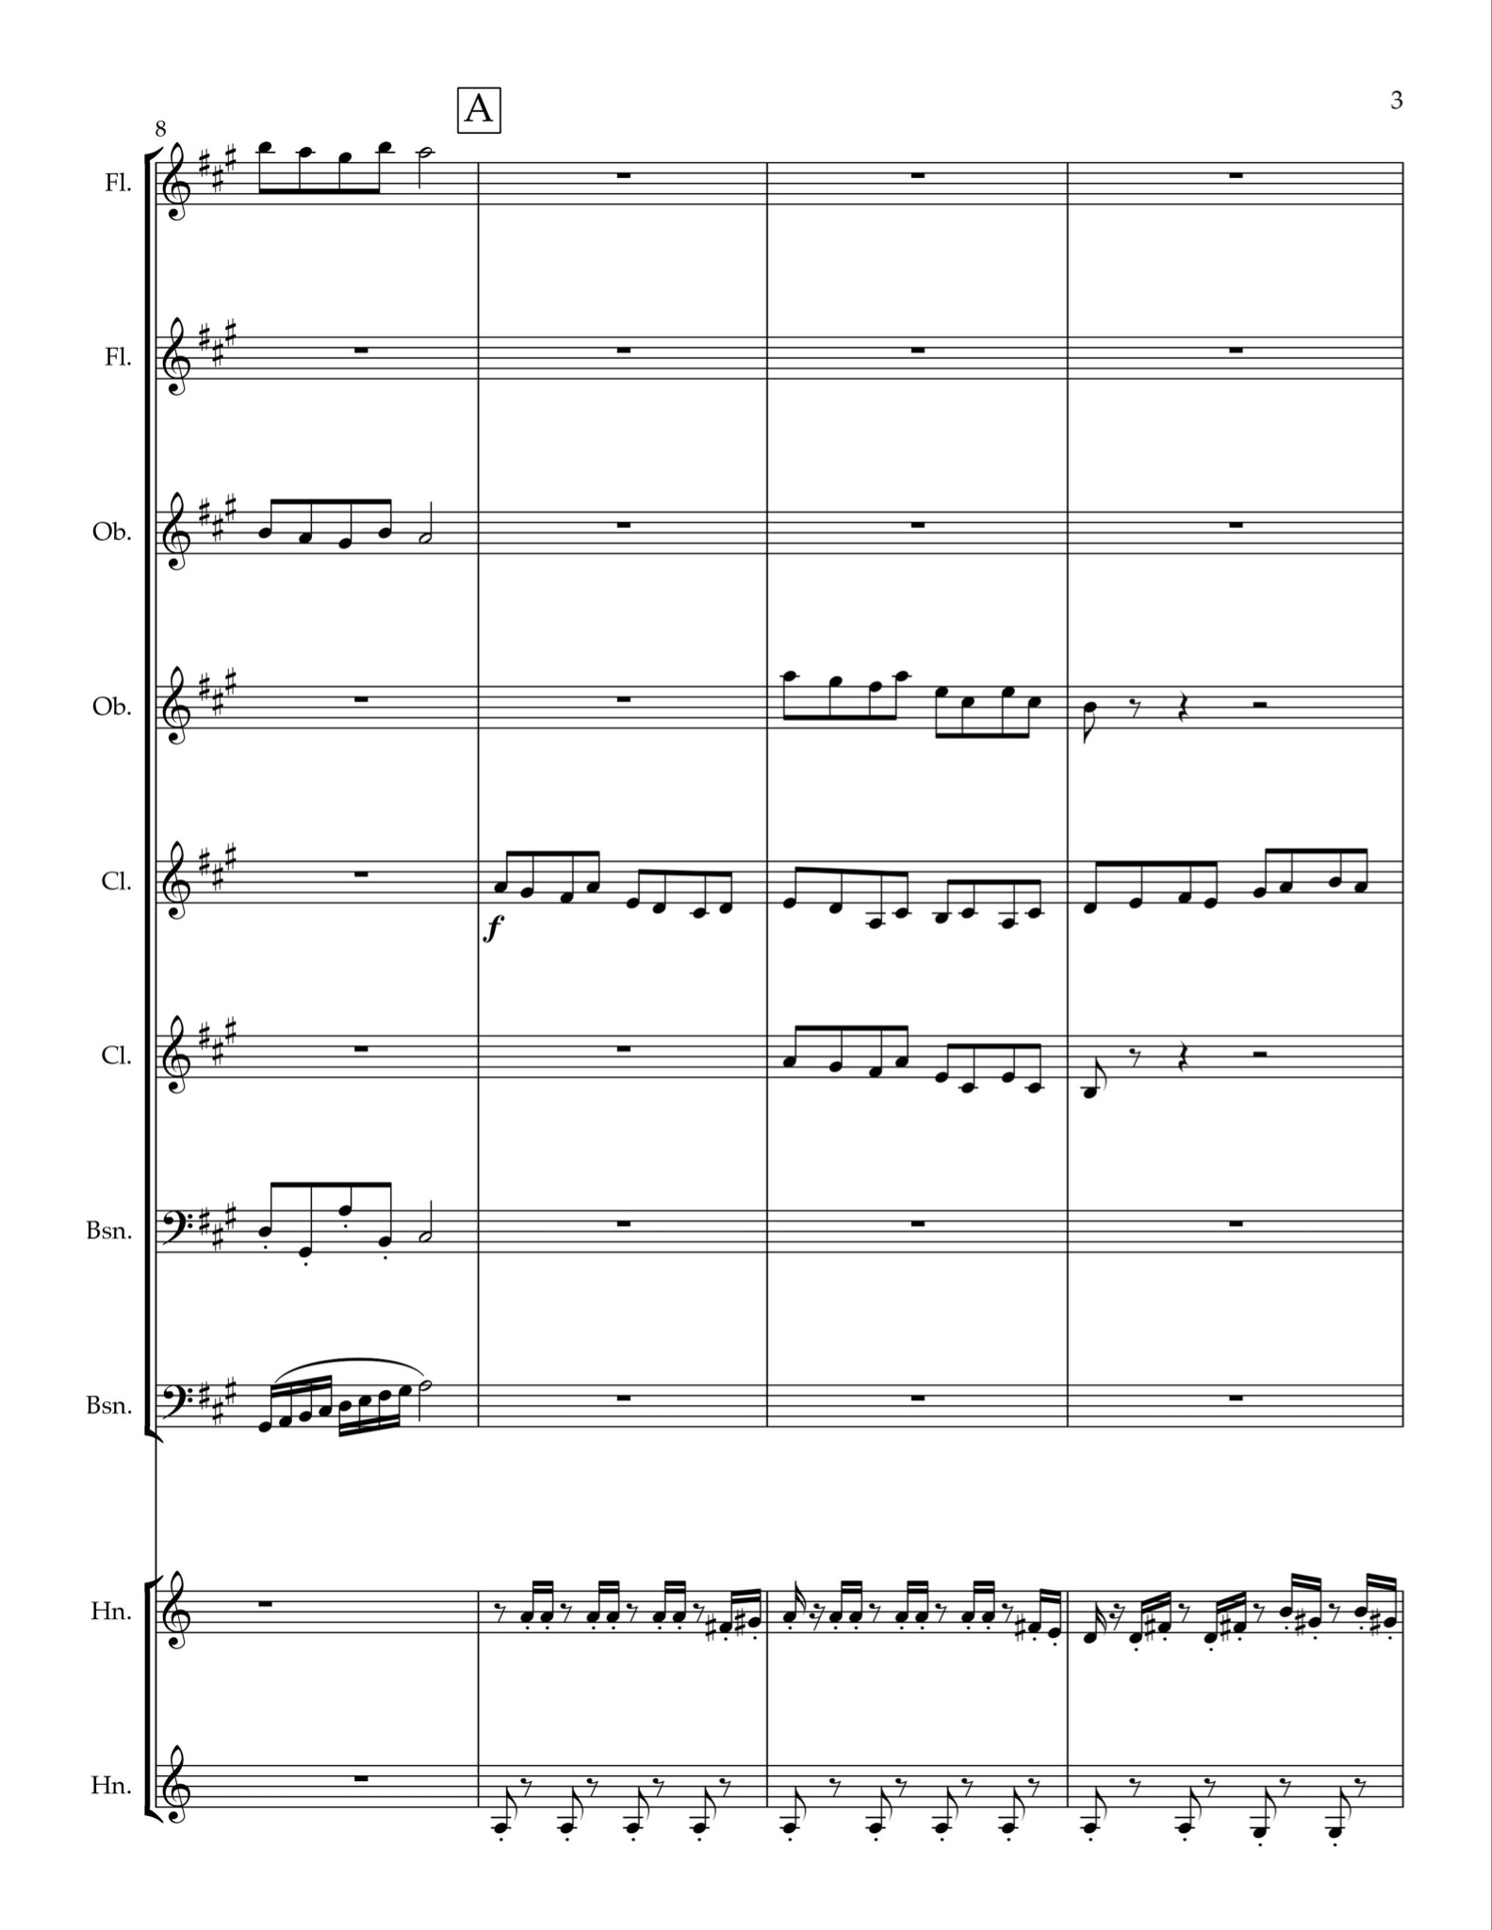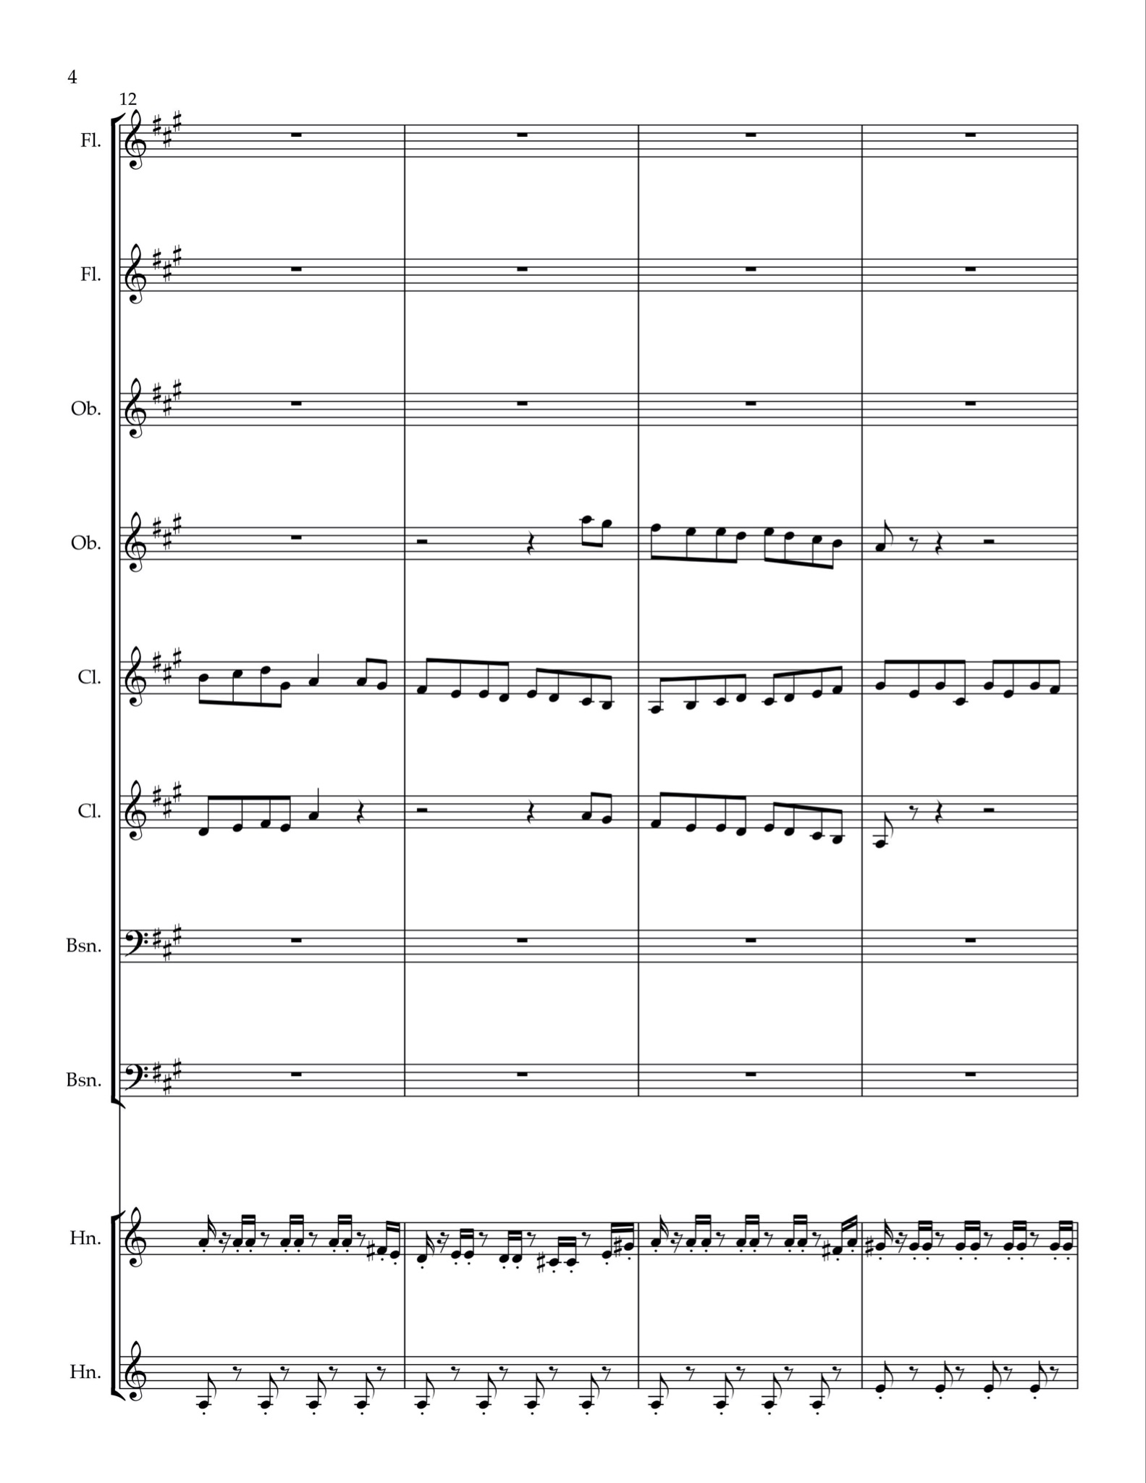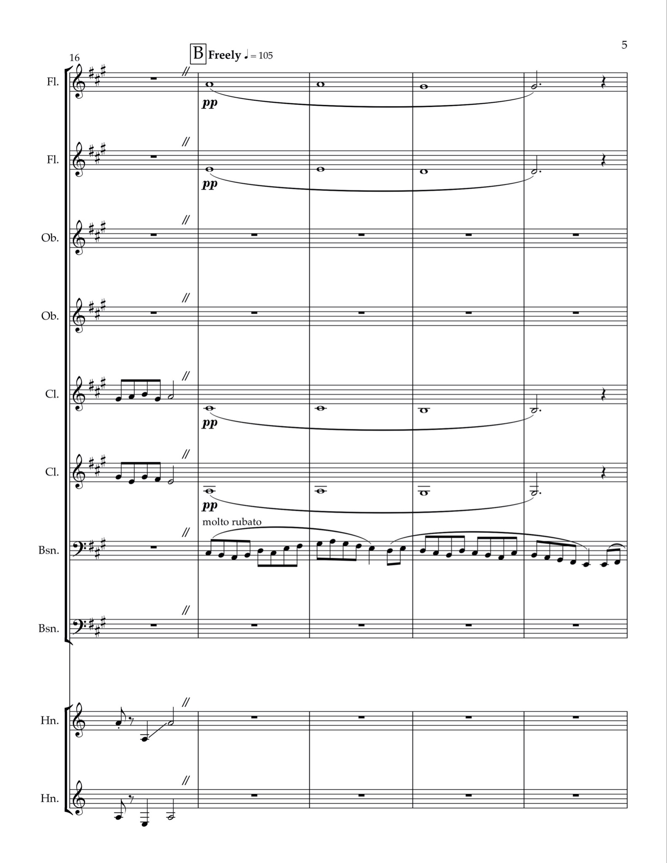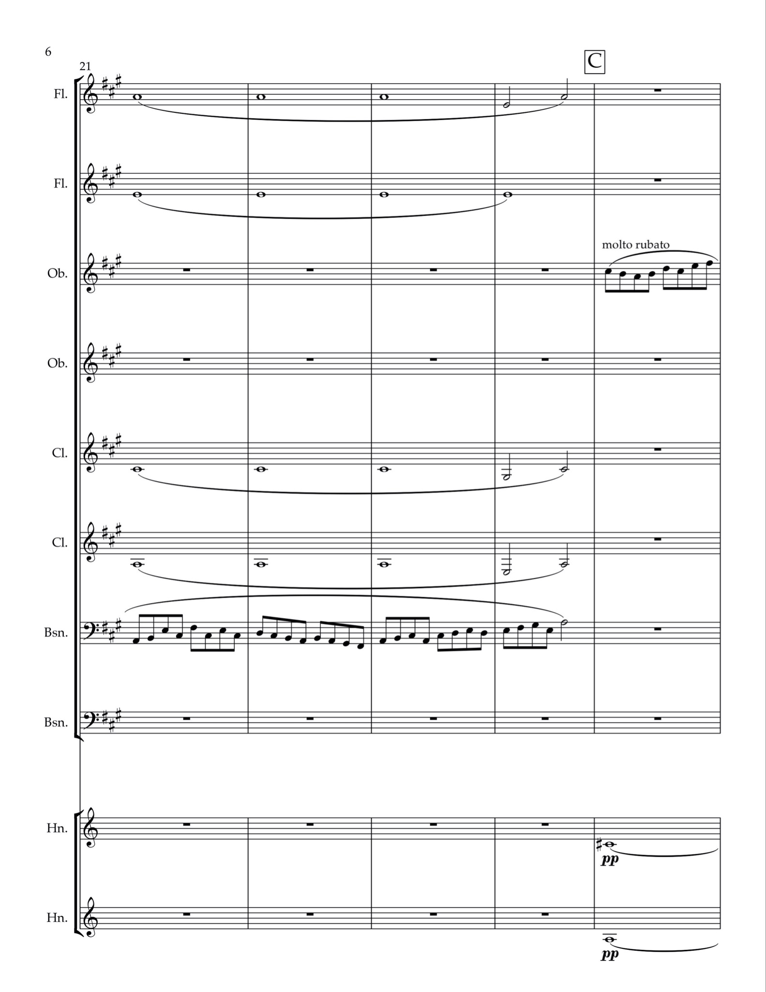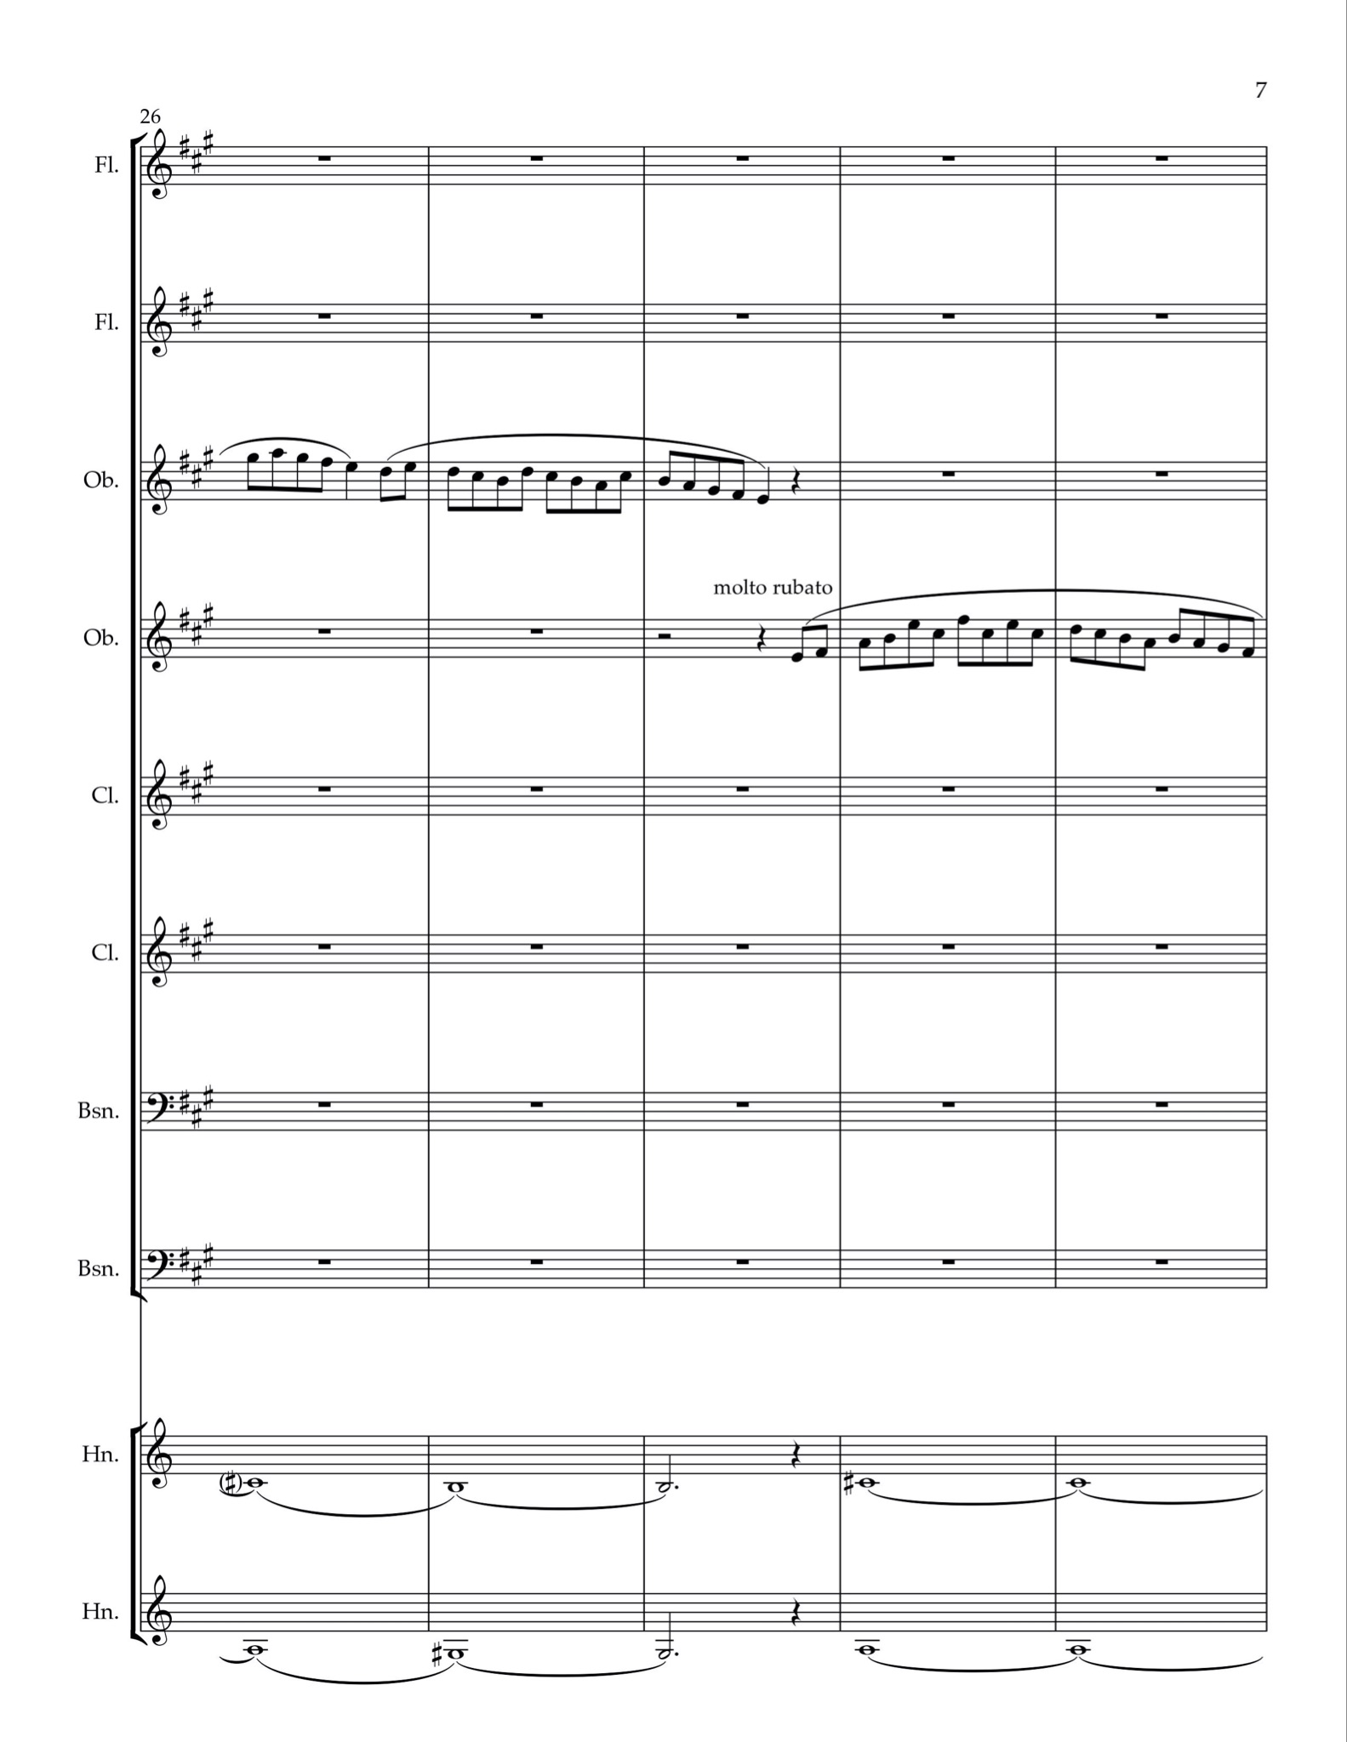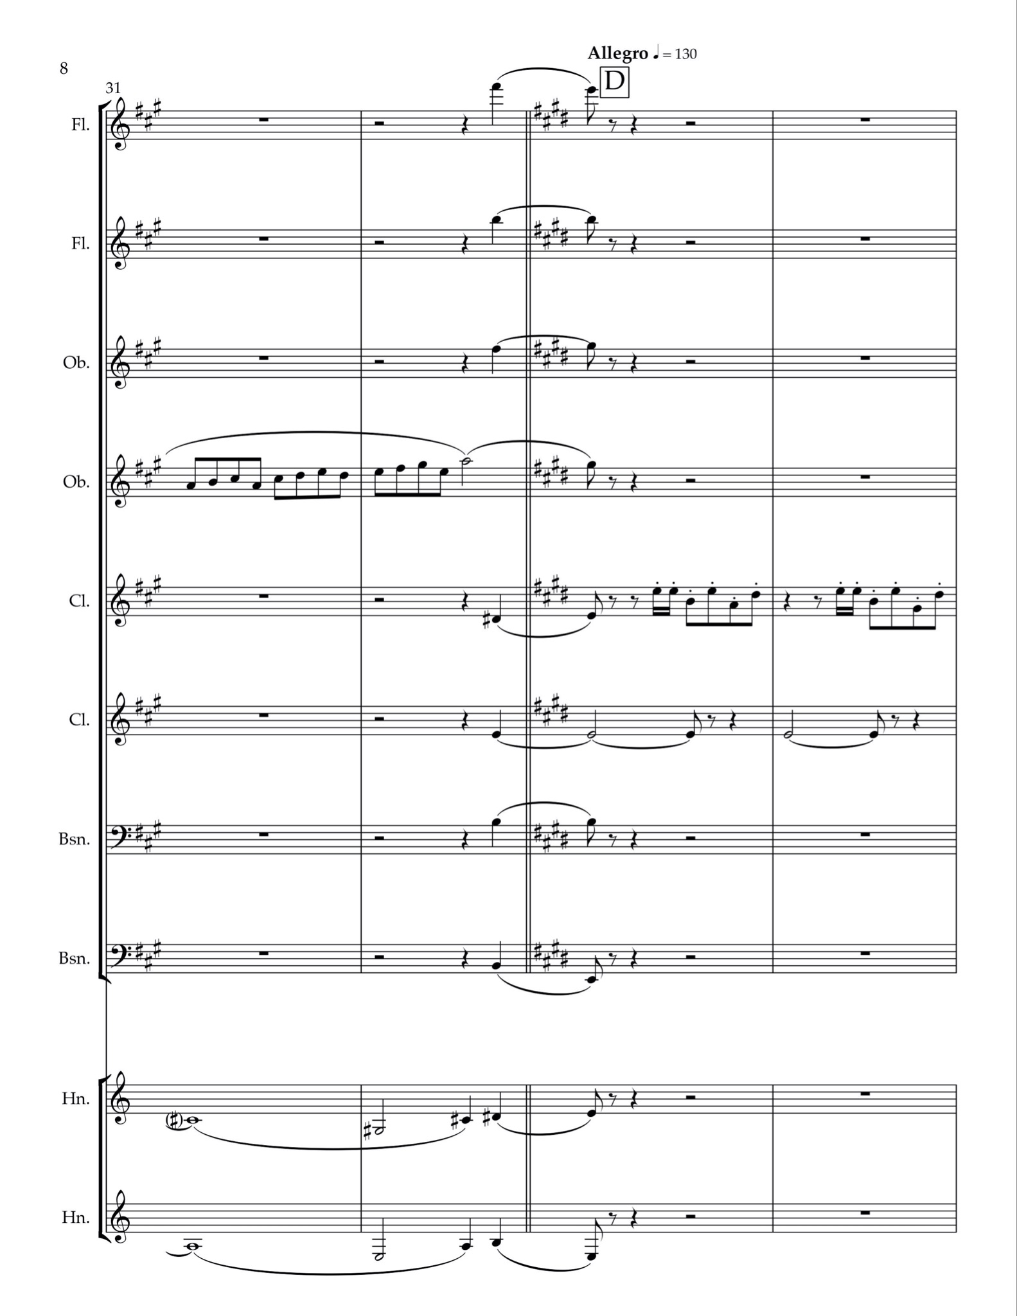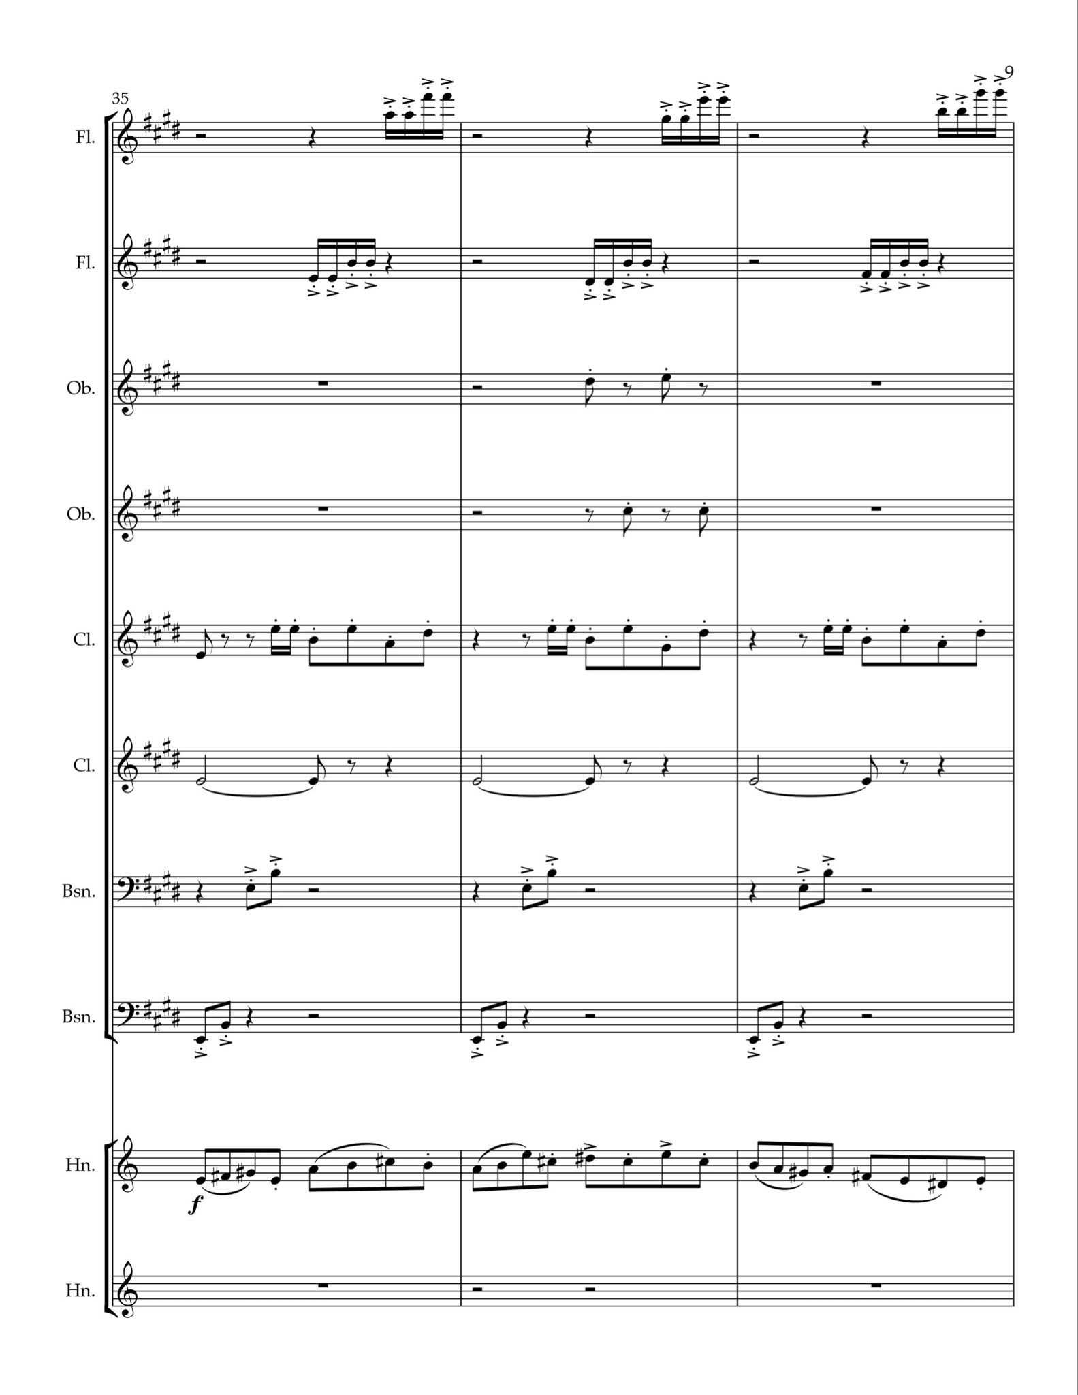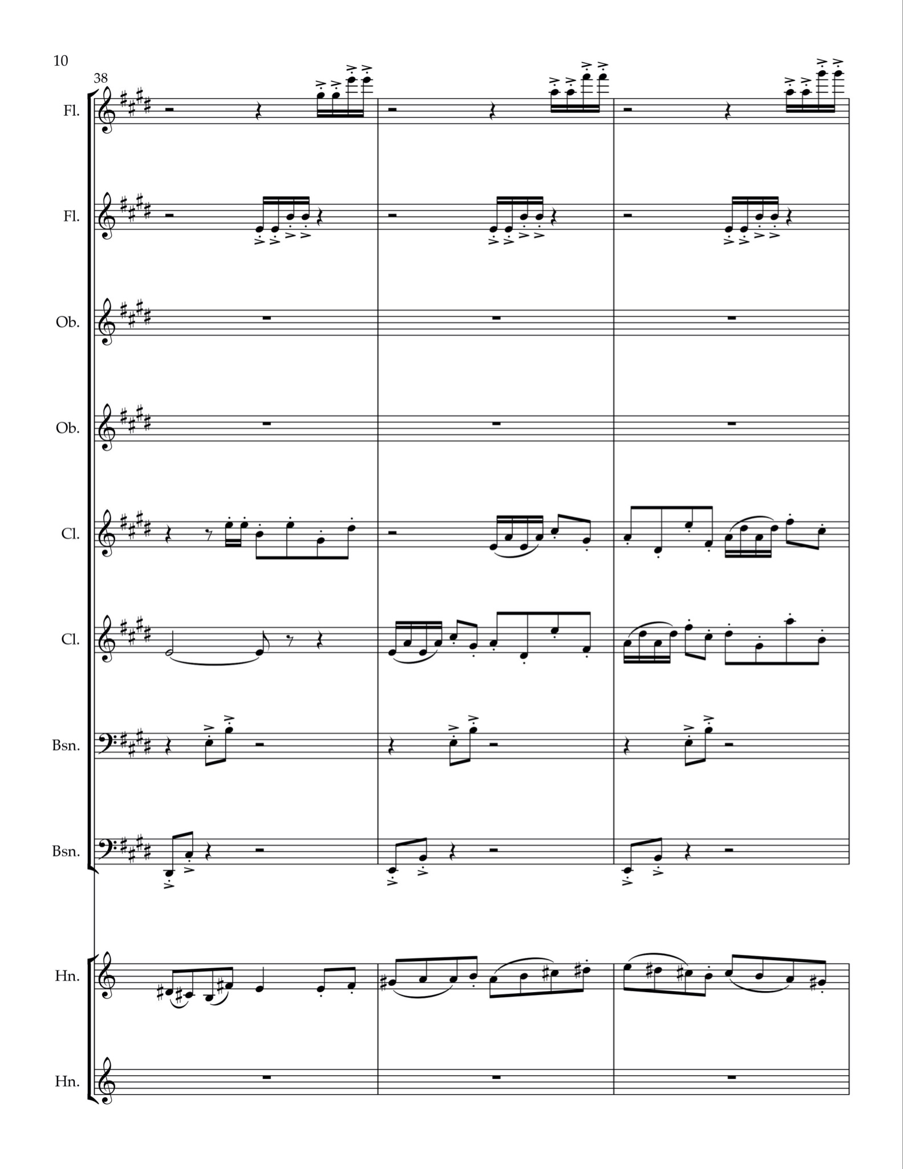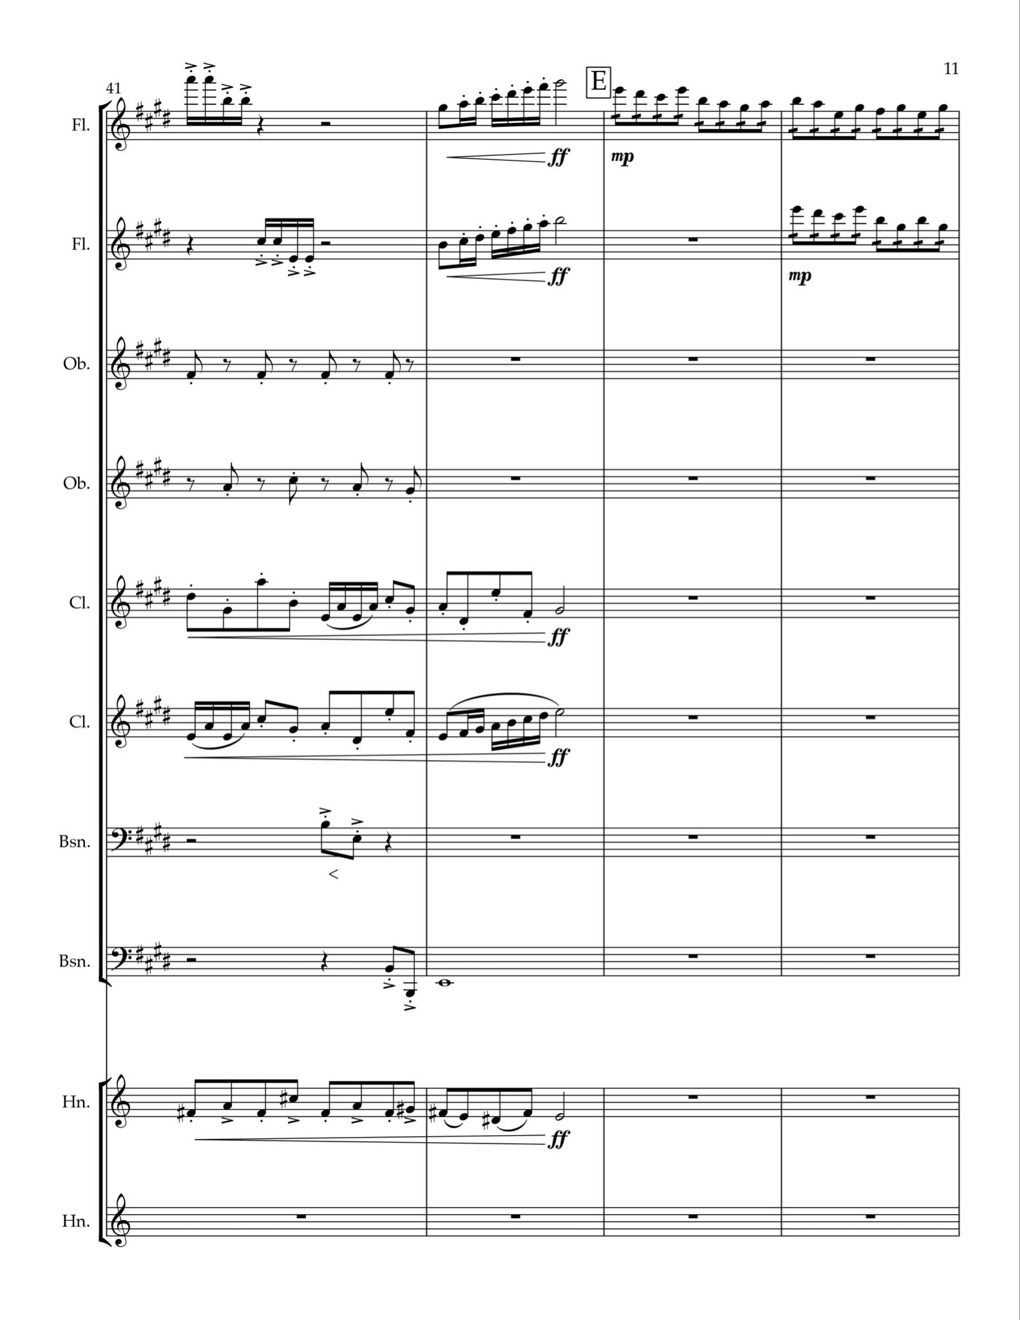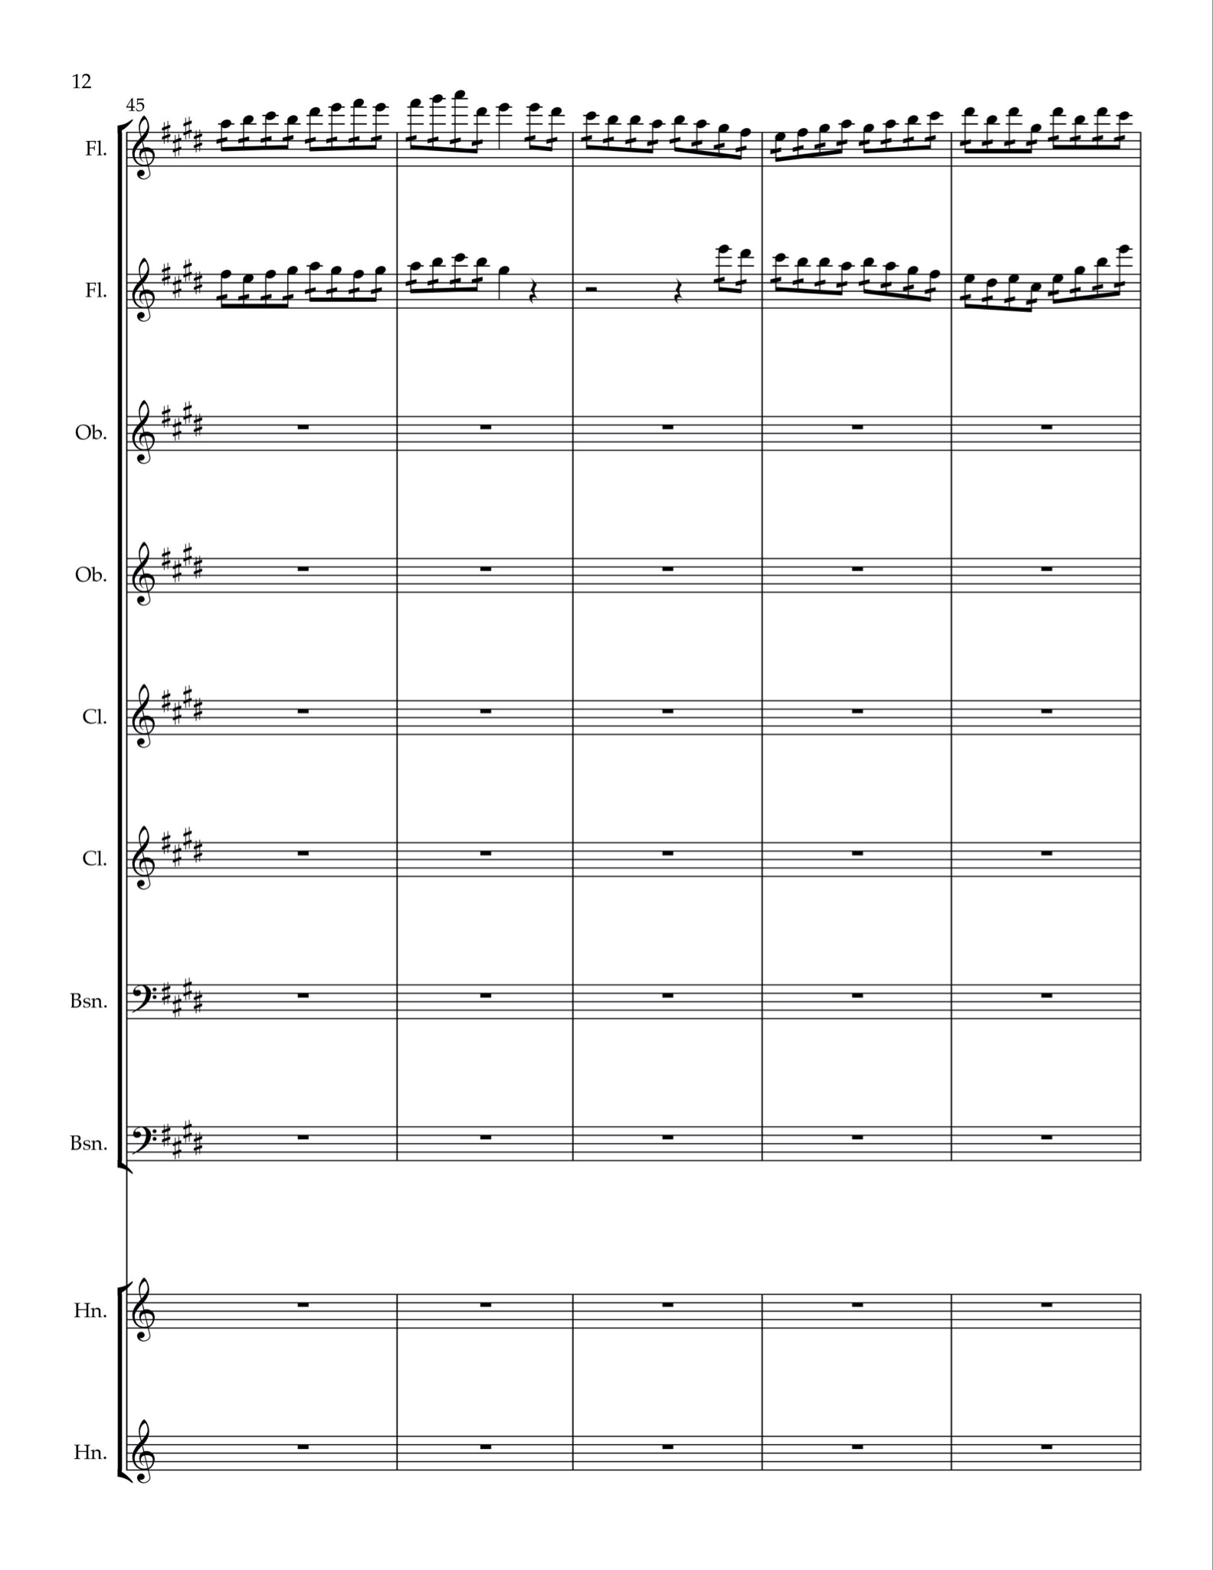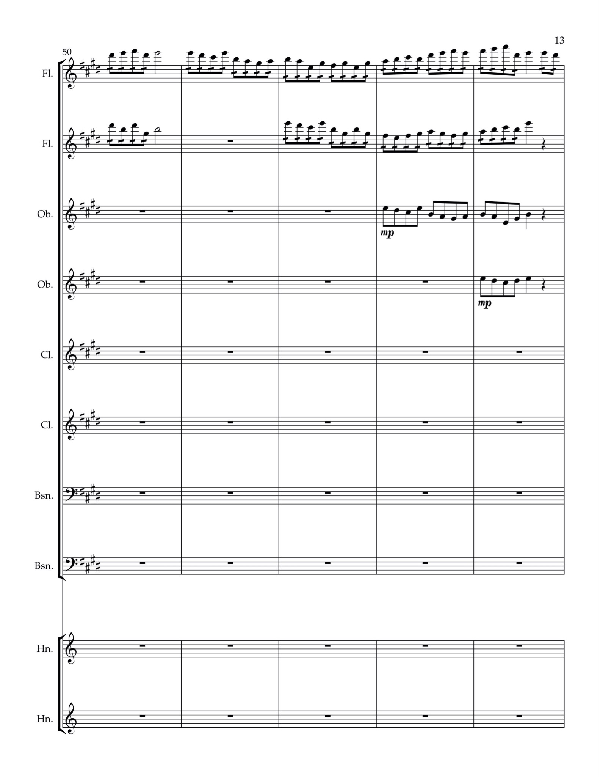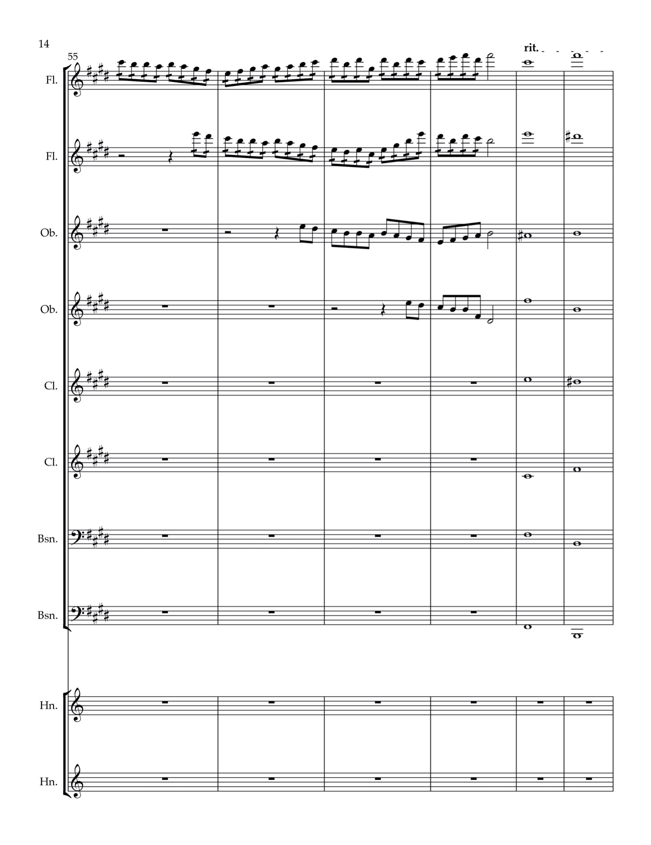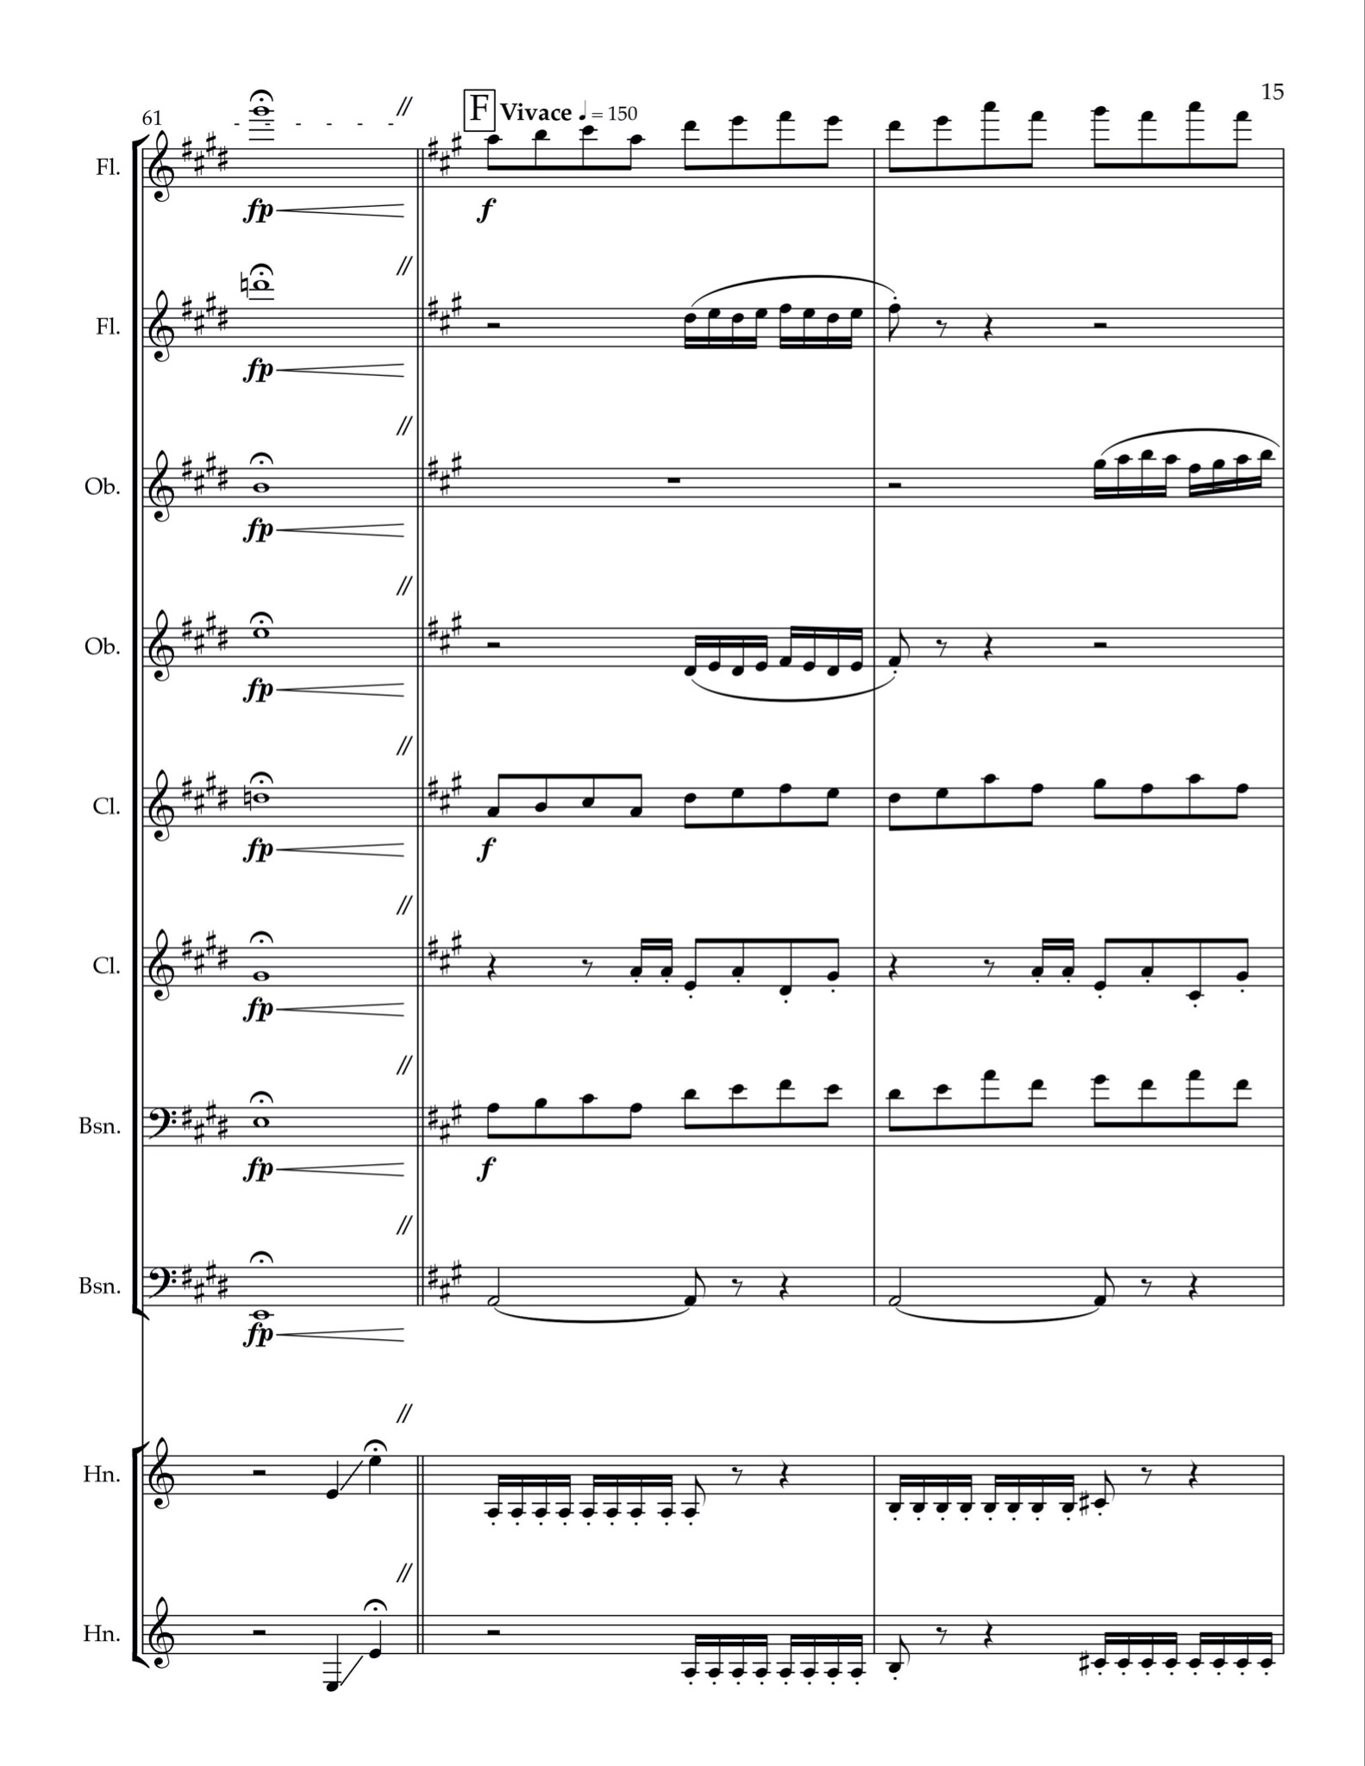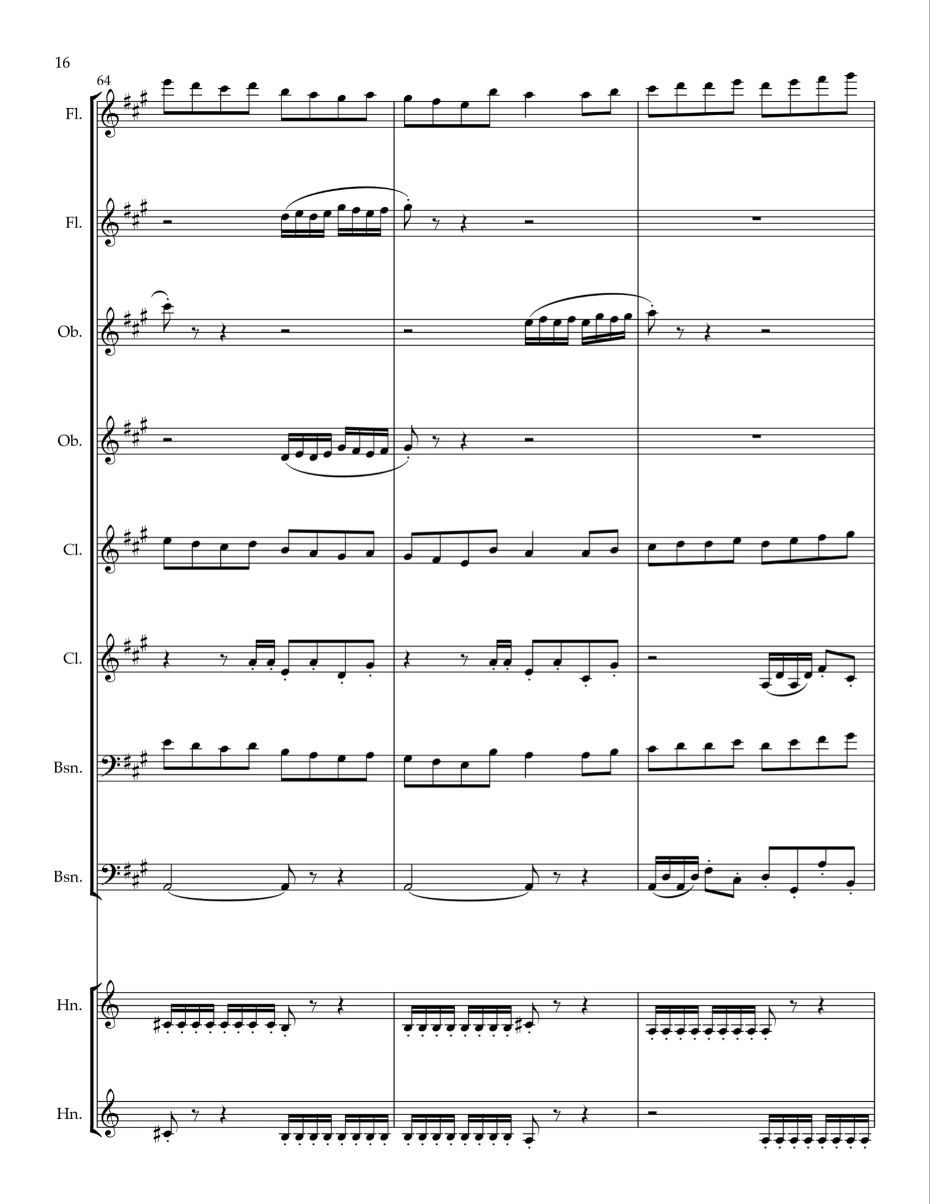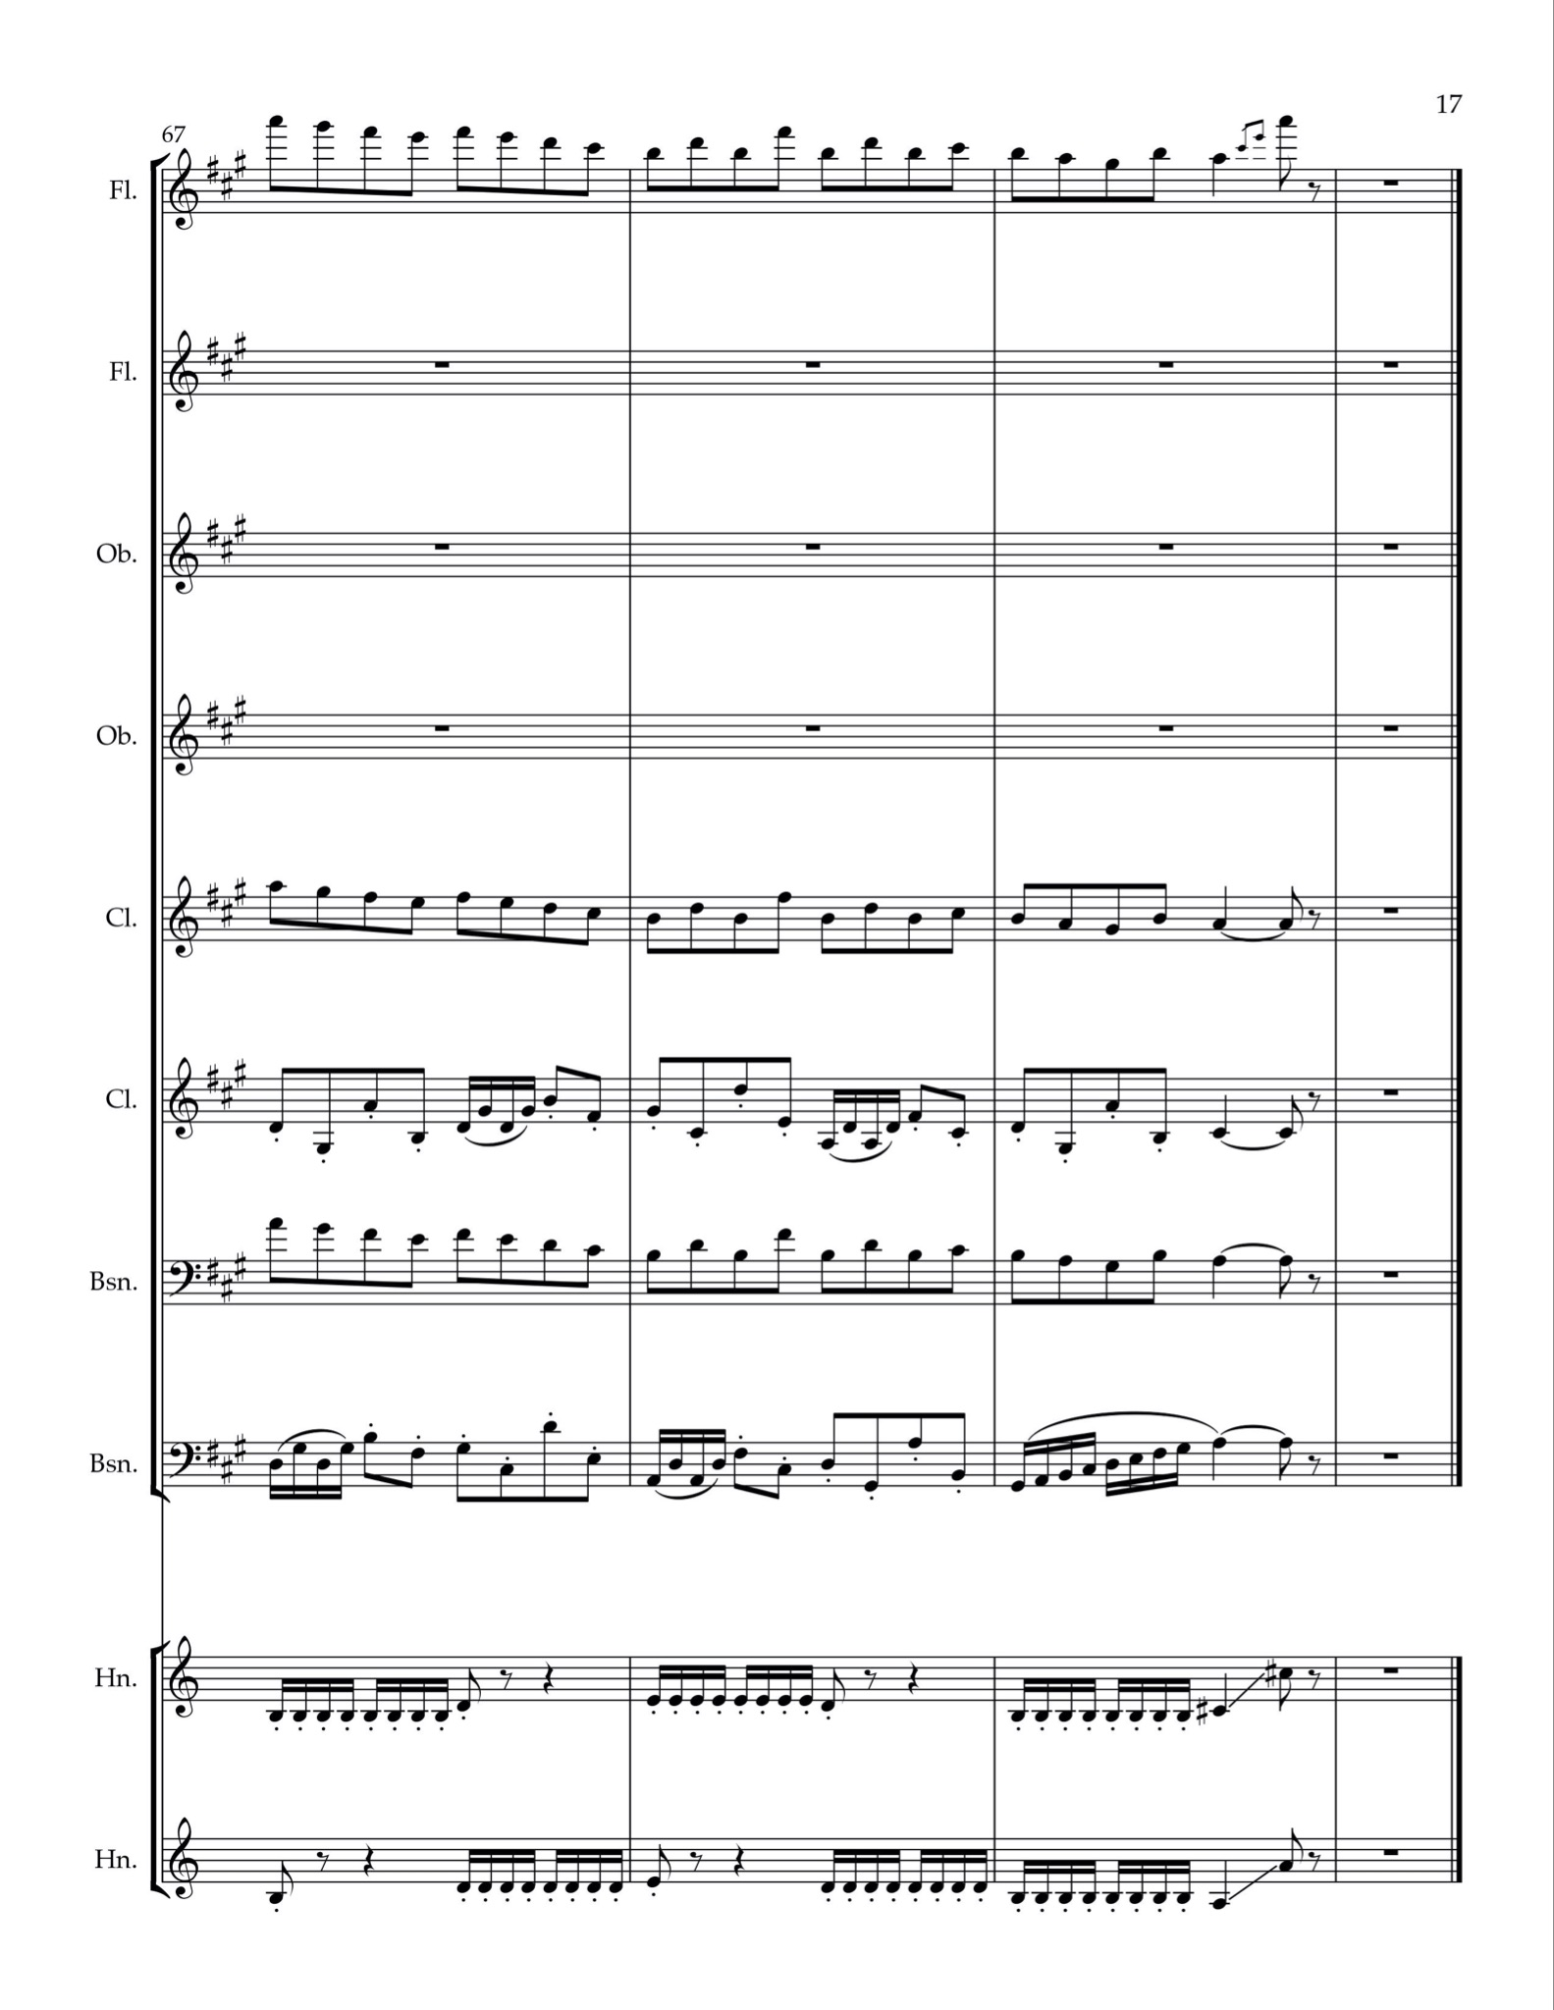

Figure 35. Original jig in traditional style.
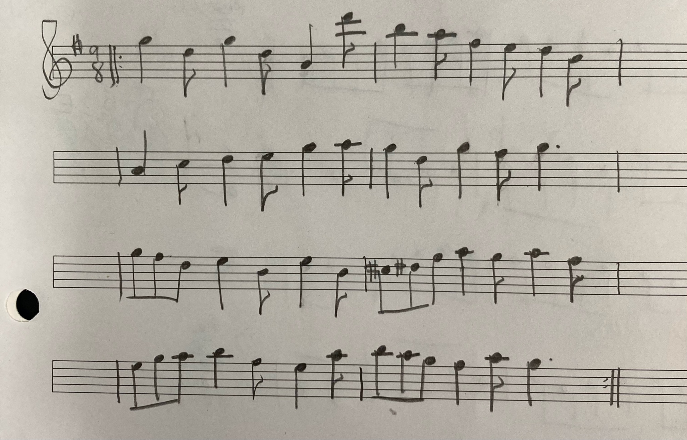

Figure 36. Original jig in modernized style draft.
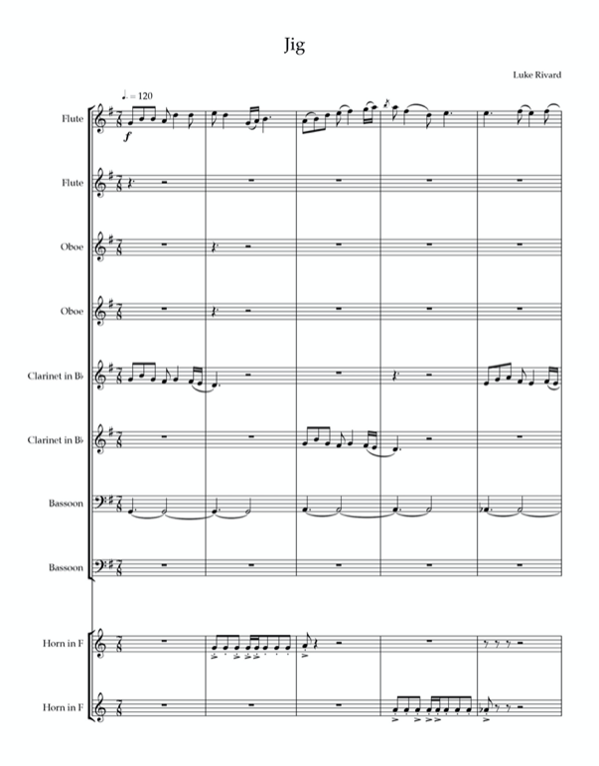
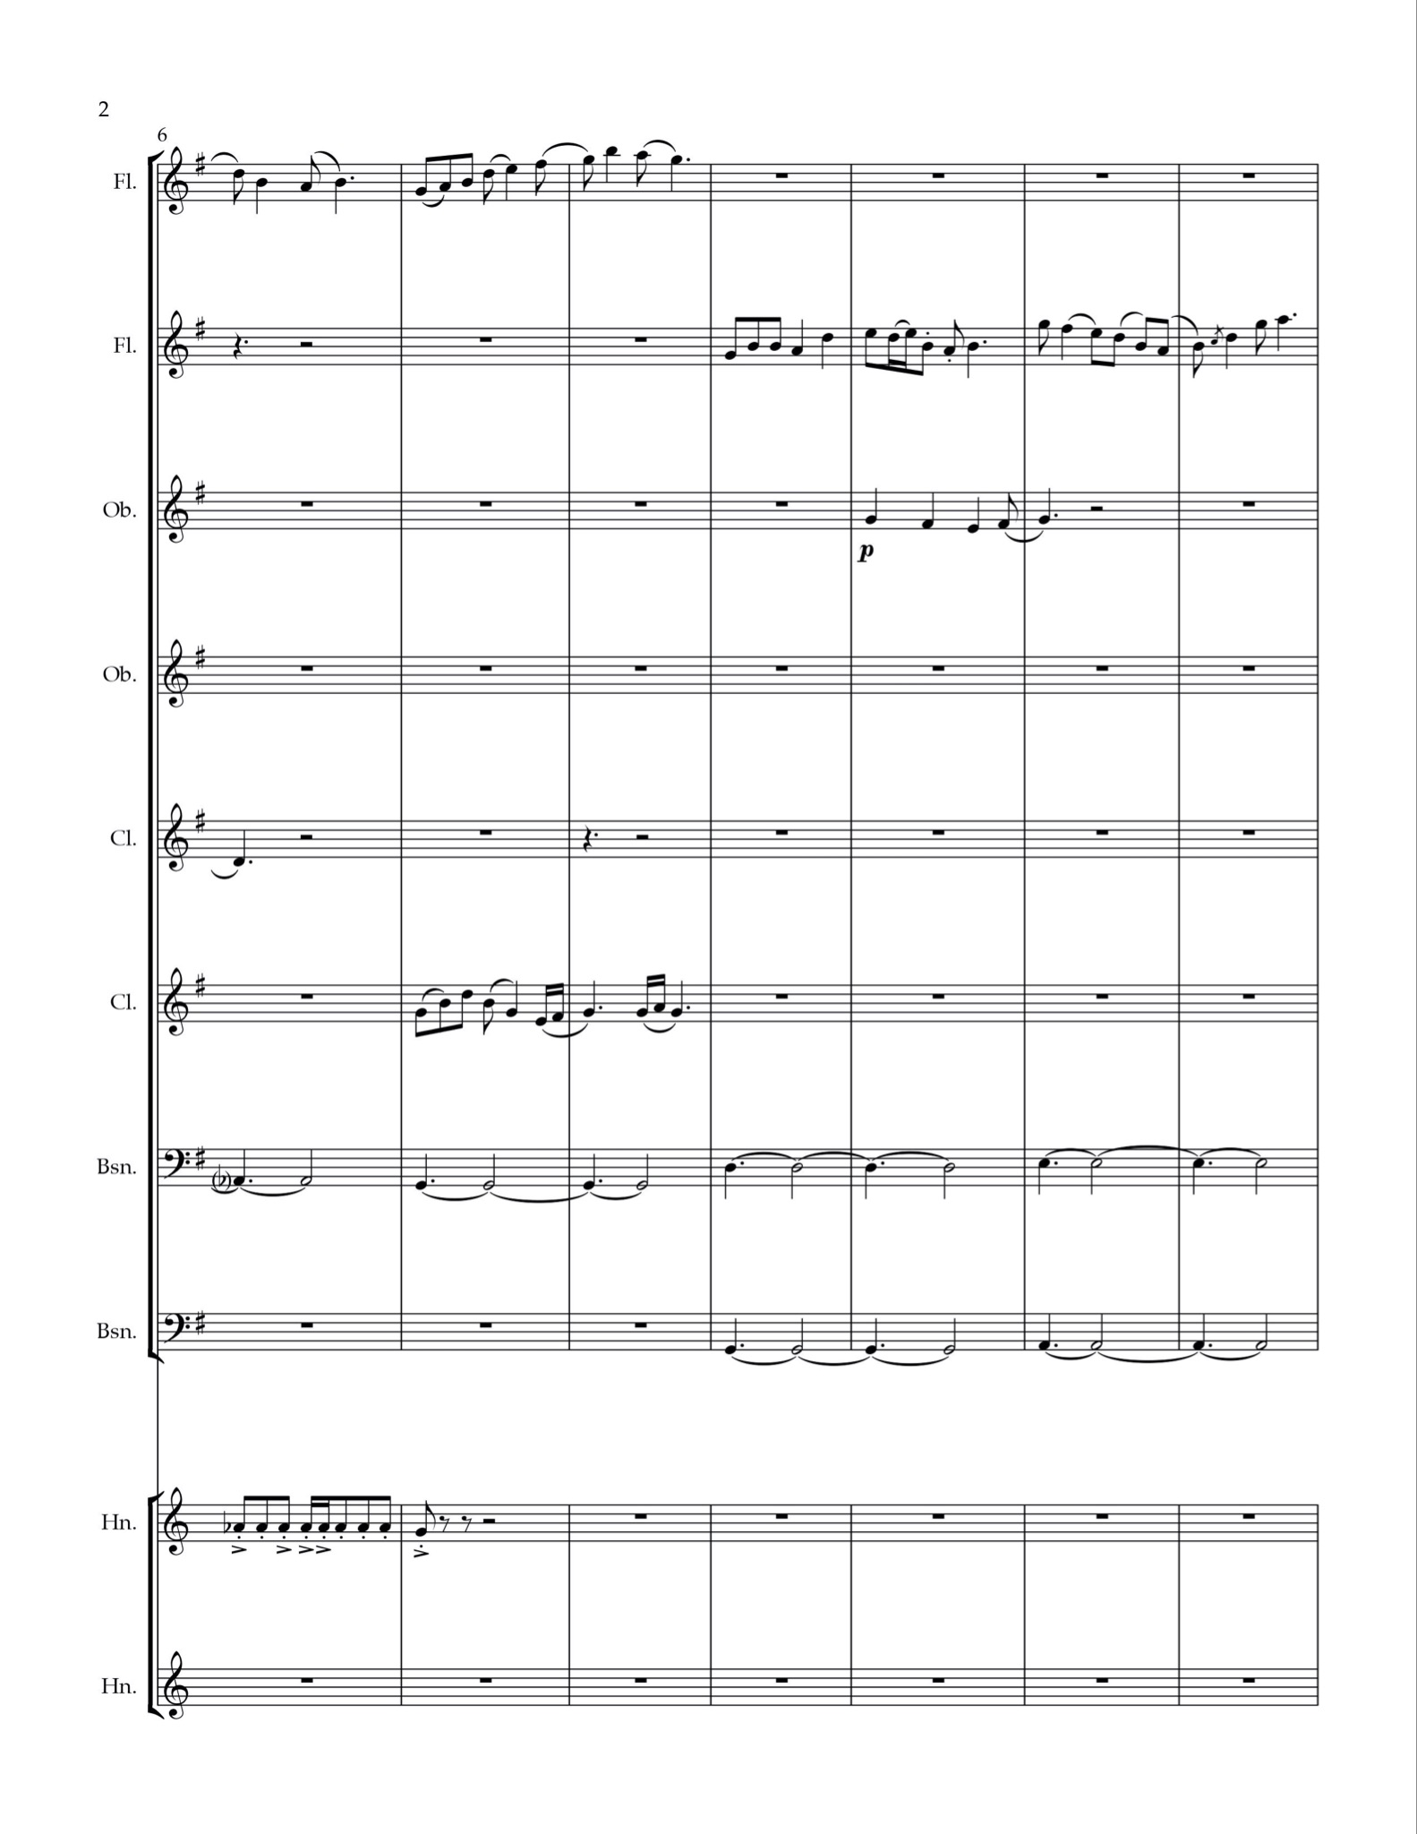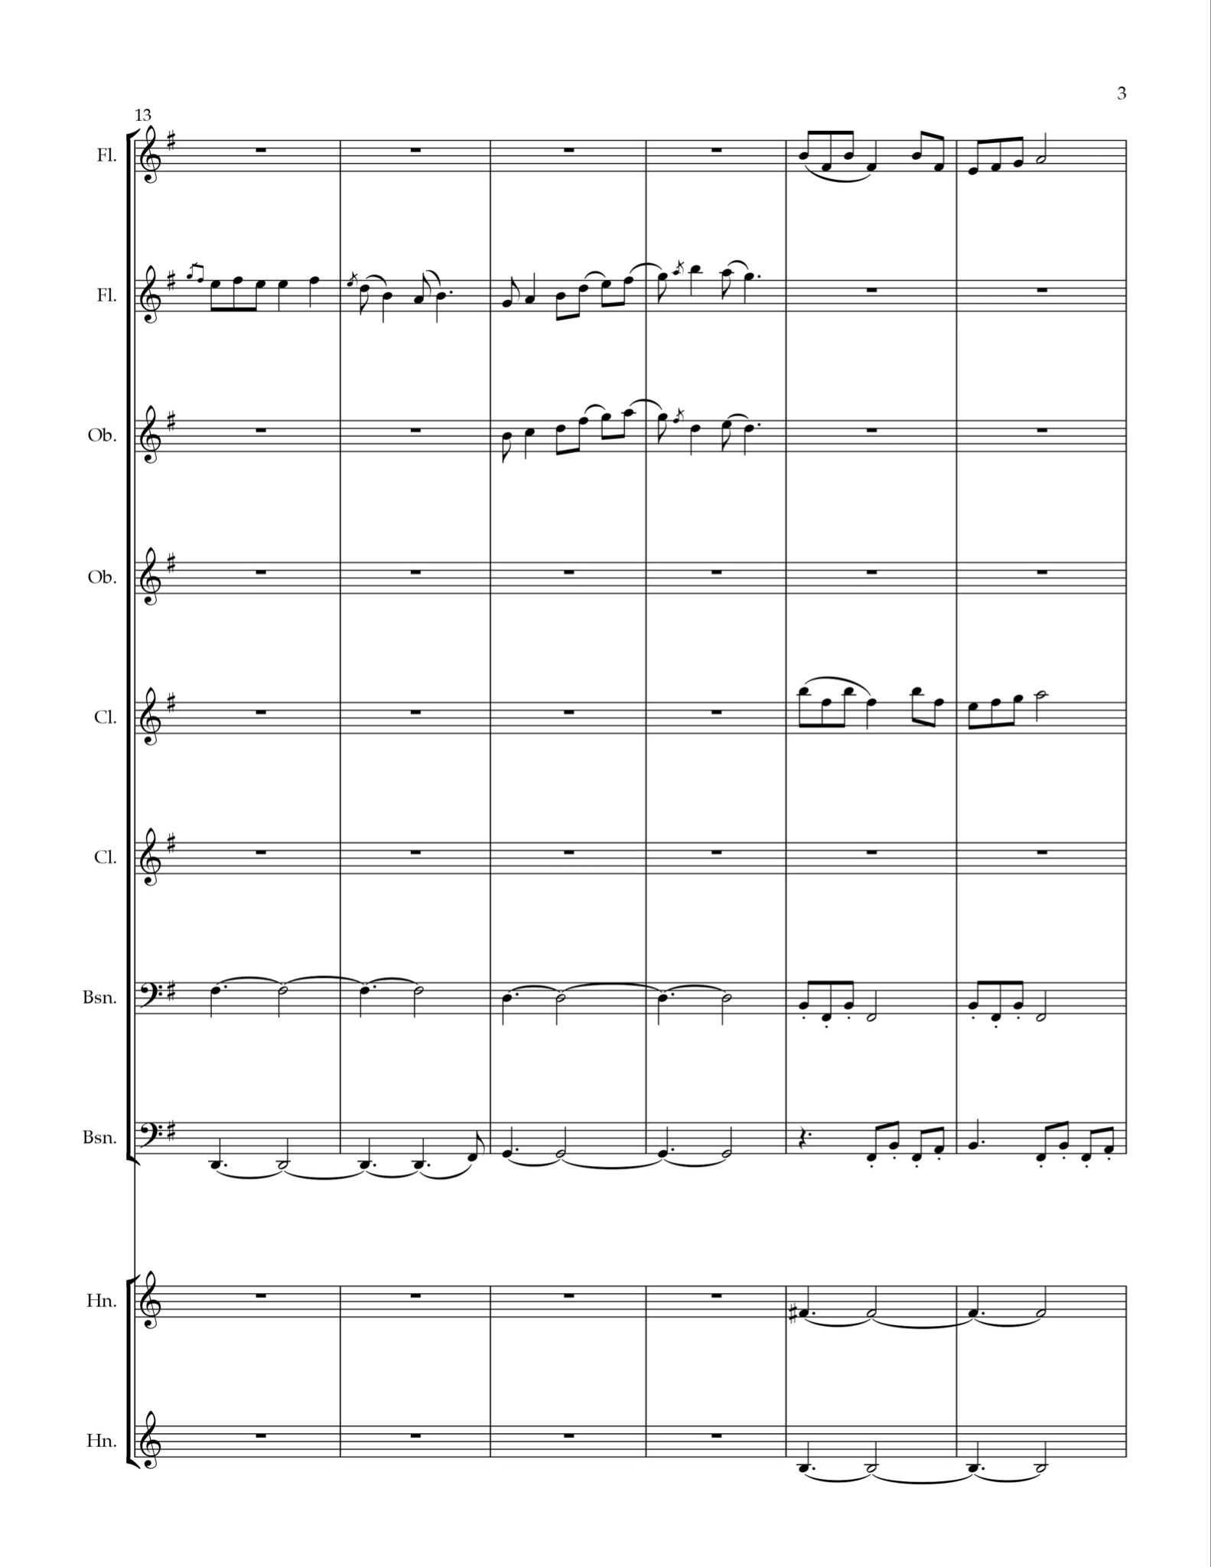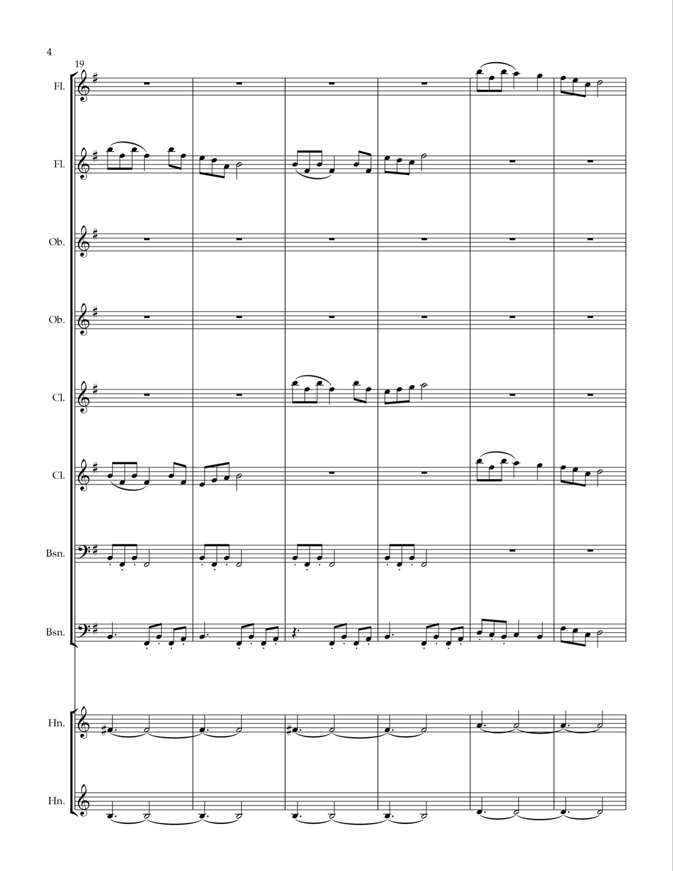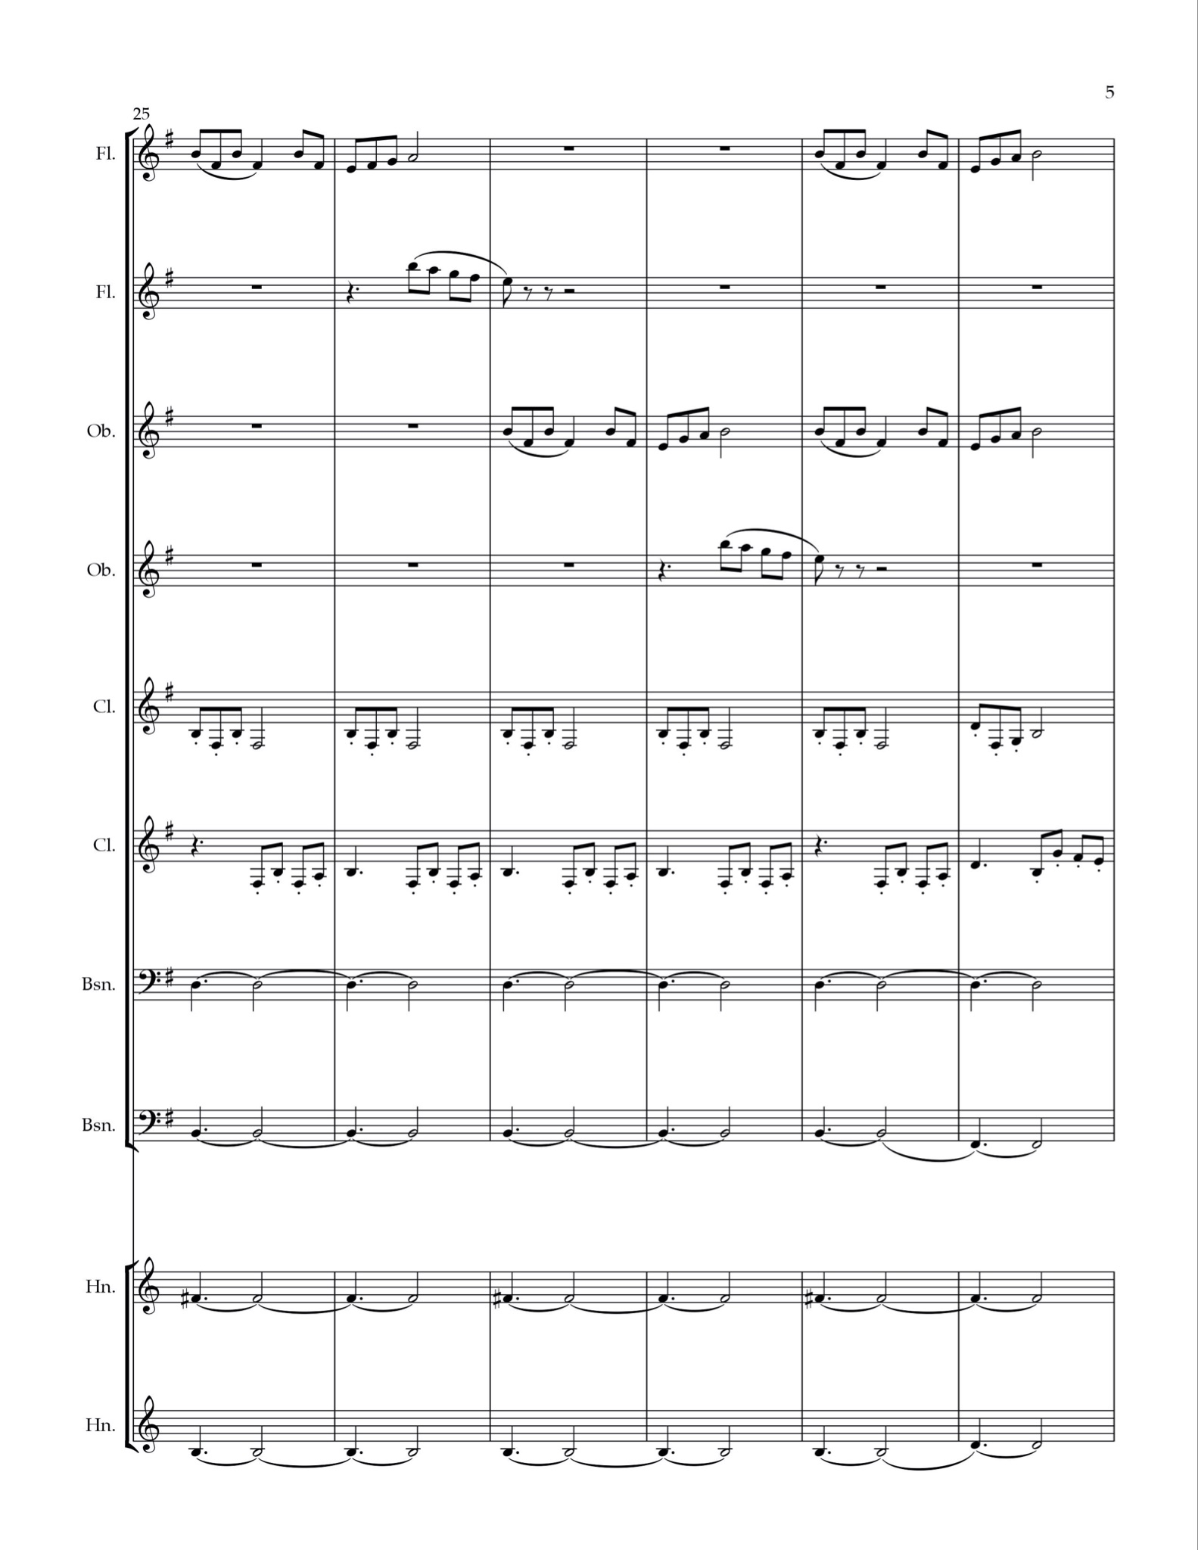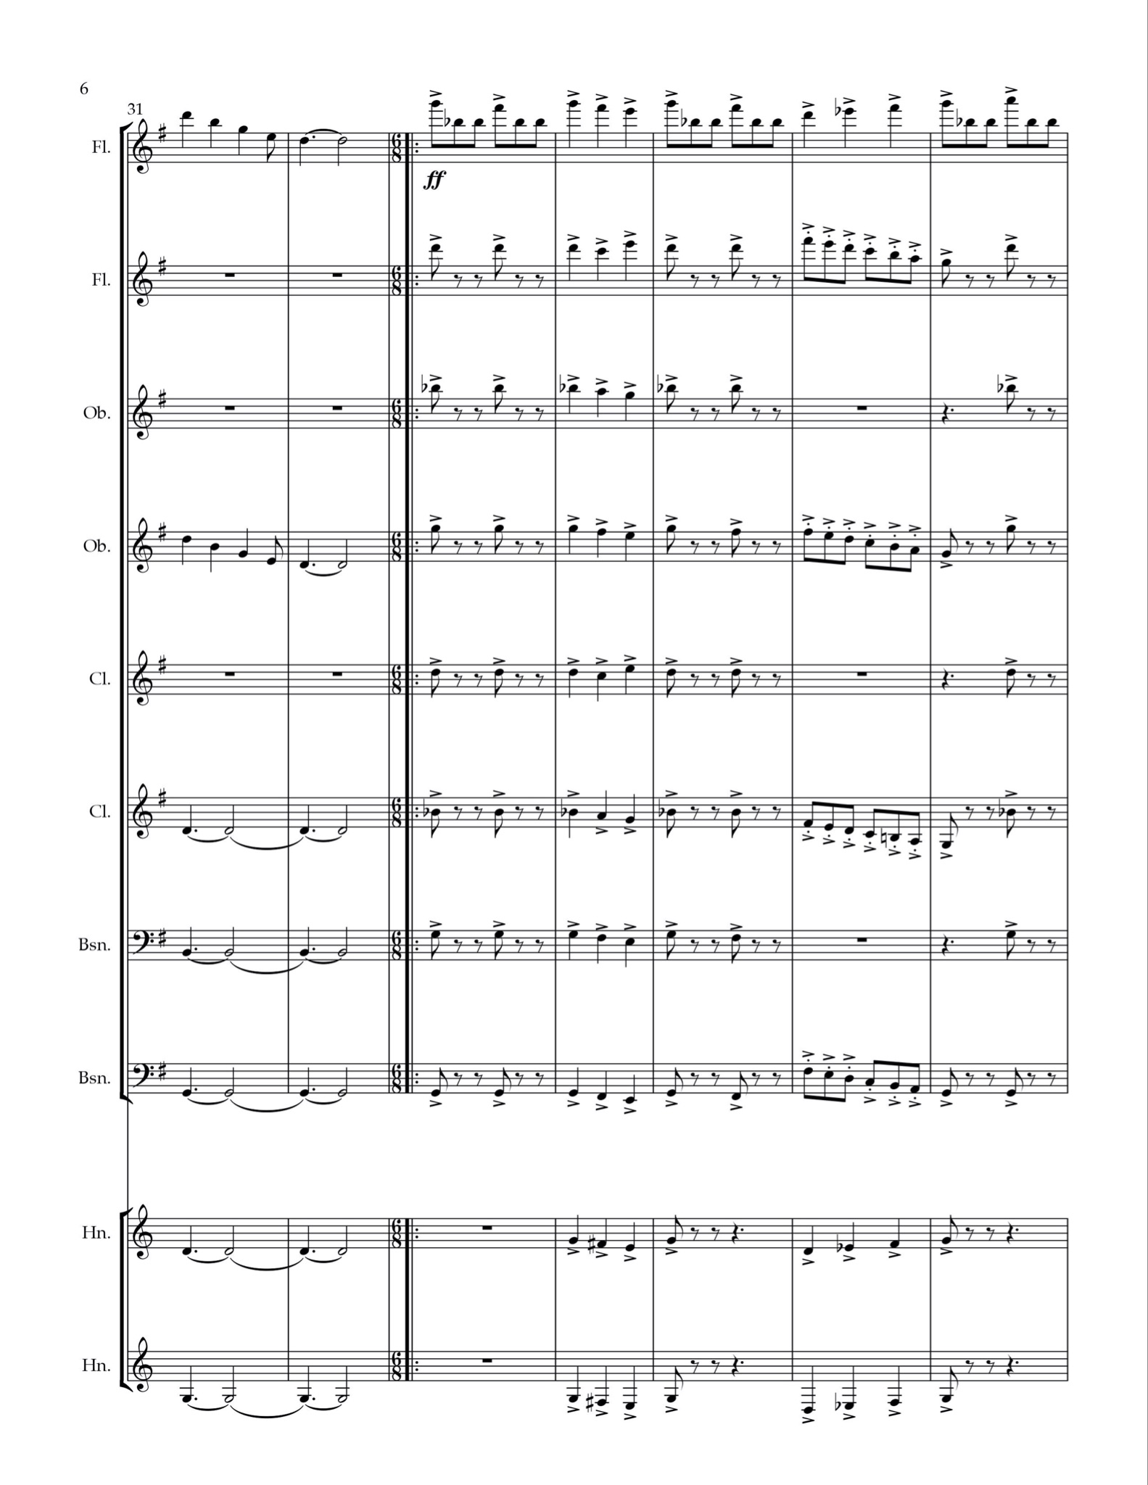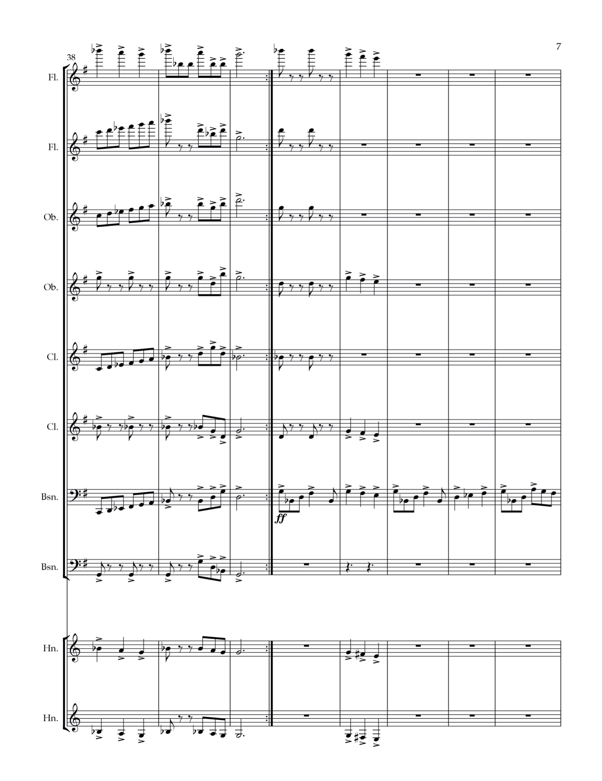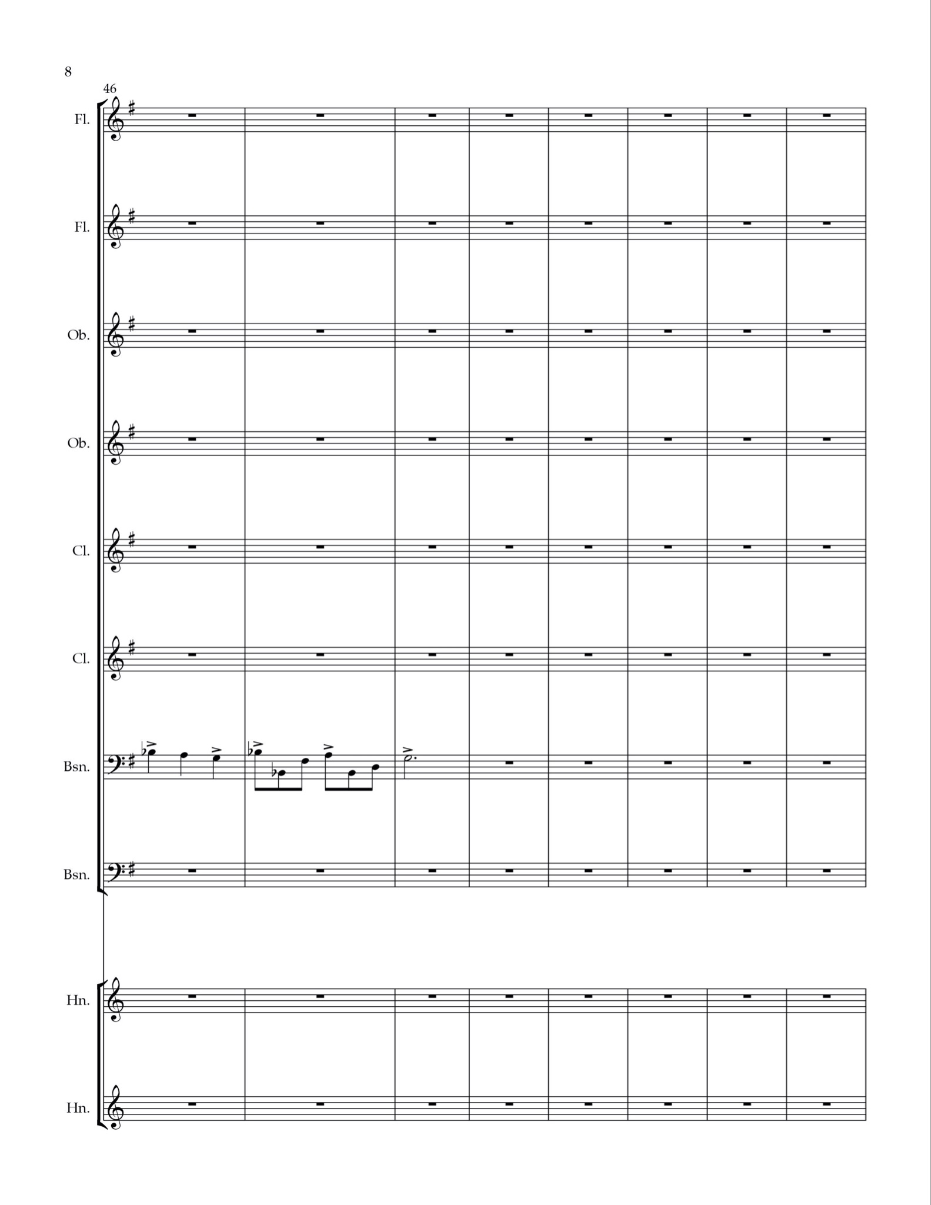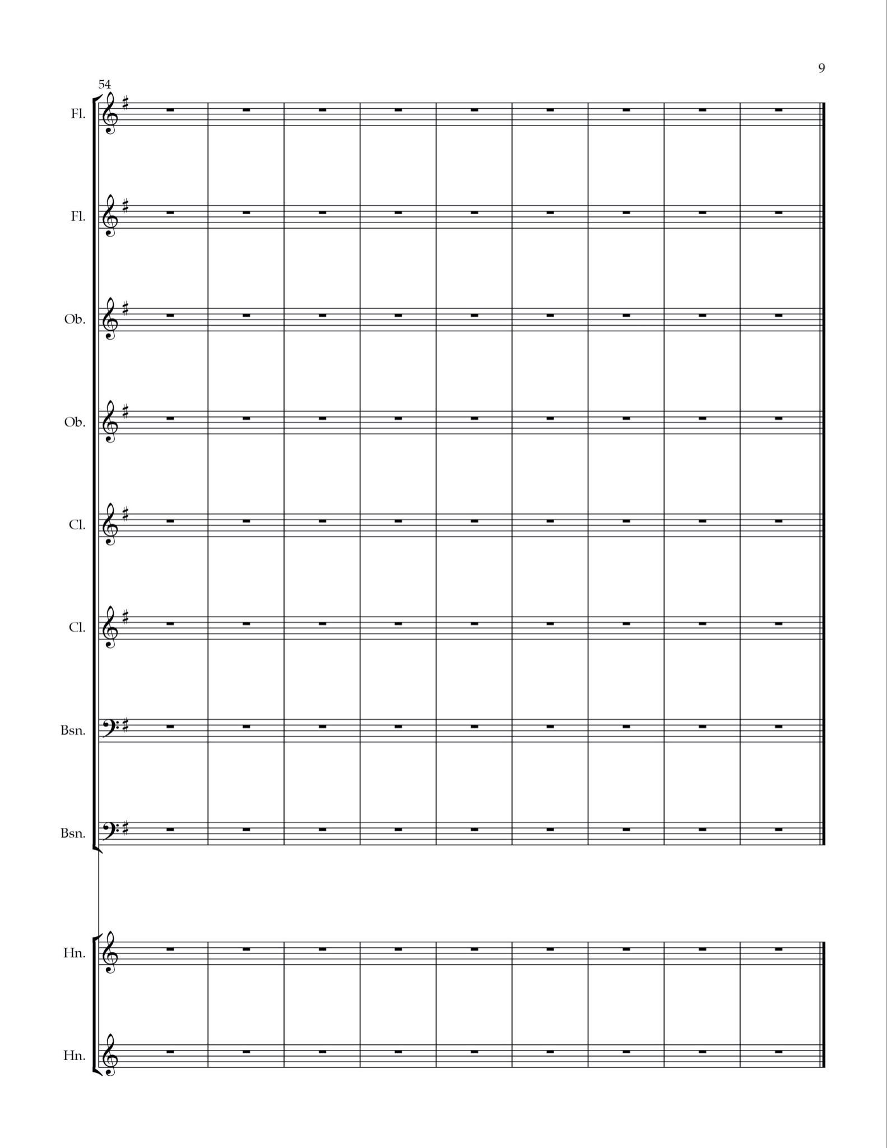

Cathy Foster and Dave Foster, interview by author, Waterloo, MI, May 29th, 2022.
Alan Merriam, “Uses and Functions,” in The Anthropology of Music (Evanston, Illinois: Northwestern Univeristy Press, 1964), 219-223
The Grand Irish Songbook (Milwaukee, WI: Hal Leonard Corporation, 2006).
See Appendix 1.
The Munster Men, “Inisheer,” February 28, 2021, https://www.youtube.com/watch?v=IkU8FqL9wmk (accessed July 16, 2022).
Nigel Gatherer, transcription of “Inisheer,” 2007, https://thesession.org/tunes/211 (accessed July 16, 2022).
Cathy Foster and Dave Foster, interview by author, Waterloo, MI, May 29th, 2022.
Cathy Foster and Dave Foster, interview by author, Waterloo, MI, May 29th, 2022.
Cathy Foster and Dave Foster, interview by author, Waterloo, MI, May 29th, 2022.
Cathy Foster and Dave Foster, interview by author, Waterloo, MI, May 29th, 2022.
Ahern, Pat et al., The Companion to Irish Traditional Music, ed. Vallely Fintan (New York, NY: New York University Press, 1999) 530-532.
Jacques-Christophe Naudot, “Sonata No. 2, IV. Gayment,” https://www.flutetunes.com/tunes.php?id=1830 (accessed July 15, 2022).
Georg Philipp Teleman, “Twelve Fantasias for Solo Flute, 1.” Edited by Jean-Pierre Rampal, New York, NY: International Music Company, 1970.
See Appendix 2.
The Grand Irish Songbook (Milwaukee, WI: Hal Leonard Corporation, 2006).

