End of Summer FURSCA report
Detecting True Edges in PolSar Images using Artificial Intelligence.
Introduction
Our research was focused on detecting true edges in PolSar images using artificial intelligence( computer vision ). These images come with a particular kind of multiplicative noise, called speckle, that requires a different approach from the ones used in optical images for most of the tasks in image processing.
We get those images by sending microwaves from PolSar sensors on the earth surface, and then collect those reflected microwaves back. A PolSar image is a set of reflected microwaves. In order to work with this kind of image we have to convert it in a matrix where every pixel(reflected microwaves ) on the image is represented with some numerical value in a matrix. The main problem that we were planning to solve was edge detection. In this research, we considered Gambini's algorithm, a well-known algorithm used for edge detection in PolSAR images, with some CFAR (Constant False Alarm Rate) algorithms in real and synthetic images.

This is a synthetic image for testing. Yellow rectangle that we see is defined region.

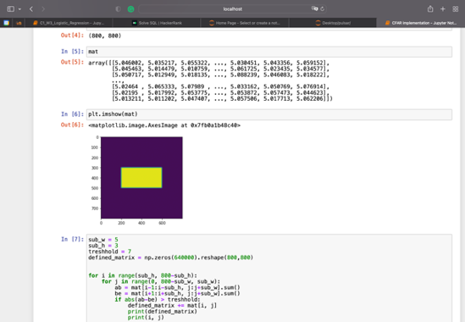
This is a synthetic image for testing, in shape of triangle(yellow color),

Results
Most of those 10 weeks I’ve spend on understanding basics of python and understanding how CFAR algorithm works. At the beginning I was trying to understand what kind of programming skills I have to have in order to start the implementation of that algorithm, then I started taking online courses on those skills. After some time, I finally had some basics in order to start implementation. And with help of professor Marengoni, I’ve gained more understanding of how that algorithm works. This turned out to be the hardest part, because you have to put theory in practice. I had some basic program that goes through the whole matrix and compares neighboring points in order to define If there is any contrast difference between them( edge ). That program worked on that training image . But that because I’ve set parameters for that program manually, such as: size of compared neighboring points, angle. I started to get some results but I still need to refine my implementation and run a comparison between the two methods.

Conclusion
During this project I’ve gained practical skills in the Python programming language, by learning different libraries, Also, now I have more understanding of how image processing works in general and how working on research looks like. Also this project helped me to realize in which field of AI I want to go in future.

I want to say thanks to my advisor professor Marengoni for navigating me through my first research, Elizabeth Palmer and Renee Kreger for giving us that opportunity to be a part of FURSCA. I had a wonderful experience, which definitely had a positive impact on my future academic development.

