End of Summer FURSCA Report
​​ Stock Market Prediction Using an Improved RNN Model
Bilguun Narmandakh and Yuming Zhang

Introduction
The stock market is one of the major fields that investors are dedicated to, thus stock market price prediction is always a hot topic for researchers from both financial and technical domains. This research investigates the usage of machine learning methods in financial market prediction tasks focusing on short-term price trend prediction. In other words, we aimed to build a Machine Learning model using an Improved Recurrent Neural Network.

Result
This summer, I worked on predicting Google stock prices using the artificial intelligence technique. I used deep learning, a subset of artificial intelligence, to train a model to predict future stock prices. Specifically, I used Recurrent Neural Network with Long Short-Term Memory for my summer research project.
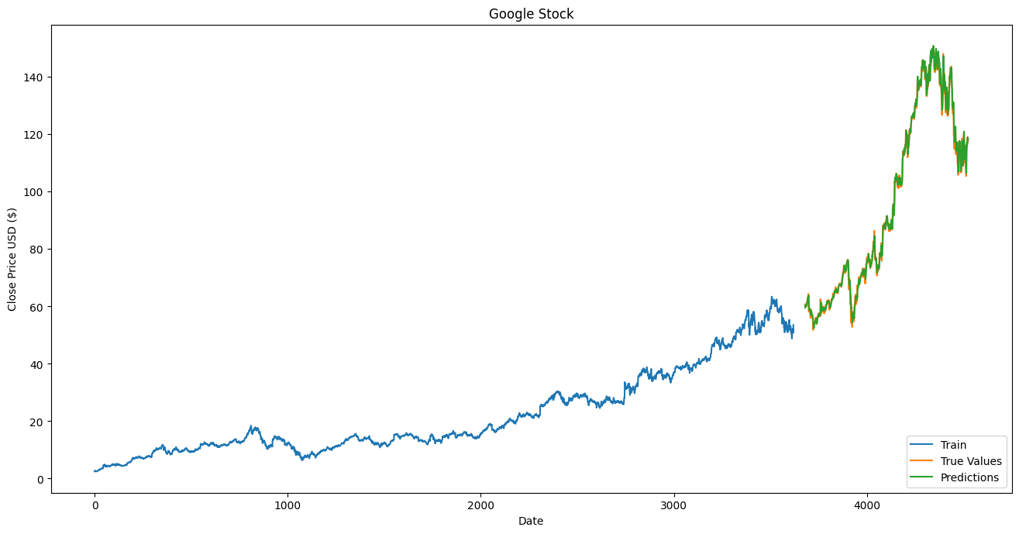
In all of my models, I used the data from 2004-08-19 to 2022-08-09.

Figure1: Google Stock prediction using only closed price

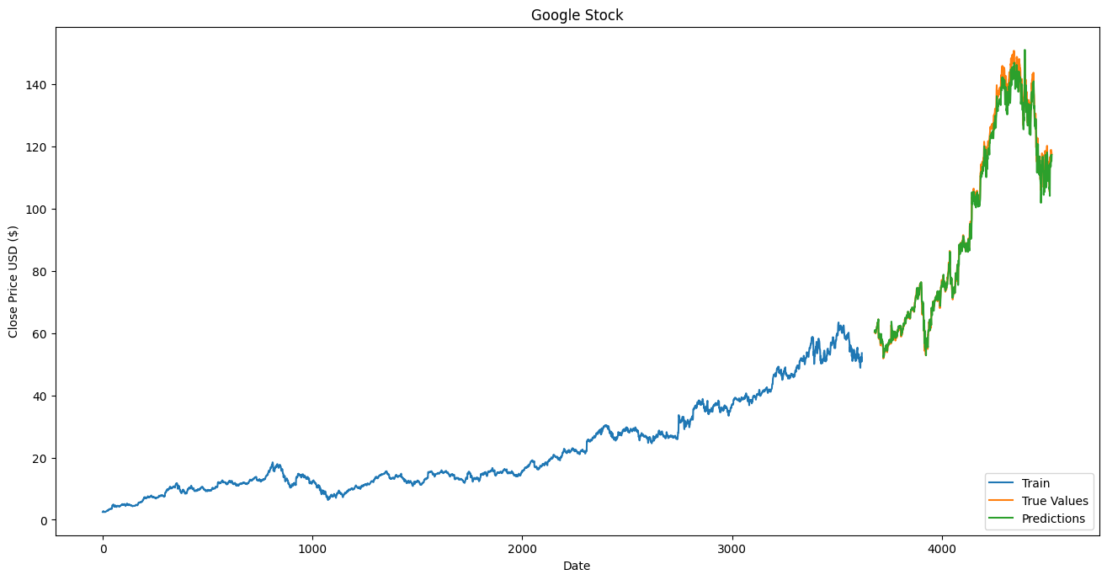
Figure2: Google Stock prediction using 5 features (close price, volume, open price, high price, and low price)

I used 60 days' data to predict the next day’s stock price. As you can see, there is a small gap between the 3000th day and 4000th day because the model needed to learn the pattern from the previous 60 days' data to predict the next days. Also, 80 percent of the data goes for the training part, and 20 percent of the data goes for the testing part.
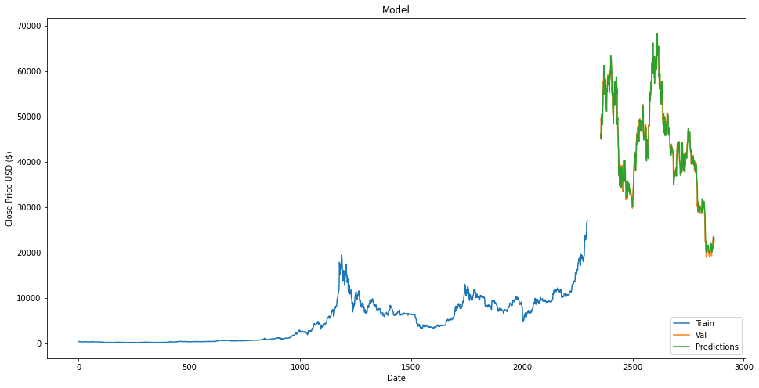

Figure3: Bitcoin price prediction using only closed price

After I finished building a model to forecast Google stock price, I used the same coding on predicting Bitcoin price, which is the most sustainable cryptocurrency.

After I completed all the goals that I planned for the summer research, I built a binary classification model which is supposed to predict whether the stock price is lower than or higher than the previous day’s stock price using 60 days of stock price data. Unfortunately, the accuracy of the model is between 44 percent and 56 percent, which is lower than I expected. Though I didn’t get a good result on the binary classification, I think it would be interesting to build a multiclass classification model in the future.
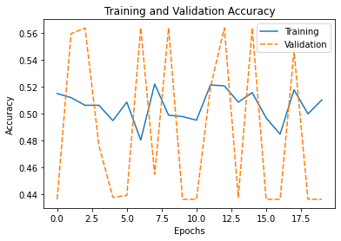

Figure4: Google Stock prediction - binary classification

Conclusion
Throughout FURSCA this summer, I have had the opportunity to learn invaluable skills in Machine Learning for a career in Computer Science. Additionally, this summer has helped me realize that I truly love coding. I plan to work as Machine Learning Engineer after my graduation.

To the Jean Bengel Laughlin '50 and Sheldon Laughlin Endowment for Student Research:
Thank you for giving me the opportunity to participate in Albion’s FURSCA program this summer. This summer provided many benefits that will greatly influence my future education and research endeavors. Thank you!

