Karina E. Muñoz
End of Summer Report
Dr. Demian Cho
Albion College Department of Physics

At the start of my FURSCA project I knew little to nothing about machine learning. I knew the underlying definition of what machine learning was, “the usage and creation of computer systems that can learn and adjust without being given explicit instructions, by analyzing data patterns and drawing conclusions using algorithms and statistical models.” However, my goal was to analytically understand and duplicate what was happening in previous research from the University of Indiana at Bloomington, in the Beggs Lab, and create an analytical version of that same data and research. Dr. Cho and I were interested in calculating how the strength of recurrent signals in neurons affects the synergetic information processing in the neural network. We will be using the recurrent connections to begin this process. We will analyze and statistically validate the reported experimental result, as well as see if it holds true for a variety of signal levels and neuron thresholds. This will allow us to verify previous data that has been collected but also expands the scope for our data as well. We expect the
neurons to function as expected, with reduced synergy, but our primary concern is why this is
the case.

As the summer continued, I learned more about machine learning than I could even process myself. As someone who had only taken a few coding classes in the past, it was a challenging task to learn how to format, calculate, and manipulate code for it to display correctly. Often, my partner, Shannon Barba, and I would send off code and it would be incorrect. The goal was to use MATLAB to build a McCulloch-Pitts model simulation and begin constructing a line of code that will simulate that of a neuron. Once we can do that, we can begin constructing the three simulations for two or more neurons in a recurrent stimulation and see exactly what their behavior is computationally. By simulating all three of these variables into MATLAB, it will give a clearer understanding of why triads with recurrence (signal between X1 and X2, upstream (the source of current) neurons, in addition to usual signal from Xs to Y, downstream (current flows is termed postsynaptic neurons) have more synergy. This was the greatest task for me so far in my academic career. I had to teach myself how to generate these great tasks, that I had only thought about doing on paper, but in time, Shannon and I were extraordinarily successful.

After many hours of planning and running calculations with Dr. Cho, and each other, we managed to create the lines of code that allowed our data to be displayed not only as a matrix but also display our time raster with corresponding weights and its initial conditions. While coding was a major part in our project, calculations were also another big aspect. Calculating synergy, understanding how Boolean logic gates, Triads, and Entropy of functions work. It was remarkably interesting seeing pieces if theory that I had only read about in scientific journals be put into practice as we began coding and running calculations. I believe that running calculations before-hand was an especially crucial step for me, as I like to see how things run on paper before I see them computationally. All these aspects tied into one another and were pieces of our project that were important to not only understand why but also how.

Figure 1  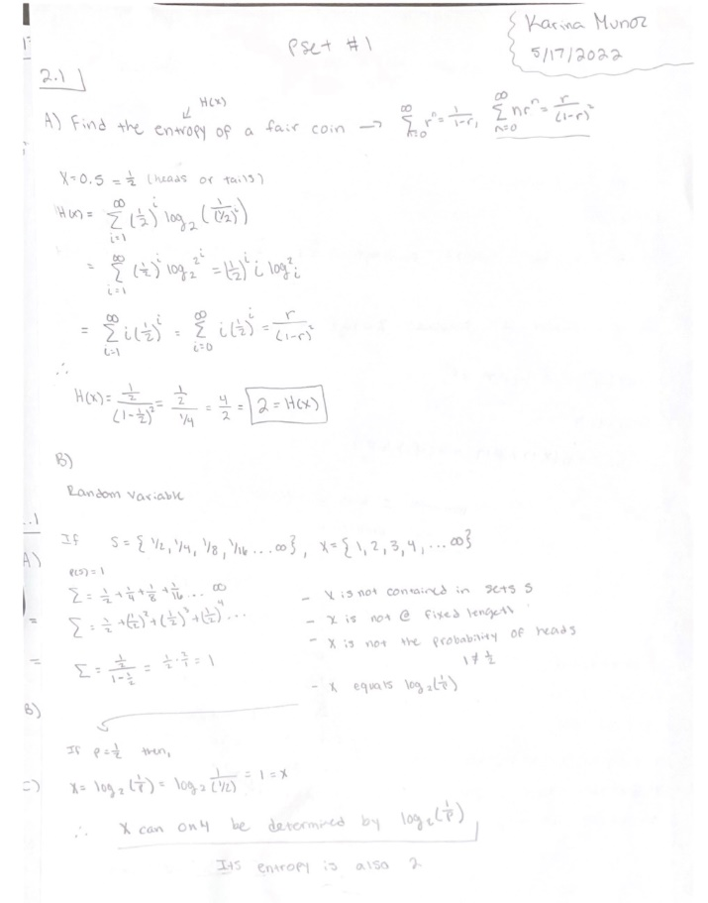  Figure 1 & 2. Examples of calculations done by hand before coding begins. | Figure 2  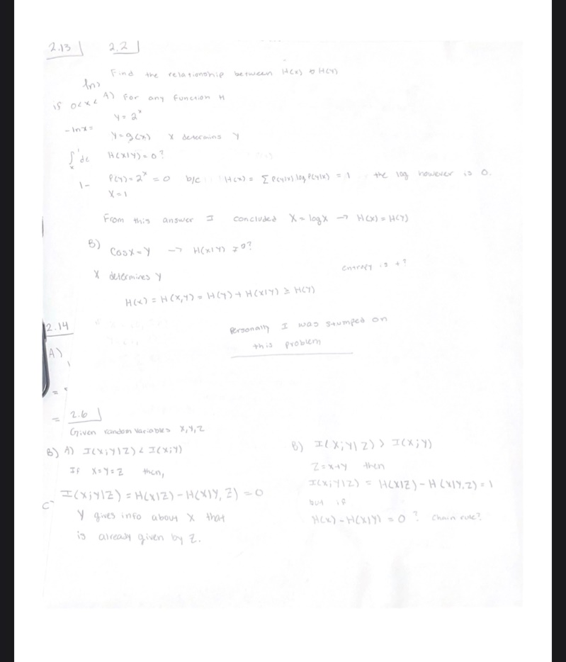
Figure 3 Figure 4
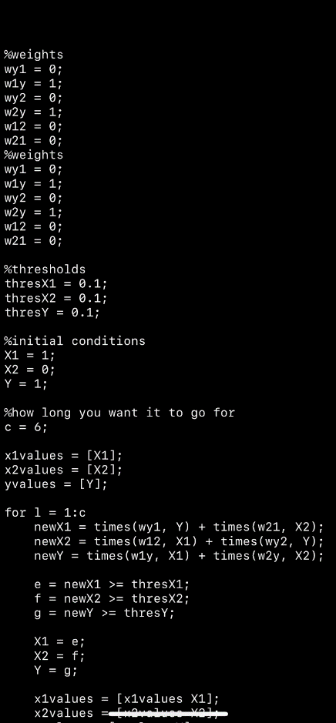 | 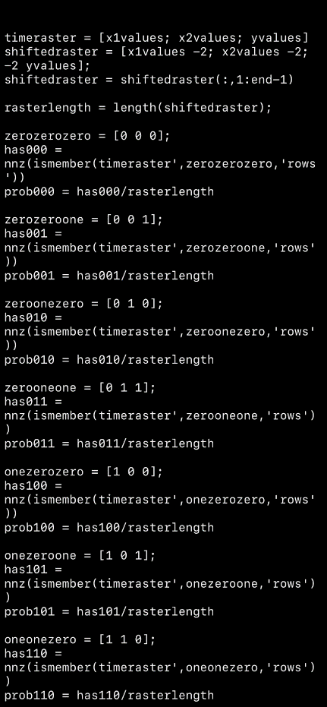
Figures three & four are examples of code created by Shannon and me to create our time raster.

The work I was able to complete accelerated my learning and understanding of machine learning. I plan to continue my work in the Fall of 2022, and the Spring of 2023. Dr. Cho, Shannon, and I are all planning to present our research at the Elkin Isaac Research Symposium in the Spring of 2023 as well as a number of other various Physics symposiums. I will be entering my junior year as I continue my research, however, this research has allowed me to open my eyes to a field of new possibilities in terms of a new career. After college, I plan to obtain my masters in either mechanical engineering or software engineering. I feel a direct tie to this plan is based on my research experience here at Albion. I will be the first engineer in my family, and it holds great meaning coming from an immigrant household, as well as being a woman in my community. I would like to give a huge thank you to FURSCA for making research available to me as well as many other students who have curious minds. I would also like to thank my mentor, Dr. Cho, and Dr. Moreau for believing in me, even when I did not believe in myself. My career, and educational aspects would be quite different if it were not for my mentors. For that, I am forever grateful!

Finally,

To the Bruce A. '53 & Peggy Kresge '53 Endowed Science Fellows- Thank you for giving me the opportunity to participate in Albion’s FURSCA program this summer. This summer provided many benefits that will influence my future education and research endeavors. Thank you!

