End of Summer FURSCA Report
Regional Genetic Diversity of Aphid ‘Superclone’
Brian Lomeli-Garcia

Introduction
The goal of my summer 2022 FURSCA project was to analyze and extract the DNA of different populations of aphids. My research was centered around Aphis nerii, also known as oleander aphids. Previous studies have suggested that the female aphids are able to clone themselves and give birth to live young (Jesse et al. 2006). Females do not need to pause for sexual reproduction nor lay eggs, but instead they clone many daughters. Aphis nerii is an invasive species commonly referred to as a pest feeding on milkweed plants (Orantes, L. C., Zhang, W., Mian, M. A., & Michel, A. P. 2012). It is a non-native bug, that is bright yellow with black legs, and stalks known as cornicles on the back of the abdomen. Studies concluded oleander aphids are remarkably invasive throughout the United States, and they most likely originate in the Mediterranean region with extremely low genetic diversity (Harrison, J. S., & Mondor, E. B. 2011). I wanted to further explore this idea and compare and contrast the DNA sequences from different populations within the United States. I was able to conduct these experiments with different reagents and kits that were able to isolate a specific biomarker gene within these locations (Chicago, Albion, South Haven, Pennsylvania, Georgia, Ohio, and France.) I explored this by studying the genetic diversity in several populations from the eastern United States, to figure out whether or not the genetic population of aphids within Albion College is related with other regional populations of aphids. My hypothesis is that the oleander aphids from Albion College, also including the other populations that we sample from, would consist of low genetic diversity, supporting former studies which suggested clonal ecology (Purkart, A., Depa, Ł., Kollár, J., Suvák, M., Holecová, M., Goffová, K., & Országhová, Z. 2020).
Methods
In the lab, we have sampled aphids from Michigan (Albion, Detroit, Holland, South Haven, Sault Ste Marie), Pennsylvania (East Stroudsburg), Illinois (Chicago), Indiana (Fort Wayne), and Georgia (Atlanta) (Figure 5). I took aphids from each specific region and used a kit (Qiagen) to extract the DNA, then proceeded to run it through a gel made of agarose to determine if the extraction was successful. After I completed a successful gel test I conducted a polymerase chain reaction (PCR) test where I was able to successfully isolate the gene that I am looking for (COI gene), used for bio-identification and genetic characterization. We worked with a couple different chemical reactions in order to properly isolate the gene which was (0.4 ul of the forward and reverse primers, 10 ul Master Mix, 2 ul MgCl2, 5.2 ul H2O, 2 ul DNA.) Before we came up with the final chemical formula we faced a couple set backs, testing different chemical reactions that unfortunately did not work.. Another problem we faced was that many of our samples were unfortunately parasitized by the wasp Lysiphlebus testaceipes, which contaminated our samples and were of no use. Once we had extracted a good amount of samples we sent them to Michigan State University where they were sequenced and sent back to us to analyze our results. With the data they sent back we were able to put into a program (BLAST) were it would transcribed into a code making easier for R-Studio program to interpret allowing us to construct our data into bar graphs, and pie charts, which helps us show the phylogeny and distance between populations and calculate the genetic distance from the different regions we sampled from.
Results
Over the course of the summer, I was able to work with different populations of aphids from the United States as well as France. The process consisted of trials and errors which led to me getting unsuccessful results at certain times. We sequenced a total of 133 samples ranging from Michigan (Albion, Detroit, Holland, South Haven, Sault Ste Marie), Pennsylvania (East Stroudsburg), Illinois (Chicago), France, and Georgia (Atlanta), but I only have results from 47 samples at this time. In one of our sets of samples that we sent to Michigan State University for sequencing they were either successful with isolating the CO1 gene properly or they were parasitized or did not properly sequence. The bar graph below showed 2 samples out of 12 from Ohio were successful, 6 samples out of 10 from Albion were successful, 2 out of 9 samples from Holland were successful, 5 out of 9 samples from South Haven were successful, and unfortunately 0 out of 8 samples from Pennsylvania were successful. The pie chart showed us the different types of haplotypes that were discovered within those regions showing the genetic diversity. In the Pennsylvania pie graph we analyzed a total of 8 different haplotypes, Sault Ste Marie there was only one type of haplotype found, Ohio there was only 1 type of haplotype found, South Haven there was a total of 7 types of haplotypes, Albion has a total of 8 types of haplotypes, and Holland has 4 types of haplotypes. Only Pennsylvania had multiple individuals with the same haplotype. The scatter plot showed if there is a relation between genetic distance to physical distance. The plot showed us that the genetic distance between sites does not relate to physical distance between sites (p > 0.05 based on a Mantel test). The phylogenetic tree describes the genetic similarities between the aphids from different regions by comparing their DNA with one another and identifying similarities and differences within the samples. Albion, Pennsylvania, and South Haven were in certain samples but were completely different to the samples of Sault Ste Marie and Holland showing that the populations are genetically different.

Discussion
As we gathered our information we discovered that we had a small data set which was not enough evidence to properly accept or deny my hypothesis. This was due to us having certain regions having more samples collected than others which made our data skewed. There were outliers within our data for example with our Pennsylvania and Ohio samples that were limited to one or none successful samples compared to the other regions where we had more successful samples to collect from. But with the data that we did collect we were able to determine that the different regions were different from each other due to the scatter plot, the pie chart, and the phylogenetic tree within the different regions were different from one another. The pie charts demonstrated that there are different haplotypes within certain regions like Pennsylvania, Holland, Albion, and South Haven. As I mentioned, due to unfortunate circumstances we had a small data set that caused some obstruction within our data: we only have a small number of samples from Ohio, which makes it impossible to know how much genetic variation there is within that region of aphids. But with the other regions we clearly see differences within those regions as shown with the phylogenetic tree. The tree is showing similarities and differences with the different samples for example Sault-Ste Marie was different from the Pennsylvania samples but was due to it being skewed. The phylogenetic tree also shows that the Pennsylvania were similar to South Haven 2021 and certain Albion samples. This is showing that we do see similarities within certain regions like Albion and Pennsylvania supporting my hypothesis of low genetic diversity. My plan is to continue working on my research and increasing the sample size and including new regions to have hard evidence suggesting that there is actually difference due to many aphids being different. I was lucky enough to gather new samples from France and plan on expanding my data region from the United States to other continents and see if there are any similarities or differences with those populations. Increasing my data set would allow me to better accurately get a data set that would allow me to properly identify if the different populations are genetically identical.

Experiences and acknowledgements
FURSCA was an important experience as I was able to work with an amazing group of people and allowed me access to a lot of helpful resources. I was able to gain new knowledge as well as improve some of my lab skills with DNA extraction to properly be able to use a coding program to analyze my data. With the amazing experiences and knowledge I gathered during FURSCA I am planning on presenting my research at Elkin Isaac this upcoming spring. I want to thank Dr. Cahill for being an amazing instructor with the help and encouragement with the different ideas I had during my FURSCA experiences. Also want to mention Renee and Elizabeth for creating great experiences with helping all the students and communicating with everyone. To the Robson Family Fellow Endowed, thank you for giving me the opportunity to participate in Albion’s FURSCA program this summer. This summer provided many benefits that will greatly influence my future education and research endeavors. Thank you!

Figure 1: Shows July data set that describes the different regions analyzing if the PCR sequencing was successful (aphid sequenced), parasitized, or no results.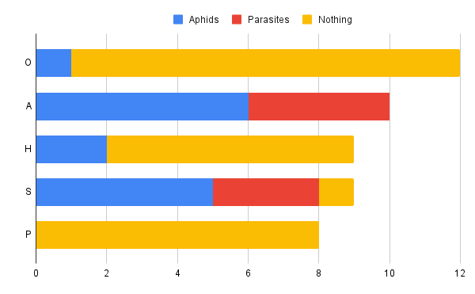
Figure 2: Is showing a phylogenetic tree analyzing the similarities within the different populations. Each line represents a different sample. Data that I collected was combined with previous data from Dr. Cahill’s lab group.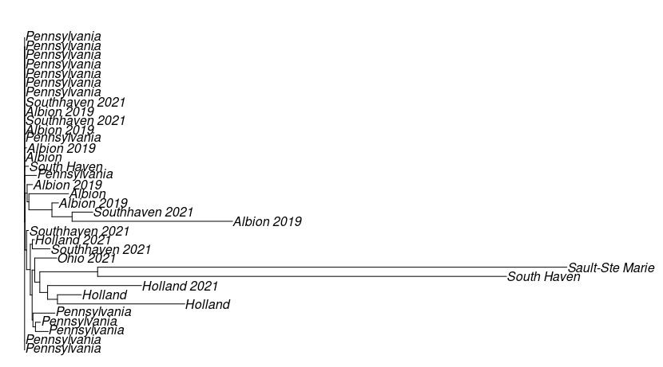

Figure 3: Show the scatter plot describing the genetic distances compared to the physical distance of the different sites that were sampled. There is not a significant relationship between genetic distance and physical distance between pairs of sites.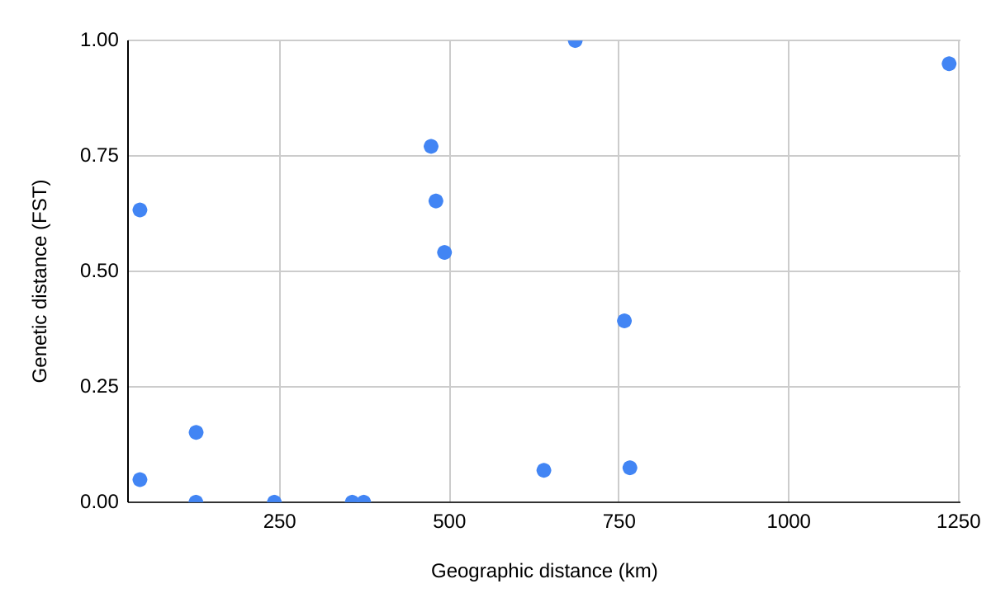

Figure 4: The images are different pie charts describing the region with the name of the region with the different types of haplotypes. Each color represents a different haplotype.

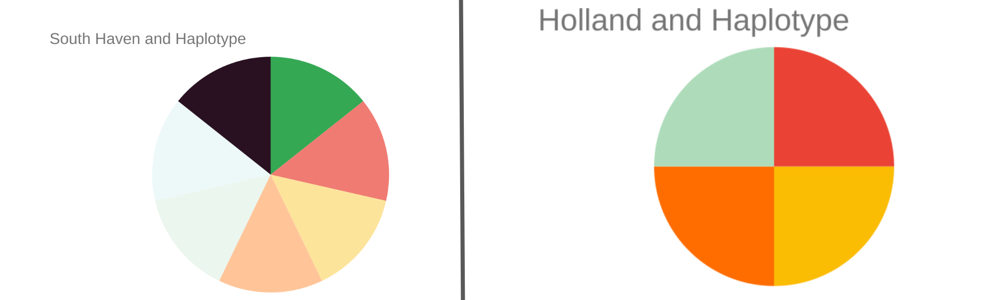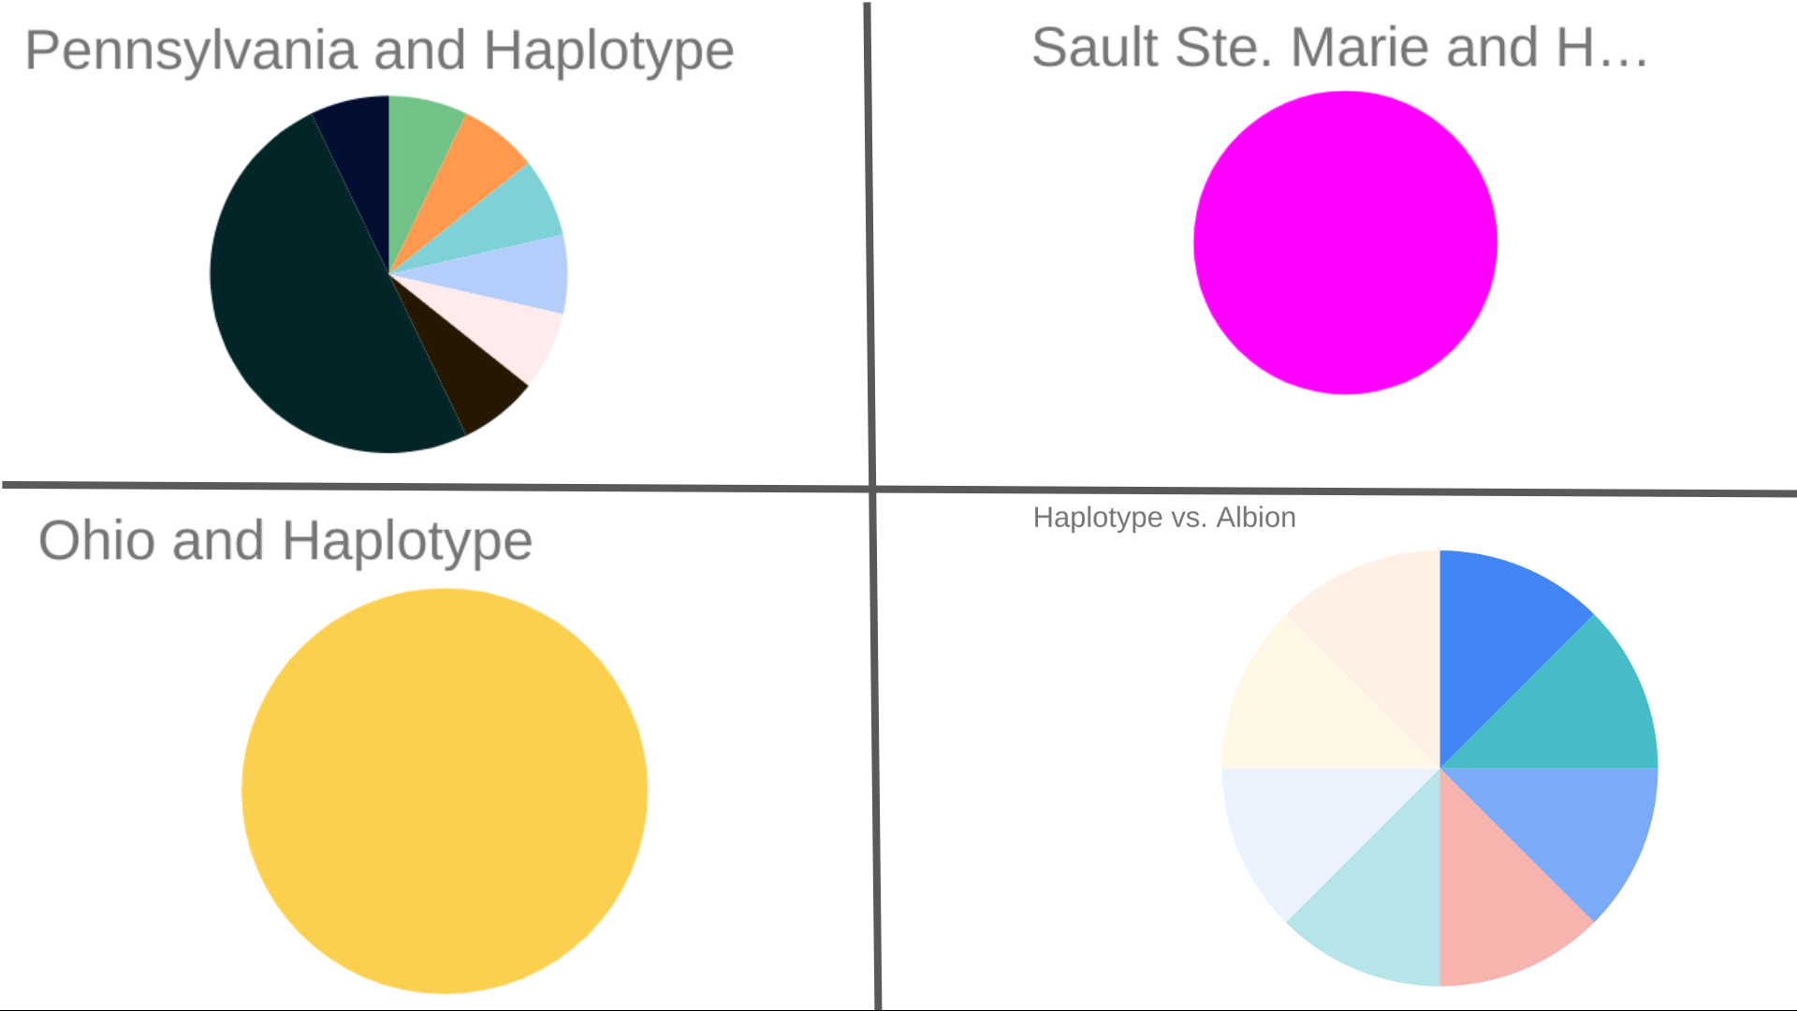

Figure 5: The image depicts the different regions we collected our data from: Albion, Detroit, Holland, South Haven, Sault Ste Marie), Pennsylvania (East Stroudsburg), Illinois (Chicago), Indiana (Fort Wayne), and Georgia (Atlanta).

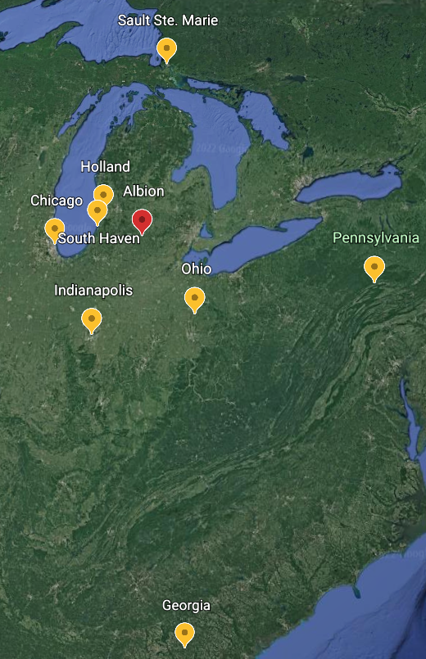

References
1: Jesse, L. (2022) Stop to watch the aphids. News. (n.d.). Retrieved August 10, from https://www.extension.iastate.edu/news/2006/jun/071501.htm

2: Orantes, L. C., Zhang, W., Mian, M. A., & Michel, A. P. (2012). Maintaining genetic diversity and population panmixia through dispersal and not gene flow in a holocyclic heteroecious aphid species. Heredity, 109(2), 127–134. https://doi.org/10.1038/hdy.2012.21

3: Harrison, J. S., & Mondor, E. B. (2011). Evidence for an invasive aphid “Superclone”: Extremely low genetic diversity in oleander aphid (aphis nerii) populations in the Southern United States. PLoS ONE, 6(3). https://doi.org/10.1371/journal.pone.0017524

4: Purkart, A., Depa, Ł., Kollár, J., Suvák, M., Holecová, M., Goffová, K., & Országhová, Z. (2020). Citizen science reveals the current distribution of the New Plant Pest Aphis Nerii in Slovakia. Plant Protection Science, 56(No. 2), 101–106. https://doi.org/10.17221/46/2019-pps

