End of Summer FURSCA Report
Introduction
The centerpiece of the project was a green clay mineral called glauconite, which typically forms in deep marine waters that are largely undisturbed by high-energy actions like waves or storms. However, in the paleozoic (540 million years ago) midwest glauconite is found in paleoenvironments that have shallow waters with evidence of high-energy activity (Amorosi 2012). This paradox is what drove my project into researching the conditions that are conducive to glauconite formation. Understanding how glauconite forms could allow glauconite to become a useful tool into understanding Earth’s past, and understanding how changes in sea level, life, and climate can affect our present and future.

Summary

The work I conducted this summer largely related to the microscopic morphological characteristics of glauconite. Previous work on glauconite focused on the chemistry of the mineral and used that as a way to make inferences about paleoenvironments (Bansal Banerjee 2016, Harding-Ekdale 2018). Although chemistry is important for formation, I hypothesized that the variety of shapes of glauconite and the features coupled with them would tell me more about the surrounding waters the mineral formed in. Conditions such as energy levels, oxygen levels of the water, or whether or not there was a lot of sediment deposition in the environment. To take this a step further, I compared my data to sedimentary data collected from previous fieldwork. This allowed me to ask questions about what morphologies are common on different types of bedding planes.
Much of this work was done in a lab using a petrographic microscope and using a method called point counting to view my thin section samples and observe morphologies. I ended up classifying glauconite into 6 different morphological types. The first one being rounded grains, or grains often circular with smooth edges. Next is vermiform; elongated grains that often curve around other minerals and often have fibroradiated rims surrounding them. Pore-filling glauconite consists of glauconite that is shapeless and it is often seen as a cement to other minerals in the sample. Sub angular grains have a distinct angular edge or blocky look. Mammilated grains look similar to cauliflower, and consist of many circular protrusions from the center of the grain. Lastly, Irregular glauconite grains are grains that couldn’t fit into the categories above possibly due to alterations made when processing the sample. Along with these classifications I also counted if grains were cracked, had rims, or had iron oxidation occur. Lastly, I wanted to count the relative abundance of my samples to see how much glauconite was in each sample.
Since my samples were coupled with stratigraphic data from where they were collected from, all this data collection allowed me to figure out what types of bedding planes had specific morphologies and abundances of glauconite. For example, I found that glauconite on cross bedded surfaces (typically indicators of high energy) had a relatively high amount of glauconite on it at 13.5%. Of this glauconite, rounded and sub angular grains were most common. As I collect more data, I can challenge these conclusions and come up with more robust conclusions. From there, I can start to make strong interpretations of the environments in the paleozoic midwest.
A second enthralling experience for me was our fieldwork week to Minnesota, Wisconsin, and Iowa traveling mostly along the Mississippi river. During this time, I was able to gain a better understanding of the rocks and time period I was working with. As we drove from site to site, it made it easier to understand the spatial extent of the ancient coastline. I even learned a lot of key skills related to geology. I focused a lot on taking strong field notes that are easily revisited in the future, and I developed this skill exponentially. I also learned how to measure rock formations, and collect good samples. In the future, these field notes and samples will be used to continue my lab work on the microscope.
Overall, I have yet to complete all of my goals with data collection and analysis, but I am on a very good pace to have robust results created during the semester, and have a solid poster to present at GSA 2023 as well as the Elkin Isaac research symposium.
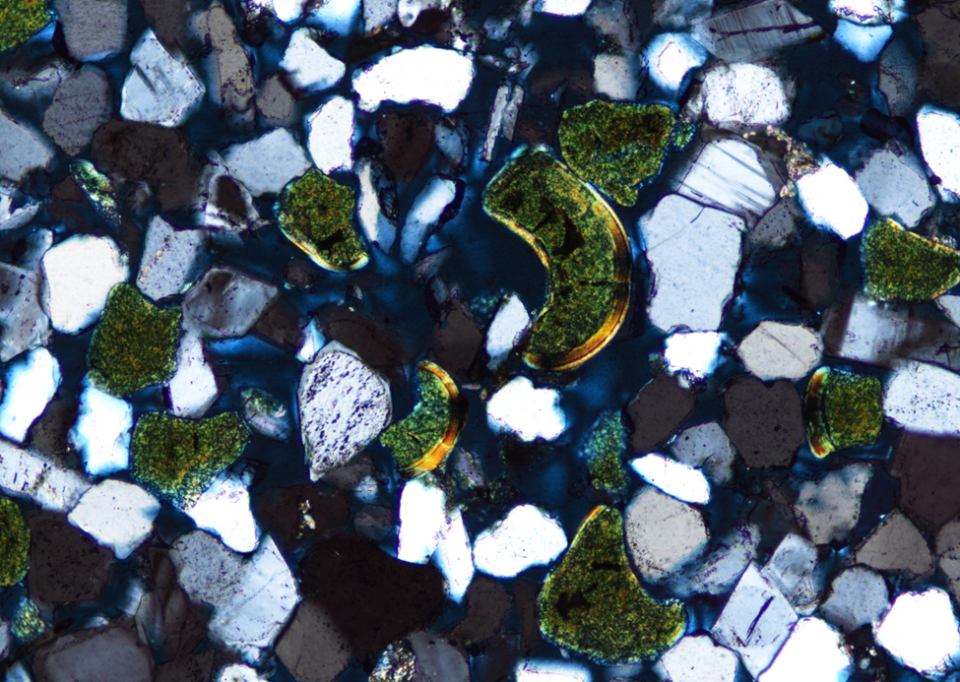

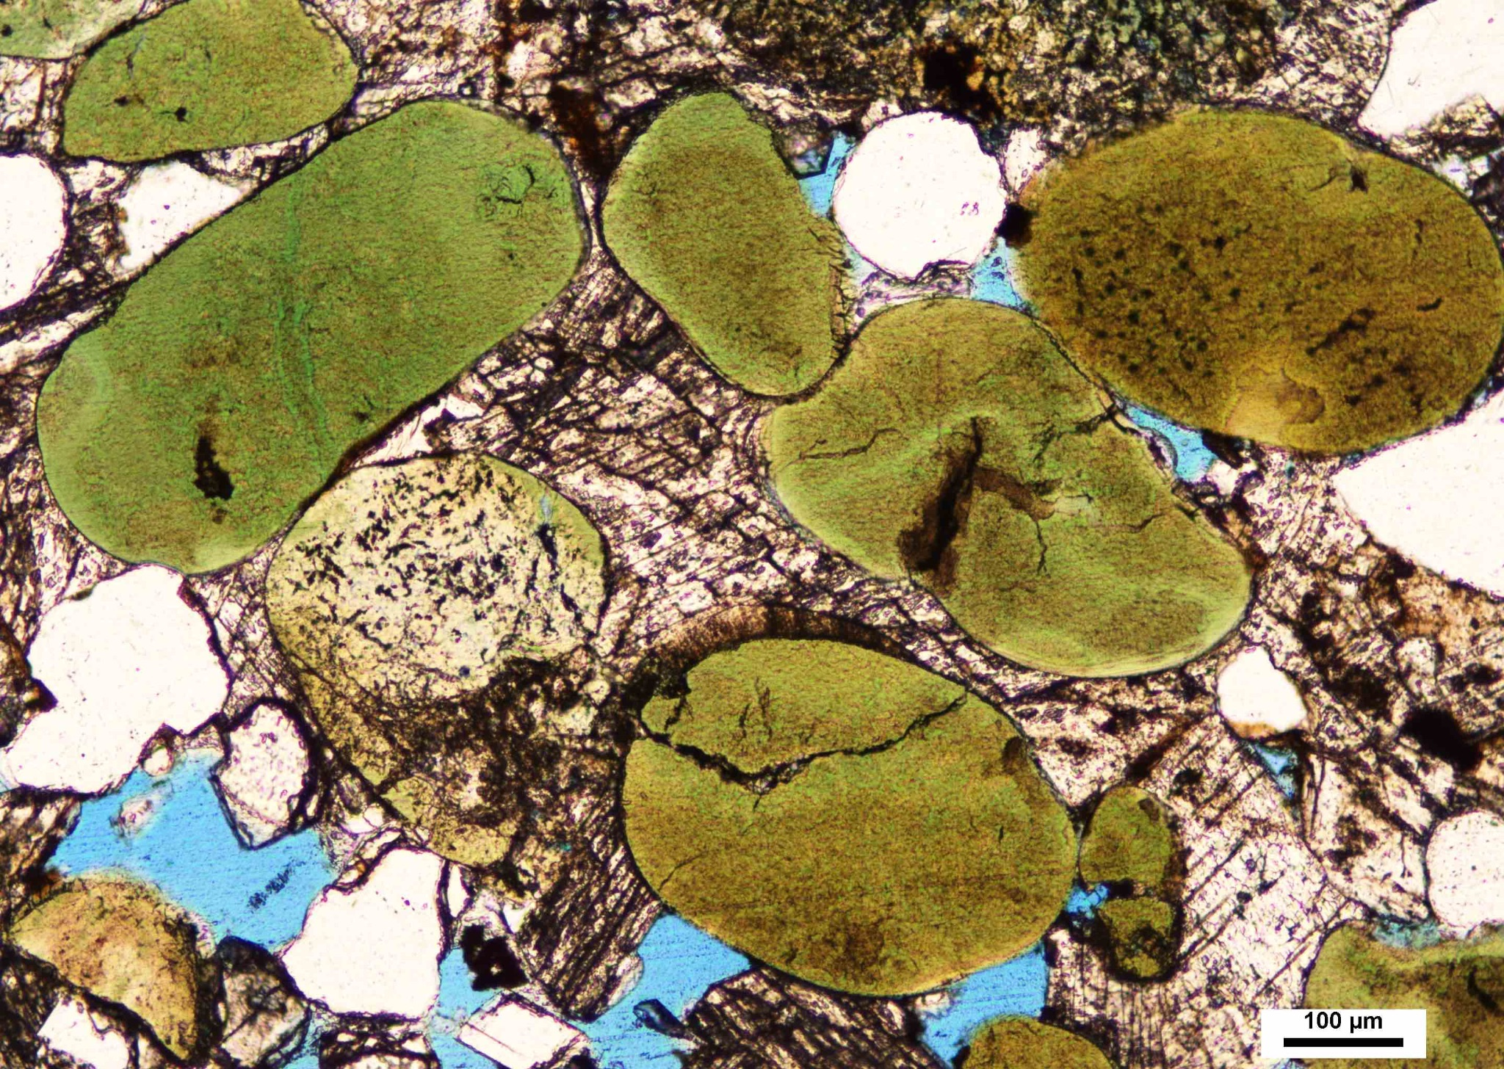

Conclusion

My experience with my summer FURSCA project is one that I will not take for granted. At the end of summer, I felt that the opportunity that I had to develop my skills as a geologist, discover more about my interests, and understand what it meant to be a scientist was not wasted. I quickly recognized that this project provided me with a unique challenge in that I would have to learn many things in a fairly short amount of time. This project was my first experience with geologic research and I didn’t necessarily know what to expect. It turns out that this project was filled with plenty of obstacles. Notable examples included needing to troubleshoot the point counting program, learning how to code in R, and needing to make plenty of revisions to how my data was collected. Thankfully, I can confidently say that I made it past most of these hurdles and put myself in a great position to continue my project throughout the next semester.

I would like to formally thank Bruce A. Kresge ‘53 and Peggy Kresege ‘53 Endowed Science fellows for providing me with this wonderful opportunity. Furthermore, I would like to thank my advisor Dr. Madeline Marshall for her continued support and guidance throughout my project. Lastly, I would like to thank the FURSCA committee for giving a prime opportunity to explore and learn more about sedimentary geology.

