Enkhtushig Enkhbat
FURSCA 2023
End of Summer Report

I. Introduction
The rapid advancement of robotics has revolutionized various fields, from industrial automation and healthcare to military technology. Although having been fascinated by new, innovative technologies for a long time, I never had the chance to contribute to the field myself. However, the Foundation for Undergraduate Research, Scholarship and Creative Activity, FURSCA, at Albion College has provided me with the opportunity to work on a robotic project and gain an invaluable hands-on experience, while possibly contributing to the development of the field.
II. Background
To perform complex tasks with precision, especially in remote-controlled scenarios, robots require an accurate feedback system to perceive and respond to physical interactions from their environment. My goal for the project was to implement a haptic feedback system integrated with tactile sensors in a robotic hand, enhancing its natural and effective utilization.
Tactile sensors, generating electrical signals in response to pressure or deformation, provide valuable information about the robot's environment, grasp state, and surface detection. Integrating haptic feedback, simulating touch sensations through force, vibrations, and motions, would enable a more intuitive interaction between users and the robotic hand's environment. We were particularly interested in exploring the potential benefits of haptic feedback in robotic prosthetics, aiming to improve usability and enhance the user experience.
III. Results
During the first 5 weeks of the project, we were able to make consistent progress as was planned in the proposal. In the first 2 weeks, with the guidance of my advisor, I built the circuit with the robotic hand and the microcontroller, and started programming the hand with the functionalities of a human hand. I explored my limitations with the servo motors driving the finger motion in the hand, and had a prototype code for controlling the hand.
In the following 2 weeks, I integrated the EMG sensors in the circuit to achieve remote control of the hand. Successful implementation of the sensor required an update in the code, reflecting the data collected from the sensor. After completion, the robotic hand was controlled by the activity in the muscle of my arm.
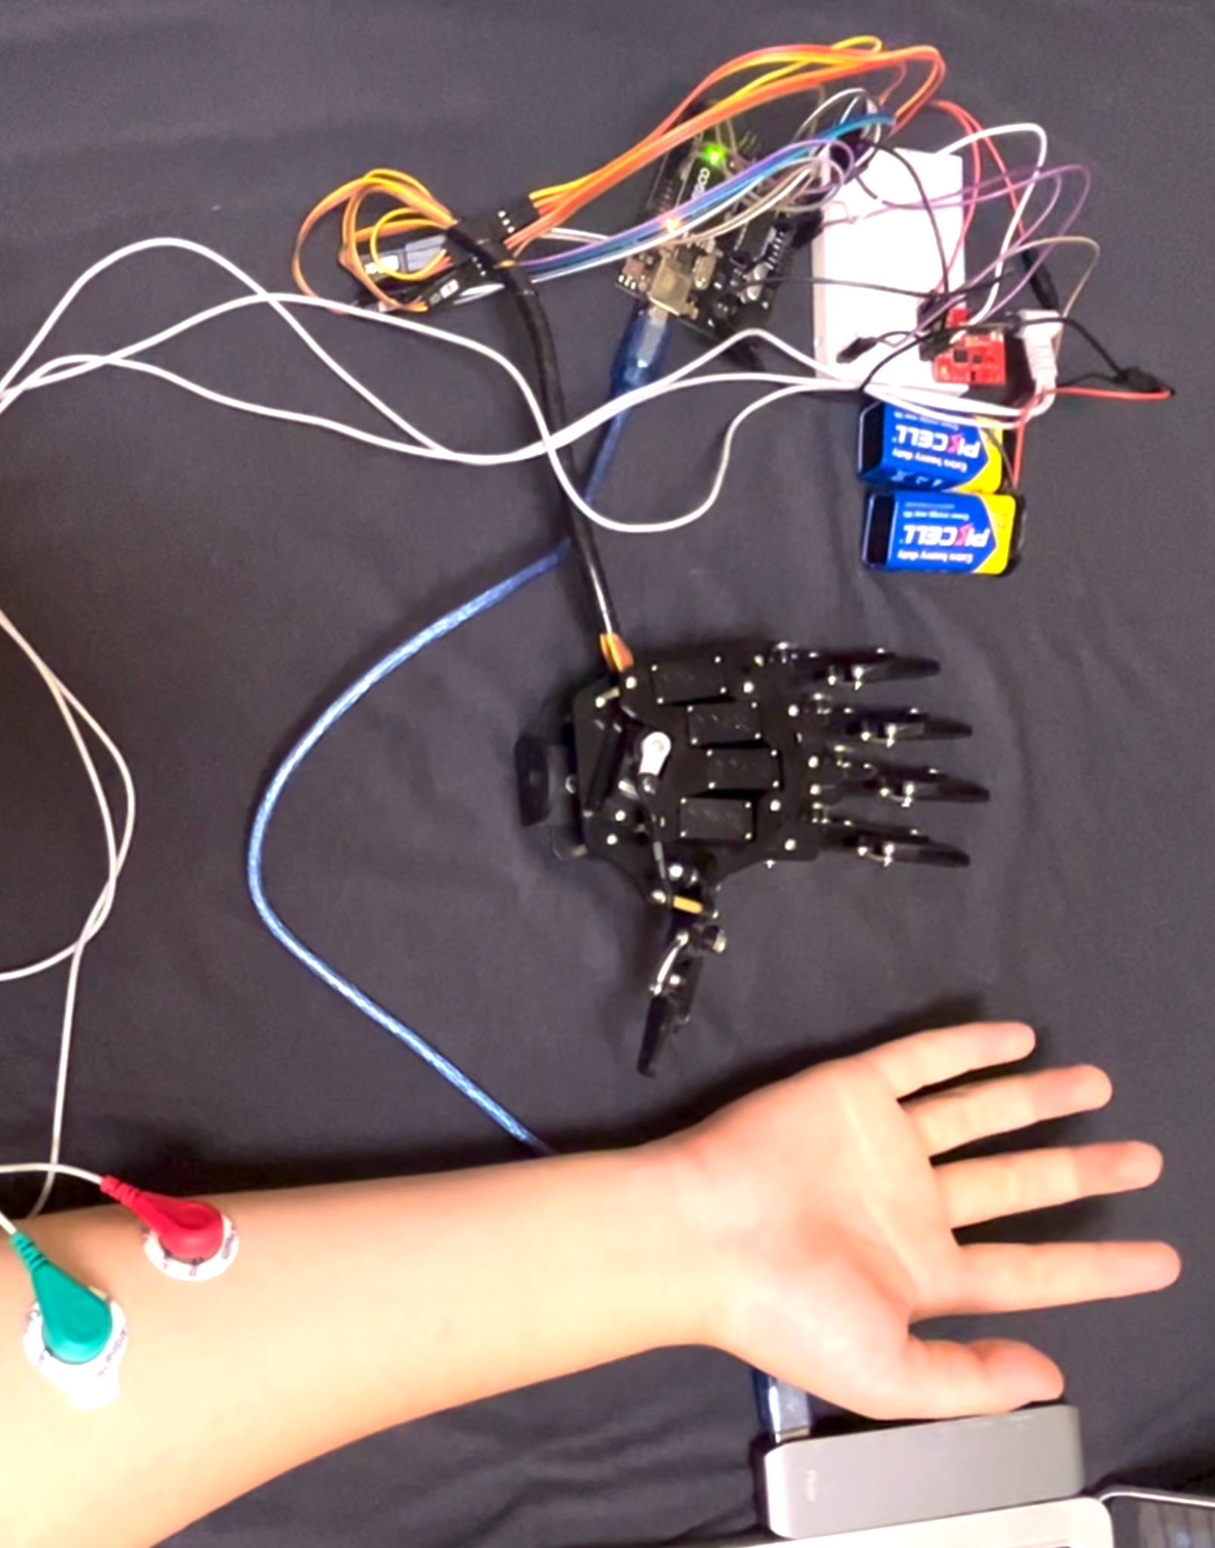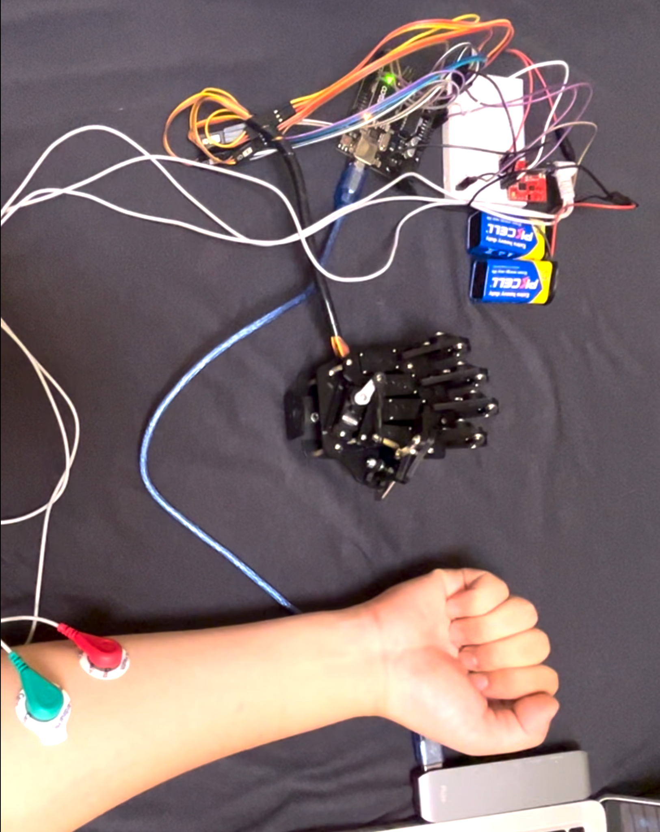
The pictures of the robotic hand following my hand movement as I opened and closed my hand

Due to the unexpected problem we faced with the shipment of the remaining parts, the project came to a halt after this phase. Although my advisor and I tried everything in our power, the parts came a week after the end of the timeline. Despite the challenges faced, I wanted to spend the wait more productively, so I spent the rest of the duration of the project working on and polishing the code and the system.
IV. Conclusion
Firstly, I want to apologize for not being able to complete the project. Nevertheless, although facing unexpected challenges, FURSCA has been a great learning experience for me as I developed a deep understanding of electronics, sensors and microcontrollers. And I’ve also understood to calculate outside risk factors that could hinder the progress of the project. With this realization, I plan to present my research at the Elkin Isaac Research Symposium along with its success and failures for the future recipients of this grant to learn from my experience.
I would like to sincerely thank the FURSCA committee, Elizabeth Palmer and Renee Kreger for allowing me to gain this valuable experience, and Dr. Khalifa for guiding me through the process. And I would also like to specifically thank Charles J. Strosacker for giving me the opportunity to participate in Albion College’s FURSCA program this summer, which I have benefited greatly from. Thank you!

