Rae Baker
Dr. Lyons-Sobaski
FURSCA
2023
Mile-a-Minute Weed
The Impacts of Management
Invasive species can be a threat to thriving healthy ecosystems as they often outcompete native species for resources and this can impact food chains and similar balances in that ecosystem. It’s important to be aware of our local invasive species so we can do our best to control and manage any damages or harm it might inflict. The main goal of my research was to learn about a recently introduced invasive plant species new to lower Michigan, Mile-a-Minute Weed (MAMW, Persicaria perfoliata). My hypothesis stated that invaders, such as Mile-a-Minute Weed, negatively impact the surrounding plant community by outcompeting other species. I set up a research plan to draw conclusions about how quickly MAMW grows, how it changes the immediate plant community surrounding the invasive species, and what management techniques are effective to control MAMW. Finally, from these questions, my final goal was to draft a plan of management for use in the future that best fit, ecologically, financially, and practically.
I used one meter square plots to set up my areas of study. Using a GPS system in the first week, six concentrated areas of MAMW were found, and four plots were established in each area, for a total of 24 individual plots. The four plots in each area were randomly selected to be a control plot, a pull plot, a 1% herbicide, or a 2% herbicide plot. Each week, the composition of each plot was recorded, the length of MAMW individuals (5 plants per control plot, 30 plants total) was noted, and light measurements were taken.
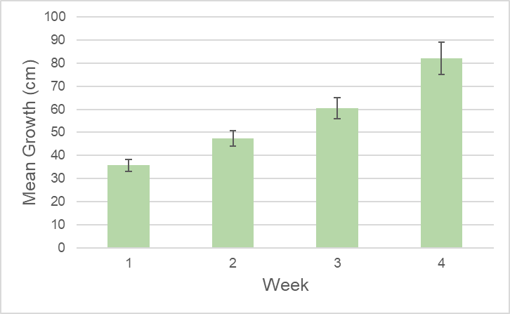
After five weeks of data recording and research, we answered many of the questions we asked initially and have a better idea about which method is the best for managing MAMW before it spreads into other parts of the state. I learned that in only eight days, MAMW had the ability to grow as much as 73 cm with growth rates varying widely for each individual. They grew in similar conditions and areas, however some grew expansively while others only grew a few centimeters. Fig. 1 depicts the mean growth of all MAMW individuals per week. The 1% and 2% herbicide plots initially after spraying were both showing similar impacts, however two weeks after spraying the 1% plots started to bounce back whereas the 2% plots continued to lose species richness.
Fig. 1, Mean growth in cm per week of MAMW individuals
measured over four weeks. Includes plus and minus error bars,
sample size of between 26 and 30 individuals at WNC.

When sprayed with a diluted 1% herbicide solution, two out of 130 plants were initially hindered in their growth, but began to grow new stems shortly after. Since these individuals survived the initial spray of diluted herbicide, it gives the plants an opportunity to live and reproduce whereas the 2% herbicide eliminated MAMW more effectively. Fig. 2 visually shows the species richness, the number of species, averaged for each plot over five weeks. MAMW was recorded growing again in both the 1% and the 2% plots, however most were either growing in the plots from areas that were not sprayed, or looked very pale. Human error also has to be taken into consideration; it’s likely that not every plant will be hit with the herbicide, or pulled manually.
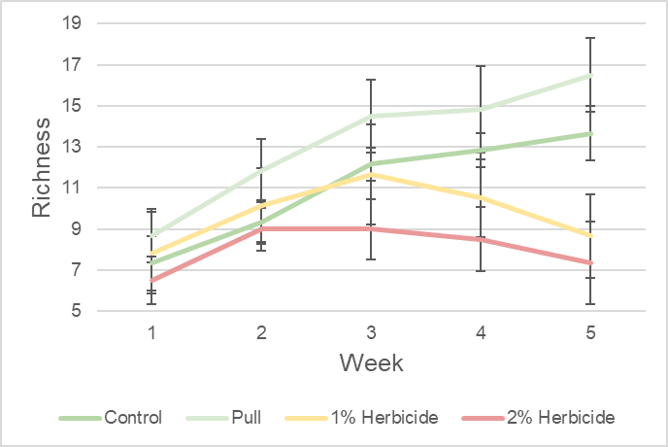
Fig. 2, Mean species richness per plot over all six areas, over five weeks. Includes plus and minus error bars. Sample size of 24 total plots at WNC.

From observations it appears that MAMW is killed best by physically removing it from the ground. This method is best for preserving the surrounding plants in the community. Due to human error, it’s very difficult to remove every individual at once and it’s likely some will be missed. At the end of five weeks, 10 individuals were growing in our pull plots. Hand pulling can also be difficult because of the plant's barbs, the plants can be very difficult to access, and the process is very labor intensive, especially at a large scale. Using a full strength herbicide does also effectively kill the plant, and due to the long spraying arms used, more plants can be accessed without clearing an area. Using a herbicide however, means that not only will the targeted species be killed, but due to drift, other species can also be negatively affected. However, to prevent the spread of MAMW, it’s most important to quickly and effectively kill it to prevent it from reproducing. It may be unfortunate that other species will also be affected, but those species will bounce back again from seeds in the areas that weren’t sprayed with the herbicide. In a very general sense, all three treatments greatly reduce MAMW populations, as seen in Fig. 3, but after other considerations are taken into account economically and environmentally, my final conclusion is that using a full strength broadleaf herbicide every year in known locations of MAMW will be the most effective treatment to prevent spread into new areas. With government grants, communities that have known locations should get free treatment.
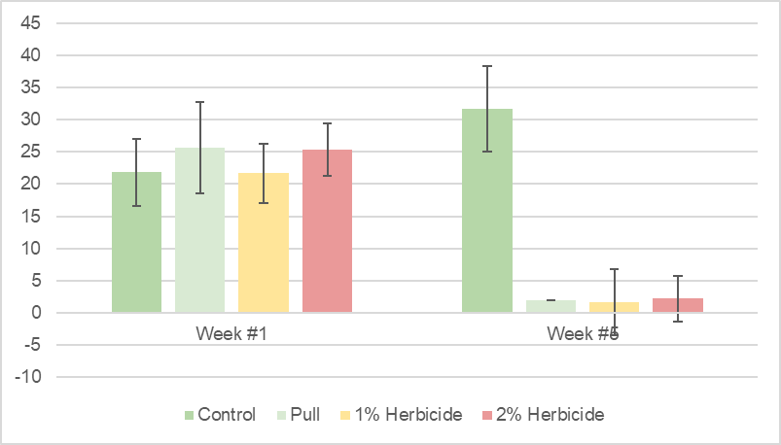
Fig. 3, Mean MAMW individuals counted per plot across all six areas. Week #1 represents data before treatment methods were applied. Includes plus and minus error bars. Sample size of 811 individuals.

For example in Kalamazoo, Brown, and Calhoun counties, a government group named CISMA is focused on managing MAMW and offers free treatment if you spot the invasive plant and call them.
I plan on sharing my conclusions at Elkin R. Issac in the spring 2024, and I plan on talking also at the Biology Research Symposium. In an attempt to spread the information about this important invasive species, I have shared information about MAMW with Mr. John Face, a blogger in Albion who writes for a local audience, and I have crafted a poster for Albion’s Whitehouse Nature Center (WNC) to describe my FURSCA research. This research is also the basis of my undergraduate thesis.
This project has taught me valuable lessons in timing, data collection, data analysis and organization. These are skills that are vital as a biology major, and as someone who plans on conducting similar research as a career. This FURSCA research has also pushed me to improve my presentation skills, another important life skill as a college student and a researcher. Being able to communicate concisely and confidently is something not everyone can get one-and-one coaching on with experienced professors. Because of FURSCA, I have been able to work closely with several people in my field, I have been able to get an incredible hands-on experience. Thank you for the opportunity to research MAMW and share it with you!

Albion Blogger’s Article:
https://micitywatchnews.com/2023/07/05/invasive-species-mile-a-minute-albion-college-
ground-zero/
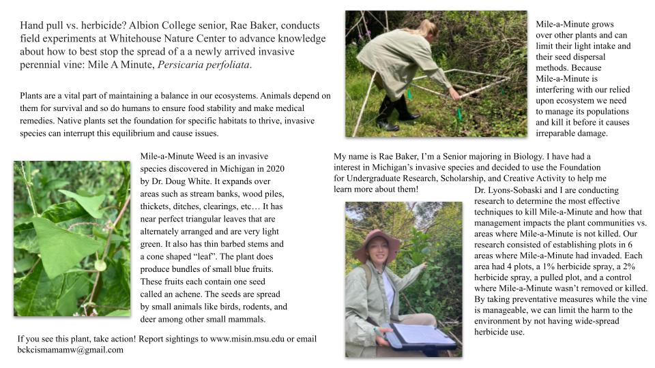
Whitehouse Nature Center Poster:

