Kaitlyn Piontkowsky
End of Summer Reflection

My project is focused on a bacterial infection that causes blighting in rice plants called Xanthomonas Oryzae pv. Oryzae. This is a gram-negative bacterial strain that infects its host through a type three secretion system. Through this system, bacterial DNA is inserted into the plant cytoplasm, the secretion system builds an enclosed bridge (called a pilus) outside of its membrane, and eventually inserts a protein called Hpa1 into the plant cell wall. I will be working on creating a nanobody which will bind to this Hpa1 structure and prevent the translocation of DNA across the plant membrane. My goals are to purify an Hpa1 antigen, as well as purifying a nanobody that will prevent rice blight.
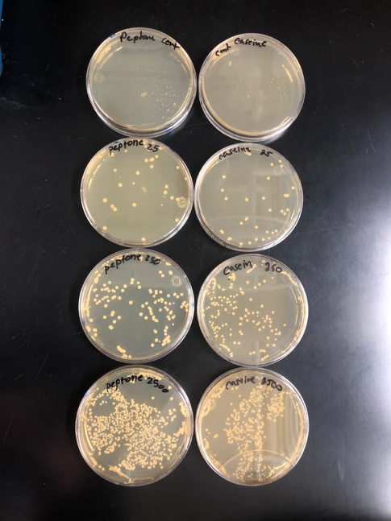
Before we switched to remote research my lab group had grew our yeast library, and tested our library size through a series of dilutions (Figure one.) Some of these yeast cells have nanobodies displayed on their surface. In order to test have many cells were displaying nanobodies, we sent our library through a test called “Fluorescent Activated Cell Sorting” (FACS) Figure two is the data we retrieved from the FACS test we did in February. This test showed us that about 16% of our yeast cells were displaying nanobodies.
Figure one. Display of plated yeast cell library dilutions which confirms library size is 2.5x10^8 large.

Simultaneously I was also working on developing the Hpa1 antigen. I hope to finish this part of my project by the end of the semester. I need to transfer DNA from one set of E.coli to another, in order to create Hpa1 proteins.

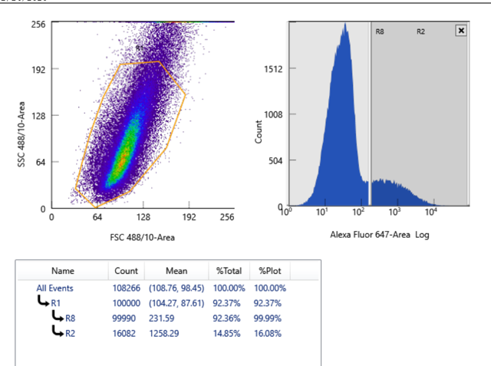
This summer obviously did not go as planned. I spent my summer diving deep into the logistics and methods of my project and developing a deeper understanding of the process by which I will complete my project. I spent countless hours on zoom calls and reading research papers. While remote research wasn’t exactly ideal, I do feel as though I’ve greatly benefited from it and will come out of this summer with a thorough understanding of my project. This summer I worked on learning to code Python- a computer language. This will help me in future work be able to interpret large sums of data, and organize it using codes. Furthermore, I played around with making figures on Adobe Illustrator, which will help me when I need to make figures in the future for presentations, grants, or papers.
Figure two. Data from fluorescence activated cell sorting. The dark grey portion of the graph on the right, shows cells that are displaying nanobodies.

My project is far from over, and I’m lucky to have the opportunity and resources I do. Since I was able to start this project my first year, I look forward to spending the next three years on purifying my nanobody and practicing my lab technique. For me, getting research experience will help my medical school application, and broaden my knowledge of biochemical investigation. I hope to present my research at the Elkin R. Isaac Research Symposium, and possibly write my thesis on my work. Again, I am very grateful for the chance to conduct research and would like to give thanks to the Orpha Leiter Irwin Fellowship for sponsoring my work this summer, as well as the Albion College FURSCA staff for offering me this opportunity.

