FURSCA 2020
Jesse Hepner

For my FURSCA project this summer, I studied the electrocatalytic reduction of bromate as a model system for removing perchlorate oxyanions from the environment. Oxyanions are labelled as an emerging contaminant in the environment because the concentrations of them are increasing, which poses the risk of a higher negative impact on human and environmental health. I will be modeling this system with bromate reduced bromide for perchlorate since perchlorate is the most difficult oxyanion to reduce. The goal of this project was to examine previous work that has been done using electrochemical methods and to figure out a more efficient and inexpensive way to remediate the problem. I have been working closely with my research partner, Morgan Goodnow, on learning the electrochemical methods and concepts we will implement when we return to campus (as the initial goal was to be in the lab designing and running experiments).
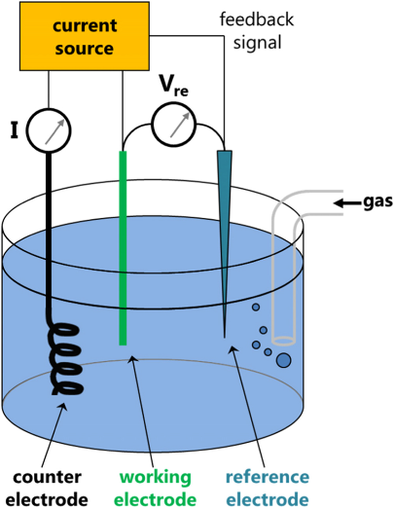
Throughout the course of the summer, I read several papers regarding the reduction process step-by-step. I also dove into a book on the basics of electrochemistry to familiarize myself with the topic and to not only understand how we will eventually do the experiments, but how and why these methods work. Our plan is to build electrodes from bimetallic nanoparticles using carbon microspheres in order to reduce bromate into bromide. In order to understand how to do this or what that even meant, we read about ultrasonic spray pyrolysis-which is a process that converts our solution with metal particles into a mist, that mist gets carried through a furnace, then is collected in a bubbler where the carbon microspheres (black powder) remain. Those carbon microspheres containing the metal nanoparticles will then be used as an electrocatalyst to speed up the reaction time as the working electrode (where the reaction is occurring) in the electrochemical cell. The current between the working and the counter electrode (the electrode that completes the current pathway) will determine how much bromate is being reduced. This idea is shown in the diagram to the right. After familiarizing myself with all of these new concepts, we started on the math that goes into creating the bimetallic nanoparticle carbon microsphere initial solution. This helped me wrap my mind around how we will actually begin the experiments in the fall.
In the future, I hope to continue this research with Dr. Kevin Metz, not only to further enhance my knowledge of chemistry, but to also get as much lab experience as I can. Ultimately, I want to develop this research into my senior thesis. This whole experience is so important to me, because I want to feel as prepared as possible for future internships or even graduate school. After I can really spend some time in the lab and start to get results, I would like to present my findings at the Elkin R. Isaac Research Symposium. I also hope to someday be able to present my results at a national meeting of the American Chemical Society.
What I was able to complete over the past 10 weeks wouldn’t have even been possible without the very generous support of the Robson Family Fellows Endowment. Thank you to Dr. Robson for this amazing experience. Even though I couldn’t be in the lab this summer, Dr. Robson provided me with a chance to understand concepts I wouldn’t have otherwise been able to go really in-depth on. It will be that much easier for me to get right into lab when I return to campus in the fall. Even in that short time, I was able to learn and question a wide range of material. I feel as though I am one step closer to finding a perfect fit for my career in the world of chemistry. Dr Robson, you have opened up so many opportunities for me to grow as a young researcher and I am so thankful.

