Hannah Erickson
July 23, 2020
End of Summer Report
My research this summer was focused around performing an RNAseq analysis on gene expression data from Tetrahymena thermophila. Tetrahymena are small freshwater ciliates that live in lakes and ponds. These ciliates have seven different mating types and they are able to recognize when another cell is either the same mating type, or a different one. This process is called mating type recognition, but little to no information is known about what genes control this process. My research goals were to gain knowledge about the mating type recognition pathway.
As very little information is known about mating type recognition, any data found can be useful. Over the past ten weeks, I have revealed a lot of information about the mating type recognition pathway. I identified a total of 5,096 genes related to mating type. These results are good at this point but do require more analysis.
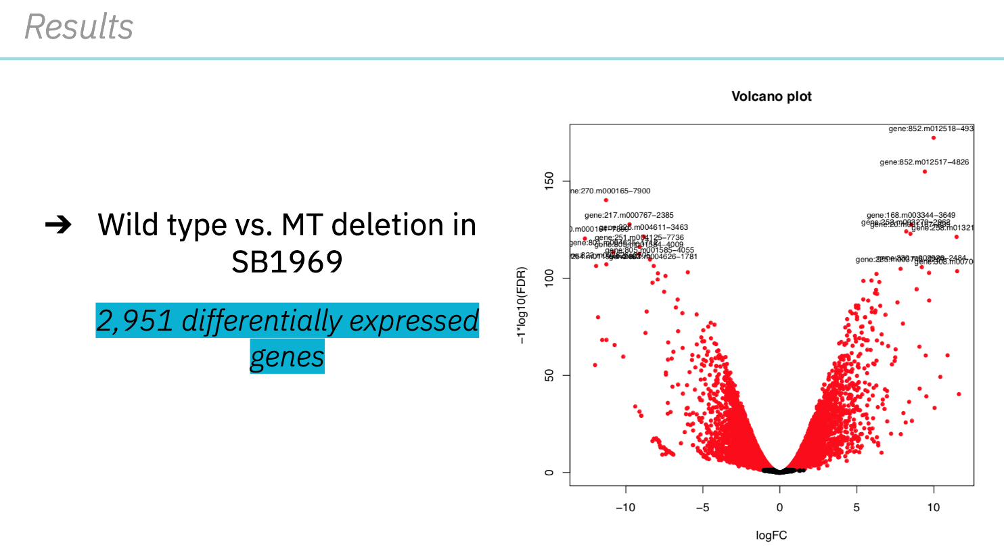
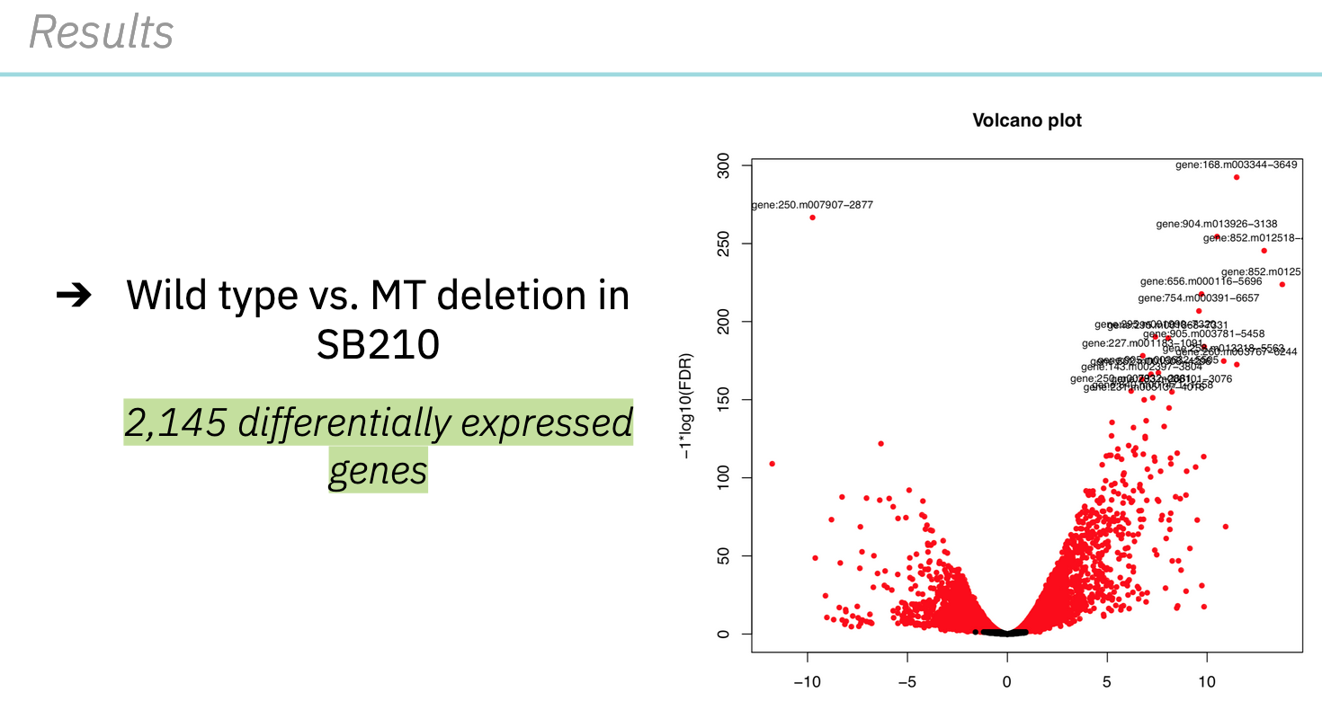
I presented these results, along with others, at the 2020 Ciliate Molecular Biology Conference. While I made significant progress this summer, I still intend to keep working on this project. Over the course of the last 10 weeks, I have learned programing and data analysis skills. These will be very useful to me in the future.
I do believe that this research is important, because mating type recognition is fairly unexplored up until now. More importantly, Tetrahymena as an organism are vital to the health of many freshwater lakes and ponds. For my future plans, I do intend to present my work at the 2021 Elkin Isaac Research Symposium. I also plan to write my thesis on my research this summer. Before this FURSCA experience, I was curious about the scientific research field. This experience has been very valuable to me and gained even more of my interest. Finally, I would like to thank the Jane Seymour Kilian, ’39 Endowed Fellowship for making this opportunity possible. It has been extremely beneficial to me and I will look back on this summer as a very positive experience.

