FURSCA End of Summer Report
This summer, I was attempting to synthesize and biologically test 3 photo-switchable anti-cancer drugs that inhibited the c-Raf pathway. My summer FURSCA project had the goal of synthesizing one additional AZO compound and analyze it’s and 2 other previously synthesized compounds’ ability to photo-switch. Through this, we were planning to determine how much light and at what wavelength is necessary to completely switch to become active in the trans conformation. In these results, we were expecting that the most recently made AZO compound would be more efficient in its photoswitchability. Finally, I planned to test these compounds to see their ability biologically on the c-Raf pathway for which it is intended to inhibit. We hoped that it would not inhibit the pathway while in the inactive conformation and it would inhibit the form in its active conformation.
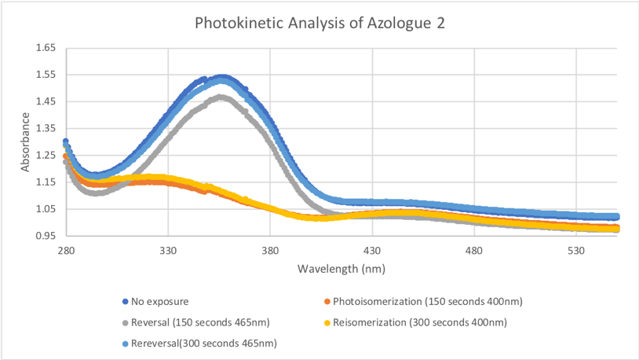
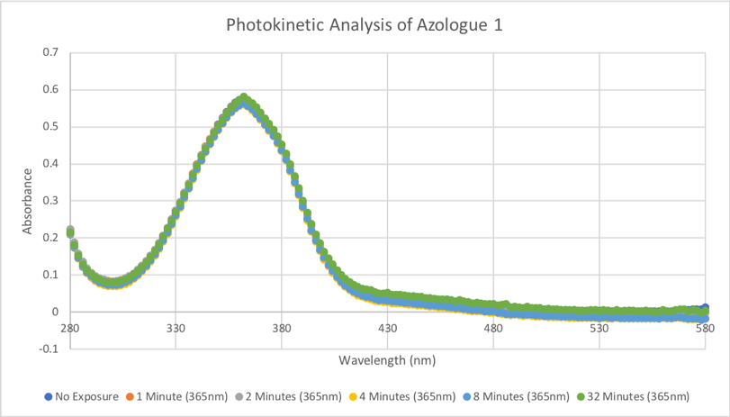
I did not achieve all of the goals as I had originally set out to. In synthesizing my newest AZO compound, I came very close. Synthesizing new, never been made before compounds is a puzzle. You have to run different reactions with different chemicals to make your compound. In the mindset of Thomas Edison, this summer, I found a lot of ways how not to make my compound. The final synthetic scheme I tried to accomplish this summer turned out to be successful but I had one final step before completing my molecule and I was left with no time to complete it. As for testing the photo-switchability, I was able to do this with my previously made AZO compounds which turned out how we anticipated. The photokinetic analysis of Azologue 2 was completed by our friends at the St. Mary’s College of Maryland previously last year. The change in peaks with different exposure times to different wavelengths of light indicate its ability to switch into its different conformations of light. This summer I competed the Photokinetic analysis of Azologue 1 which worked out just as we anticipated. This molecule is unable to switch with light due to its structure. Para to the AZO bond is a hydroxyl group, which allows the compound to change conformations but once the molecule has been removed from under light conditions, it changes back so quickly, I was unable to measure it changing at all. I changed the amount of time for which the compound was exposed to the light and from no exposure to 32 minutes of light exposure there was still no change.
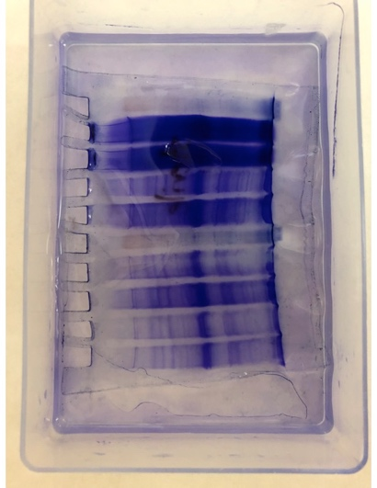
Biological tests were unable to be done on my compound this summer due to a few bumps in the road. We purchased plasmids, that contained the DNA sequence for my protein and for kanamycin resistance. The first step of my biological testing was to clone all of my plasmids which went very well! I got a lot of colonies that contained the plasmid. From there, I purified the DNA and had different cells transform the DNA. Then I induced these cells to produce my protein. This gel shows a thicker band where we believe to have our protein. To finally start biological testing with my compounds, I needed to purify this protein. After many protein columns and different techniques, we were unable to purify this protein. We hypothesize that this was not indeed our protein. So, after many long hours, I was unable to test my molecules. However, I was able to lead the biological testing on another compound that was made in our lab and it was very successful.
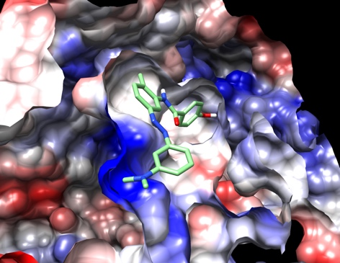
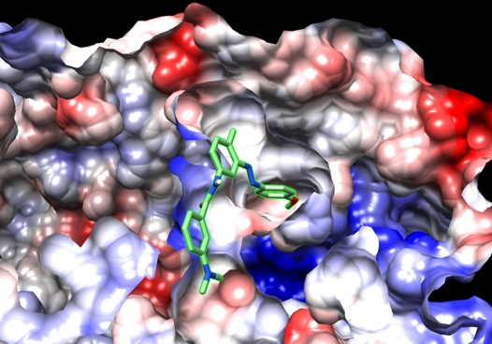
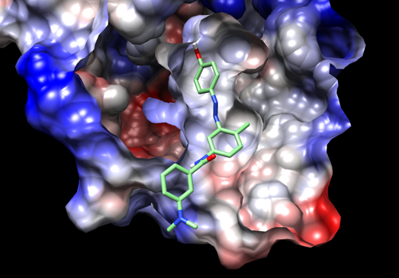
Finally, I completed computational docking which was not one of my goals, however one of my favorite successes. I used Chimera to show how my molecules fit into my targeted enzyme. Through this process, I was able to show that my ‘active’ conformation of the molecules fit into the enzyme active site while the ‘inactive’ conformation of the molecules do not fit into the active site. This is important to show that when we turn these molecules ‘off’ they will actually not inhibit the enzyme which is what we want to occur. Another important finding was that all of my proposed fit into the active site of the enzyme which is something we were particularly worried about due to us changing its shape by including the AZO bond.
Azologue 3
Azologue 2
Azologue 1
This project has been so incredibly important to me. I have been working on this project for the past 2 years and this summer gave me an opportunity to really dive into it and get the most done that I possibly could. I made a ton of distance on my project and am looking forward to what happens next. Next is more research when I return from Cork, Ireland where I am currently studying abroad. Then, I will be attending the annual ACS meeting in Philadelphia with the rest of the research group. Next after that would be medical school, however; after this summer and this experience, I am deciding to take 2 gap years and work in a lab before attending medical school. I am aiming for a post-bac position at NIH Labs in Bethesda, MD. Then I plan to attend a medical school in hopes (currently) of becoming a Pediatric Hematologist and Oncologist. In wrapping up this summer and this whole experience, I would like to personally thank FURSCA and the Orpha Leiter Irwin Fellowship for the funding. It has been an incredibly summer that has changed the course of my further education and I could not have done it without your generosity. Thank you again.

