San Pham
Aug 22, 2019
End of Summer Report for FURSCA Summer 2019
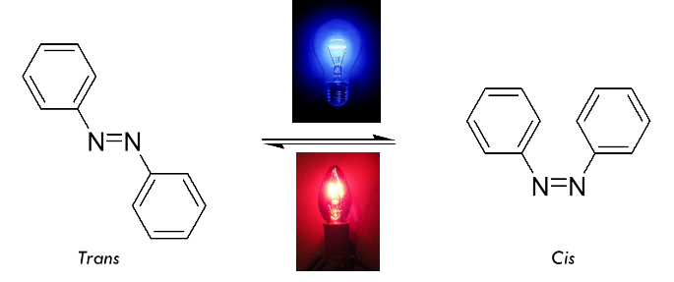
Figure 1. Light-sensitivity of azo molecules’ shapes.
During the summer, as a member of Dr. Craig Streu’s lab, I worked on developing light-switchable versions of already published cancer drugs with the intention of creating selective cancer therapy that minimizes side effect as much as possible. The cancer drugs I work with are inhibitors of key proteins that help with cell growth and division. To be effective, the drugs need to fit in with the shape of protein as in a key fitting into a lock. Thus, shapes of the drugs are fundamental for the drugs’ effectiveness, and I have been working on creating drug molecules that can switch shapes with light. For this project, I researched established drugs and modified them by adding azo bonds, which are nitrogen-nitrogen double bonds. These azo molecules are able to switch shapes when proper wavelength of light is shined on as shown in Figure 1. With these drugs, we can activate and inactivate them at specific sites such as only at tumor growths so that they would not affect other healthy cells like usual cancer therapy. Since these are novel molecules, we have had to come up with original synthetic schemes and made modification along the way. I was given two drugs to work on, with one preventing cell division and growth of cancer cells while the other preventing cancer cells from building blood vessels that give them nutrient and oxygen to grow on and allow them to invade other parts of the body. The former one is called azo c-Kit inhibitor, and the latter is azo Tie2 inhibitor. As the names describe, my drugs inhibit c-Kit and Tie2 which are the proteins responsible for the processes I describe earlier.
Figure 2. Azo Tie2 inhibitor (left) and azo c-Kit inhibitor (right)

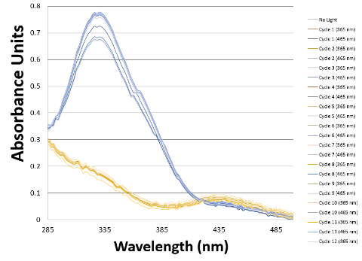
Out of the two projects, I was able to synthesize azo c-Kit inhibitor, as shown in figure 2. The drug was synthesized with a five step synthetic scheme. There were some problems with attempting to increase yields or to make a reaction work but we were able to overcome them. The molecule then was tested with light to analyze its photodynamic property. The transitional difference between the blue and yellow lines means that the drug is able to switch shape, as shown in figure 3. The drug was shown to have the ability to switch shapes back and forth multiple times without degrading, and it only took 10 to 15 seconds for the drug to switch shape. This is considerably important considering that we
Figure 3. Light-sensitvity of azo c-Kit inhibitor’s shapes
used light with wavelength that is in the range of ultraviolet light, thus, there should be minimal concern for exposure to ultraviolet light. We also were able to test the drug on proteins to check for its effectiveness. However, this was close to the end of summer so we were not able to analyze the data. If the data is good, we would be working on publishing the project by the end of this fall semester. Figure 4 shows pictures of some reactions that I ran over the summer.
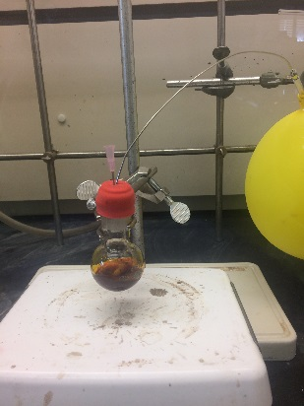
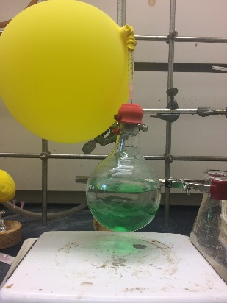
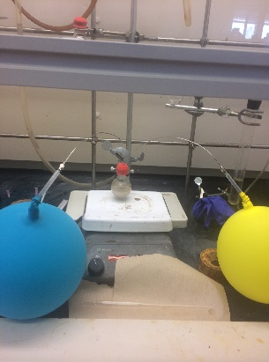

Figure 4. This summer’s reactions

Because of timing, we were not able to work on Tie2 project. However, during the process of making azo c-Kit inhibitor, I was able to synthesize the common intermediate that is a part of both azo c-Kit and azo Tie2 inhibitors. I will only have to work on finishing the molecule for Tie2 and testing the drug during the semester. This shared component of both drugs was why I was assigned two projects.
Participating in Summer FURSCA and this research has reinforced my interest in doing chemistry, specifically medicinal chemistry and organic chemistry. It has also helped me gain more insights in organic chemistry besides what I have learned in class, and gave me a brief glimpse on biochemistry, which I will be studying in this fall semester. The project was important to me that it helps me utilize my knowledge I have from class for real life’s problems and also allows me to learn and improve my lab techniques. But most importantly, it has helped me realize that I want to get a career in doing research. I was originally a pre-medical student looking for extracurricular activities relevant to healthcare, however, after doing research for a while, I realized that not only do I want to treat people directly, I also want to do research, the foundation that help doctors with treating patients. Currently, I am considering between the options of doing an MD/PhD versus doing a PhD program only. Nonetheless, in the end, I want to do more research related in medicine. This experience has helped shape my career’s goal and it was a fun and rewarding experience for me. I plan to present my work at Elkin Isaac Symposium as well as American Chemical Society conference in the spring of 2020. If everything progresses well, I hope to publish my work on azo c-Kit inhibitor.
I would like to thank the Robson Family Fellows Endowment for the generous support and opportunity that I was provided with. The experience has opened my eyes and allowed me to learn so much more than what a simple class have to offer. I will continue to work hard so not to waste the important opportunity you have given me. Thank you once again.

