The RNA transcription process is imperative in living cells as the genetic information of DNA is sent to a messenger RNA molecule, due to it being the first stage of protein synthesis. Clustered Regularly Interspaced Short Palindromic Repeats (CRISPR) normally utilizes a Cas9 protein that cleaves the DNA allowing for alterations. However, I will be using the dCas9 protein that binds to the DNA and does not alter the genomic information. The focus of the research this summer was to examine the interaction of the dCas9 protein with bacterial transcription in vivo utilizing Escherichia coli. The goal was to target the purF and HisG genes, the beginning of the Purine and Histidine pathways, to better understand gene expression and RNA synthesis.

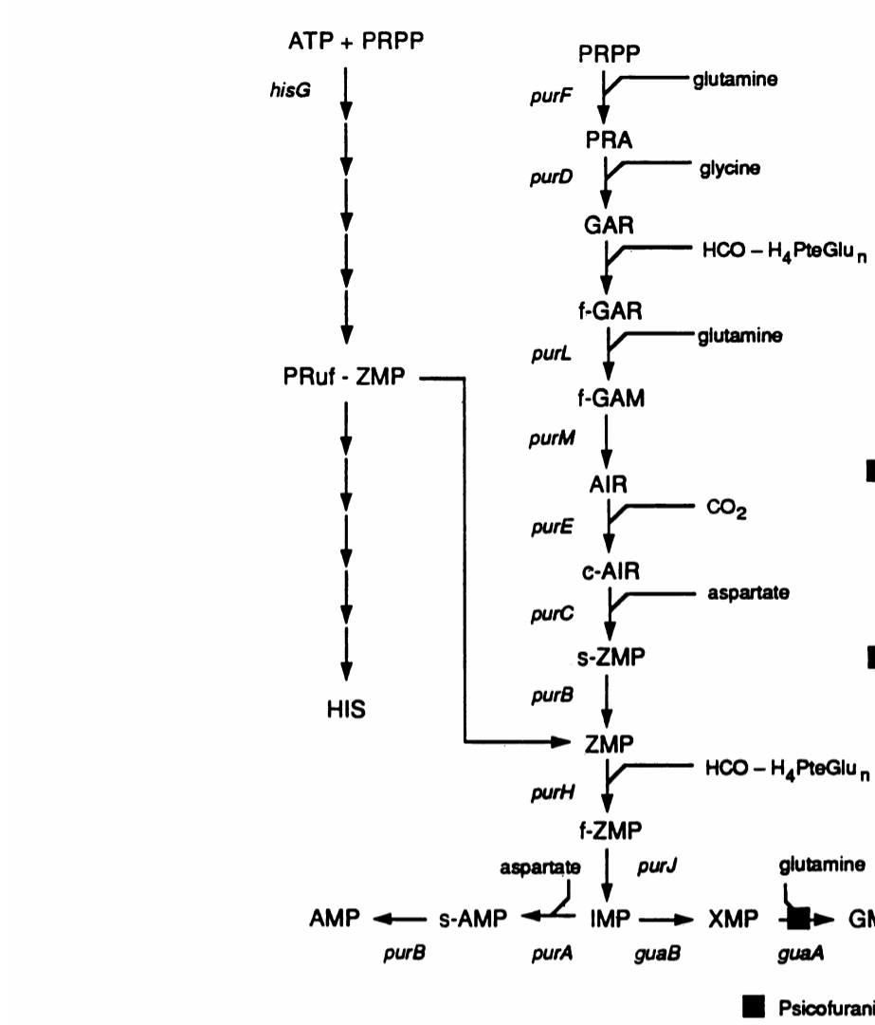
Pathway of the Histidine and Purine nucleotide synthesis, respectively

Due to the length of the project, it will take the remaining of my Albion College career to complete the pausing of transcription to target the PurF and HisG genes. This summer I was able to successfully learn and perform the techniques required for completion of my project. I spent a majority of the summer growing E. coli in order to develop consistent growth patterns before I alter the growth of the patterns by targeting the PurF and HisG genes. I developed many growth curves that depict the growth patterns of the E. coli before any alterations. As shown below, around 120 minutes, the E. coli experienced a lag phase before undergoing an exponential growth pattern. Ideally, these are the expected results for the standard growth pattern of E. coli.
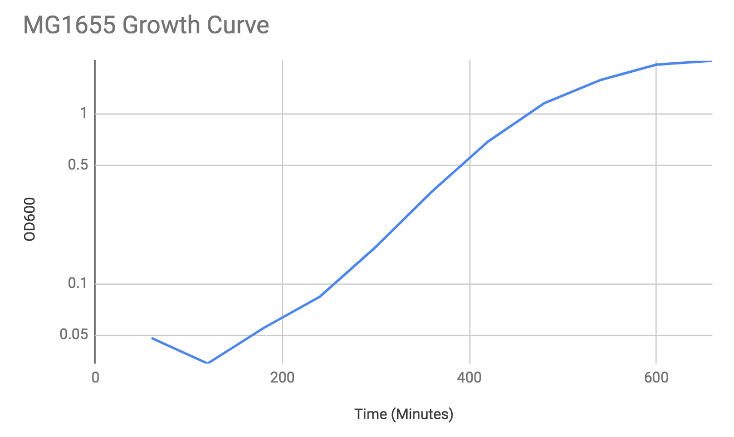
MG1655 in M63 Minimal Media
Based off of my work in this project, I will be creating a thesis, presenting my results at Elkin Isaac Research Symposium, and the National Meeting of American Society for Biochemistry and Molecular Biology. With this experience, I have further developed my skills of working in a small group with many different views of problem-solving. This project would not have been possible without the financial support from the Orpha Leiter Irwin Fellowship. I would like to thank the organization profusely for allowing me to pursue research which will build onto my knowledge as a pre-medicine student.

Thank you for this experience,

Sara M. Crisenbery

