Hunter Penrod
FURSCA
June 23, 2020

End of Summer Report

For my summer research, I dove into the literature on earthworms, or Lumbricus terrestris, in order to make assumptions of whether nootropics could possibly increase the learning speed in earthworms. The goal was to work on my honors thesis and do research at the same time, and researched past experiments done on worms and other invertebrates to learn about learning in invertebrates, how their nervous systems compare to the nervous systems of mammals, how nootropics affect mammals, and how nootropics affect invertebrates. I have inserted the first two pages of my paper following my references page.
I achieved many of my goals during these past two months. I am currently revising the third draft of my thesis, and am working with my thesis committee to improve my literature paper even further. I am very grateful for being able to work on it through FURSCA, as I am graduating a semester early, and many of my research plans for the previous spring semester were cancelled due to the pandemic. However, FURSCA provided me with additional research opportunities, and I am very thankful for it.
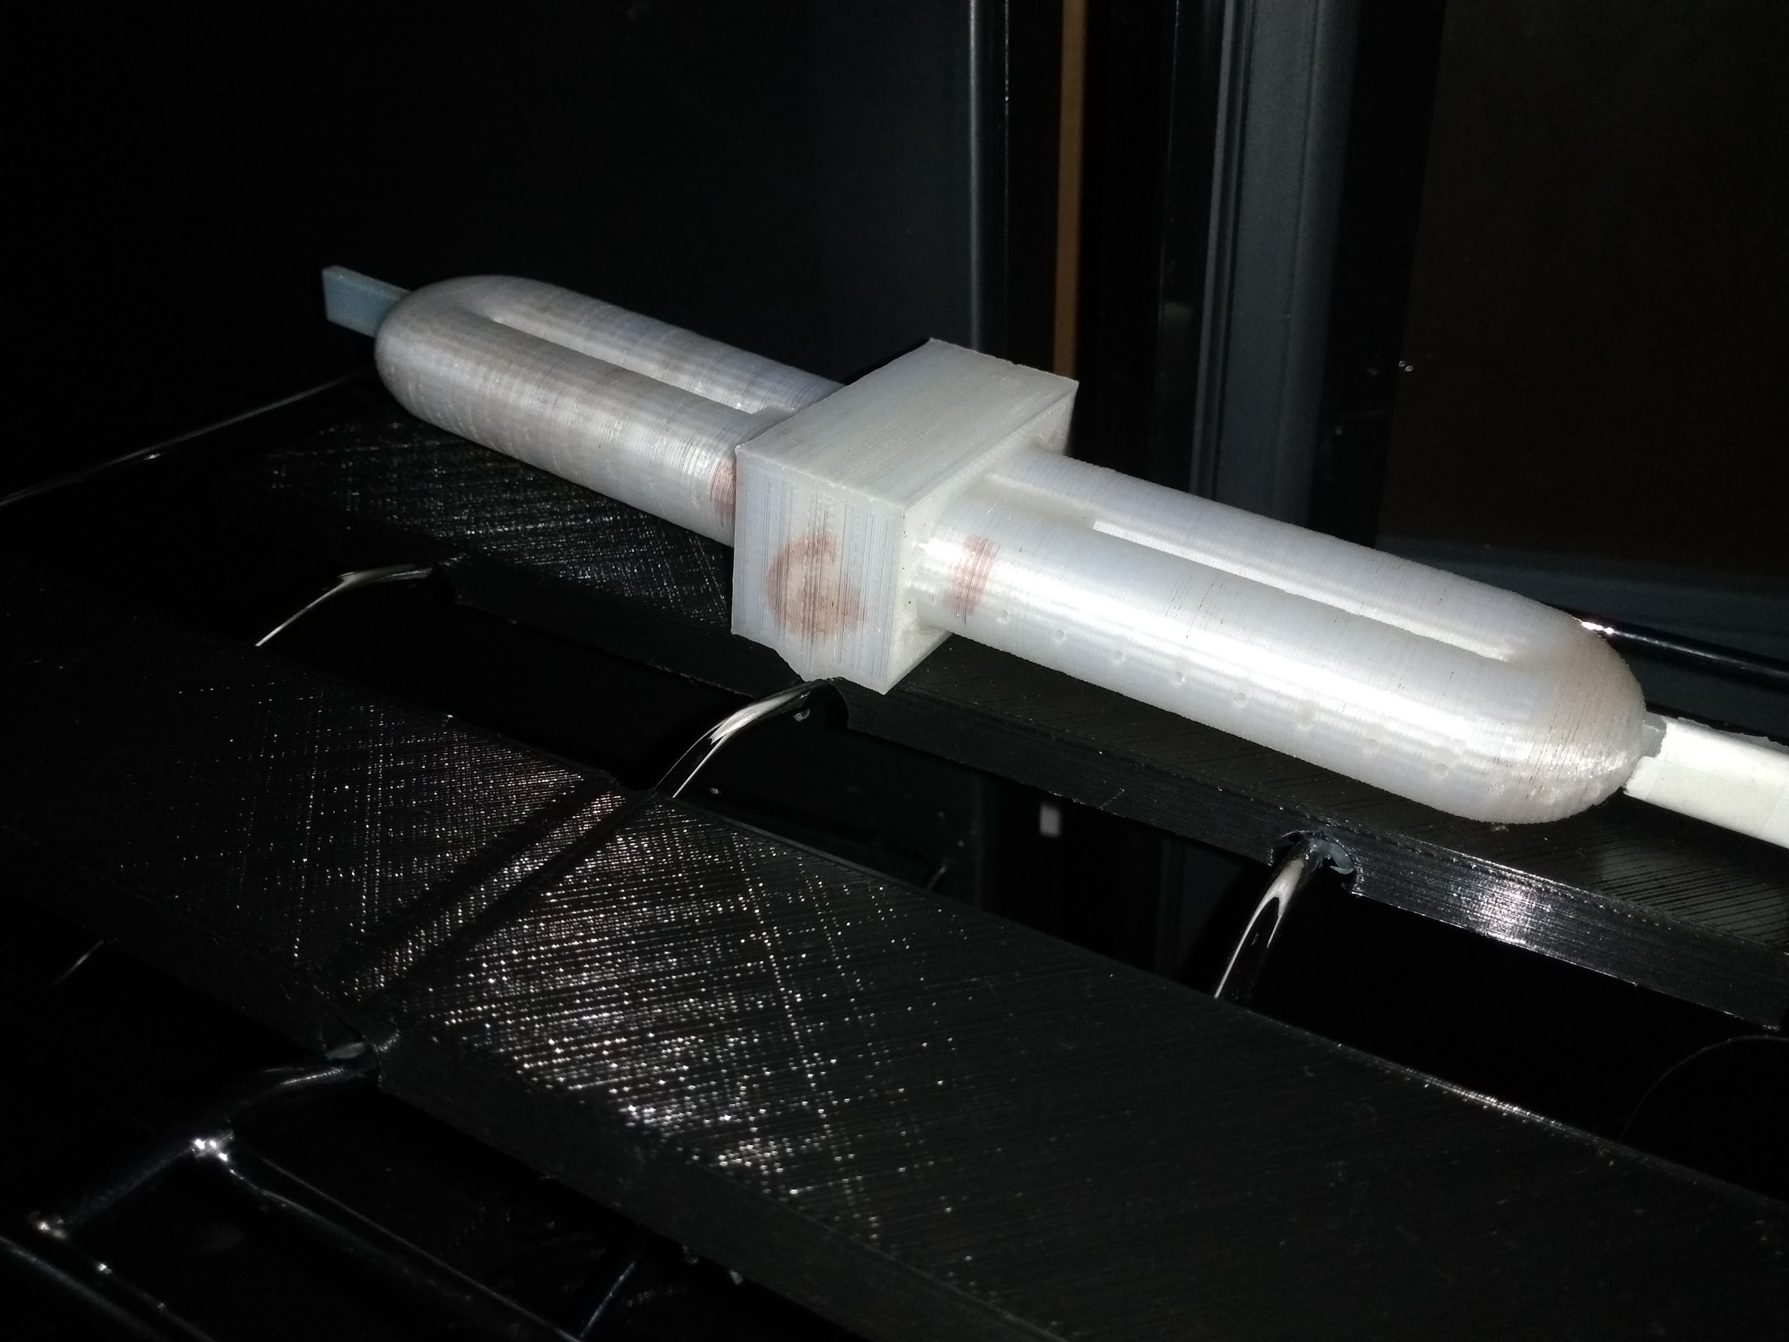
In addition to completing the first few drafts of my thesis, I also was able to make the assumption that some types of nootropics could very possibly increase the learning speed in earthworms. Previous research done by Wilson, Ferrara, Blaker, & Giddings (2014) states that earthworms have the capacity to perform avoidance learning. Avoidance learning is demonstrated in this study through the earthworms learning how to keep an unwanted stimulus, or a light shining above them, by turning on in order to avoid the aversive stimulus. Earthworms are also able to habituate or become sensitized to a stimulus. Furthermore, nootropics are widely known to enhance the learning speed in mammals such as mice and rats (Bhanumathy, Harish, Shivaprassad, and Shushma,2010; Joshi & Parle, 2006; Kulkarni & Verma, 1992), and the literature I read suggests that on molecular and cellular levels, the nervous systems between mammals and invertebrates such as earthworms are actually quite similar. The neurons between two different groups of animals act very similarly, insofar as they use neurotransmitters to relay information in order to change the behavior of its organism. One study demonstrated that glutamate may play an important role in the learning process of an earthworm, just as glutamate is important to the learning and memory of mammalian organisms (Glenn, Morlock, & Wilson, 2014). All of this information, as well as four experiments I found that implicated that nootropics affect the nervous systems and neurotransmitters in invertebrates (Bukanova, Solntseva, & Skrebitsky, 2002; Inozemtsev & Nepomnyashchikh, 2008; Pivovarov & Ostrovskaya, 1987; Solntseva, Bukanova, & Skrebitsky, 2001), leads to the assumption that if nootropics affect the neurotransmitters that influence learning and memory in earthworms, then the drugs can help them learn faster.

Regarding this project, my future plans are to finish my thesis and turn it in by November. I also plan on conducting research to determine if the use of nootropics actually increases the avoidance learning speed in Lumbricus terrestris. I plan on doing this by using two groups of worms: the experimental worms and the control worms. The experimental worms, or master worms, will be inside a shuttle box. A light will shine above both worm groups, but only the master worms will be able to control when the light turns off by moving within the shuttlebox a certain amount of times. Some of the earthworms will be exposed to the nootropic Prevagen before trials. The worms will be put into a solution made from water and the nootropic, and results will be compared to the master worms that were not exposed to the nootropics to indicate if earthworms learned faster with the help of the drugs.
A photograph of a shuttlebox. Worms are put inside of the device so their movements can be measured and recorded.
Unfortunately, I will not be able to present at Elkin Isaac during the Spring semester of 2021, as I will graduate by then. I was originally supposed to present my findings at some psychology organizations, but I am not sure how that will turn out in light of the pandemic.
This research experience helped me learn about something that I would have not previously thought I’d be interested in if I had not been suggested to do this type of research with one of my professors. I am grateful for the opportunities I was presented with. FURSCA provided me with a way to continue to learn throughout the summer.
I would like to thank the Bethune Fellows Student Research Endowment for assisting me with such a wonderful experience. I understand that many of the opportunities I am presented with through Albion College would not be possible without groups such as yourself. Thank you so much!

References
Barry, R. J. (2012). Habituation and Sensitization. Encyclopedia of the Sciences of Learning.
Bhanumathy, M., Harish, M. S., Shivaprasad, H. N., & Sushma, G. (2010). Nootropic activity of Celastrus paniculatus seed. Pharmaceutical Biology, 48(3). 324-327
Bukanova, J. V., Solntseva, E. I., & Skrebitsky, V. C. (2002). Selective suppression of the slow-inactivating potassium currents by nootropics in molluscan neurons. International Journal of Neuropsychopharmacology, 5. 229-237
Carew, T. J., Sahley, C. L. (1986). Invertebrate learning and memory: from behavior to molecules. Annu. Rev. Neurosci. 9: 435- 88
Garnder, L. E. (1968). Retention and overhabituation of a dual-component response in Lumbricus Terrestris. Journal of Comparative and Physiological Psychology, 66(2). 315-318
Ghelardini, C., Galeotti, N., Gualtieri, F., Romanelli, M., N., Bucherelli, C., Baldi, E., & Bartolini, A. (2002). DM235 (sunifiram): a novel nootropic with potential as a cognitive enhancer. Naunyn-Schmiedeberg’s Arch Pharmacol, 365. 419–426
Glanzman, D. L. (2010). Common mechanisms of synaptic plasticity: Minireview in vertebrates and invertebrates. Current Biology, 20. R31-R36
Glenn, A. M. Morlock, E., A., & Wilson, W. J. (2014). MK-801 effect on escape behavior in the earthworm, Lumbricus terrestris. Poster presented at the annual meeting of the Pavlovian Society, Seattle, WA.
Golubev, A.I. (1988). Glia and neuroglia relationships in the central nervous system of the
Turbellaria (Electron microscopic data). Fortschr. Zool, 36. 31-37
Hawkins, R. D., Clark, G. A., & Kandel, E. R. (2006). Operant conditioning of gill withdrawal in Aplysia. Journal of Neuroscience 1, 26(9). 2443-2448
Inozemtsev, a. N., & Nepomnyashchikh, V. A. (2008). Habituation of Caddies Chaetopteryx villosa fabr. larvae to vibrational stimulus and effect of piracetam on it. Journal of Evolutionary Biochemistry and Physiology, 44(2). 198-203
Jacobson, A. L. (1963.) Learning in flatworms and annelids. Psychology Bulletin, 60(1). 74-94
Joshi, H. & Parle, M. (2006). Evaluation of nootropic potential of Ocimum sanctum linn. in mice. Indian Journal of Experimental Biology, 44. 133-136
Kulkarni, S. K. & Verma, A. (1992). Evidence for nootropic effect of BF-16A (MENTAT®), a herbal psychotropic preparation, in mice. Indian J Physiol Phannacol, 36(1). 29-3
Lani, C., Lenzken, S. C., Pascale, A., del Vecchio, I., Racchin, M., Pistoia, F., & Govoni, S. (2008). Cognition enhancers between treating and doping the mind. Pharmacological Research, 57. 196-213
Law E, Nuttley WM, van der Kooy D. (2004). Contextual taste cues modulate
olfactory learning in C. elegans by an occasion-setting mechanism. Current
Biology, 14. 1303 –1308.
Madan, C. R. (2014). Augmented memory: A survey of the approaches to remembering more. Frontiers in Systems Neuroscience, 8(30). 1-5
Pivovarov, A. S., & Ostrovskaya, R. U. (1987). Effect of pyrecetam* on habituation of the acetylcholine receptor membrane of helix lucorum neurons. Bulletin of Experimental Biology and Medicine, 104(7). 51-53
Qin, J., & Wheeler, A. R. (2006). Maze exploration and learning in C. elegans. The Royal Society of Chemistry, 7. 186-192. Solntseva, E. I., Bukanova, J. V., & Skrebitsky, V. G. (2001). The nootropic drug vinpocetine modulates different types of potassium currents in molluscan neurons. Comparative Biochemistry and Physiology Part C, 128. 275-280
Wilson, W. J., Ferrara, N. C., Blaker, A. L., & Giddings, C. E. (2014). Escape and avoidance learning in the earthworm Eisenia hortensis. PeerJ. 1-11`

Literature Review of Possible Nootropic Effects on Learning and Memory on Lumbricus terrestris

Invertebrates, or animals without backbones, have held the key to discovering more about our own nervous systems for more than a century (Jacobson, 1963). Some invertebrates, such as insects, worms, and molluscs have small, simple bodies that help us understand what our nervous system does on molecular and cellular levels. Past studies on worms, insects, and snails have informed us of many important processes that the nervous system goes through, including the molecular and cellular processes that are associated with learning and memory (Carew & Sahley 1986; Hawkins & Kandel 1990). These simple nervous systems were studied in order to gain insight into our own nervous system, resulting in the realization that we share many things in common with select species of invertebrates. Some similarities include the molecular functions of our neurons (Glanzman 2010) and glial cells (Golubev, 1988), which are vital for our nervous systems to function.
Countless research studies done in the past have indicated that invertebrates have the capacity to learn, even beyond simple learning such as habituation and sensitization. Invertebrates, such as flatworms, Caenorhabditis elegans, and earthworms have shown changes in their behavior; furthermore, some species may have achieved complex learning, such as association and classical conditioning (Law, Nuttley, & Kooy, 2004; Qin & Wheeler, 2006).
Nootropics are drugs that are taken to improve cognitive performance (Madan, 2014), such as motivation, memory, attention, and concentration (Lani, Lenzken, Pascale, del Vecchio, Racchi, Pistoia, & Govoni, 2008). Nootropics are also studied to determine if they could be of any use to help solve problems among older adults with neurocognitive disorders, such as dementia.
Studies from nootropics in rats have shown that there may be positive results, insofar as nootropics help rats learn faster (Ghelardini, Galeotti, Gualtieri, Romanelli, Bucherelli, Baldi, & Bartolini, 2002; Kulkarni & Verma, 1991). If rats can learn faster due to nootropics, and if on a very simple basis, the nervous system of rats and some invertebrates have some similarities, then the notion that nootropics could help invertebrates learn faster is very possible.
Previous studies of interest have researched the ability of earthworms, or Lumbricus terrestris, to practice avoidance learning (Wilson, Ferrara, Blaker, & Giddings, 2014). Avoidance learning is demonstrated in this study through the earthworms learning how to keep an unwanted stimulus, or a light shining above them, by turning on in order to avoid the aversive stimulus. Earthworms possess the ability to learn beyond simple actions such as habituation and sensitization and have demonstrated that they are capable of higher learning. In a study done by Gardner (1968), earthworms habituated to a vibratory stimulus, meaning that they no longer reacted when they were vibrated. Sensitization, however, leads to an increase of reaction to a stimulus (Barry, 2012). If the worms were sensitized to the vibratory stimulus, they would have moved more instead of less. These findings, coupled with the possible indication that nootropics could improve the learning and memory of creatures beyond mammalian organisms, begs the question of whether earthworms would benefit from the use of nootropics. Specifically, this paper looks to determine if previous research indicates that the improvement of rate of learning in earthworms could be achieved with the help of nootropics.

