In the summer of 2021, I wanted to conduct research to better understand the impacts that humans have on our surroundings, more specifically the Kalamazoo River in Albion. In order to gain a better understanding of our campus’ impact on the surrounding watershed, I wanted to study the types of dissolved organic carbon (DOC) being transported from our sidewalks, lawns, and streets. This project was in collaboration with student Saige Jost, whose FURSCA project focused on the overall DOC contribution our campus makes to the surrounding river. DOC is a helpful tool for taking a closer look at the flow of nutrients within the stream water-groundwater interface, which has been modified from its natural paths by our changing urban environment. Not much research has been done on the subject of urban watersheds, which is why our results and observations will be valuable to future science. Over time, humans have modified our landscape to be less permeable to water, with natural areas being replaced by rooftops and pavement, which water flows across rather than into. Because of this, water from precipitation moves very quickly over these surfaces and directly into our waterways, not allowing as much of an opportunity to be processed by the stream water-groundwater interface. The interface contains many microbes and other organisms that are able to break down DOC. Based on my faculty advisor Dr. Joseph Lee-Cullin’s dissertation, we are able to simulate the stream water-groundwater interface in the lab to take a closer look at how DOC types from different sources change over time. Our goals for the summer included the lab experiments, field tests of the surface water-groundwater interface, and then finally interpreting the data with R, a programming language used for data by researchers.
In our 10 weeks of FURSCA, we were able to complete 5 experiments, each with at least 2 sources of carbon being tested. These included hop tree seeds, pine needles, grass clippings, oak catkins, and four different mixes of gutter detritus from the street on our campus. I also decided to test two different DOC sources from the Whitehouse Nature Center near Albion’s campus, one being charred wood remaining from the controlled burn in the spring, the other was a sample of unburned wood used as a control. With the batch reactor setup based on Dr. Joseph Lee-Cullin’s dissertation work, we were able to see how leachates created from these different carbon types were broken down by both stream water and stream water with sediment. We also had controls that we were able to compare these to. To sample from the bottles containing the mixes, we filtered the water to remove particulates and bacteria, and placed the water into test tubes, which were loaded into the TOC-L analyzer. This machine was able to give us an accurate reading of the carbon amounts, and organize our data into a table on the computer. Our goals are to complete figures where we are able to subtract out our control results to see exactly how these levels are changing. Preliminary results show that the different DOC types break down at different speeds and have varying levels of DOC leaching from them. In our proposal, we planned to conduct push-pull tests which would test the DOC in it’s actual environment instead of a simulated one, but there were logistical issues involving the supplies we needed. Overall, I am really proud of the data I produced and all the lab skills I developed in completing the experiments.
I made a lot of progress in learning to code with R, and have created the first drafts of all my graphs from the experiments after uploading my data. I am still working on fine-tuning my graphs to make them more accessible and pleasing to the eye. These are in process and will be finalized for my poster presentation at the Geological Society of America this fall. We plan to find the degradation rates of every leachate we tested with R, as well as compare how the samples containing both stream water and sediment differ from those with only streamwater. Included below are two figures created in R which show the degradation of pine needles and grass clippings sourced from the quad, with the presence of both stream water and sediment.

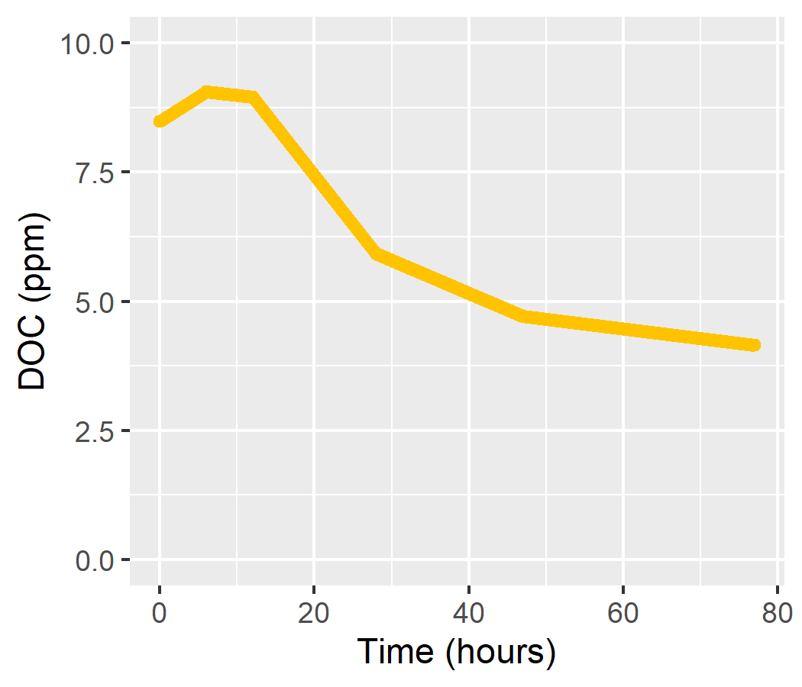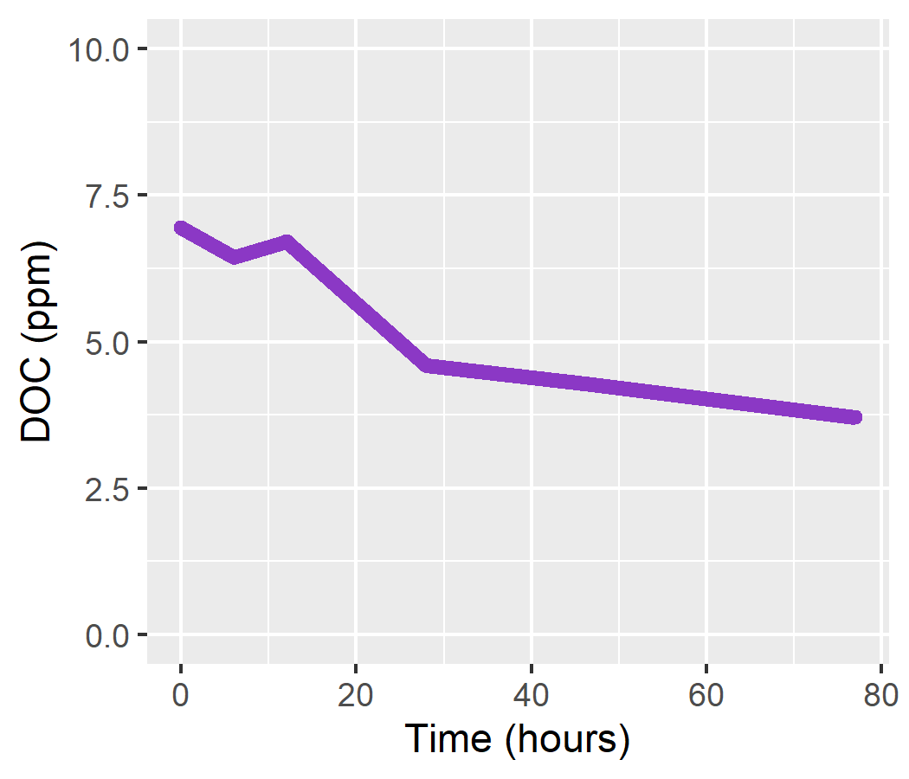
Pine Needles Grass Clippings

To conclude, this was an incredible research opportunity for me and offered a lot of experiences that will help prepare me for my future in geology. The results of my and Saige’s projects will hopefully be evidence in argument for environmental policy change within Albion’s quad and other urban environments. It will also be helpful to future research on DOC and the surface water-groundwater interface in the context of urban environments. With this work, we plan to present our findings at the Elkin-Isaac Research Symposium, as well as our Earth and Environment Department Colloquium. We have also submitted abstracts to present our research in poster format at the annual Geological Society of America conference in Portland, Oregon in October. This research will also be continued over the fall(?) by our faculty advisor Dr. Joseph Lee-Cullin. As a rising junior at Albion, this was a very valuable experience for me to try out lab work and learn about data analysis and using the program R. I will be taking these skills into my future years in geology research, which I hope to have a career in.
This project would not have been possible without all the support I received from others at Albion, and I would like to sincerely thank the FURSCA committee for organizing this summer program and funding this project, specifically the Julia Robinson Burd ‘31 Memorial Fellowship. I would also like to thank my research partner Saige Jost for all her help in conducting this research, as well as my mentor Dr. Joseph Lee-Cullin for guiding me in my project and helping me apply and learn so many new skills.

