End of Summer Report
Albion College
Aminaa Injinash and Seolah Kim
Our research aims to explore how ATM density affects the small business owner’s income in a cashless economy. In a cashless economy, the small businesses face the challenges of transforming into digitization in their daily activities. Using the ATM density as a measure of accessibility to cash, we study how an increase in ATM density affects the small business owner’s income..
We collected data of ATM locations using OpenStreetMap and combined it with the CPS data from 2013 to 2020. Our results showed that the number of ATMs has overall increased throughout these years. This noticeable change in ATM concentration means the usage of ATM becomes more available to people. Consequently, increase in ATM density leads to higher income for the owners.we find that its effect was stronger for the businesses which are restaurant-related and with less than 10 employees.

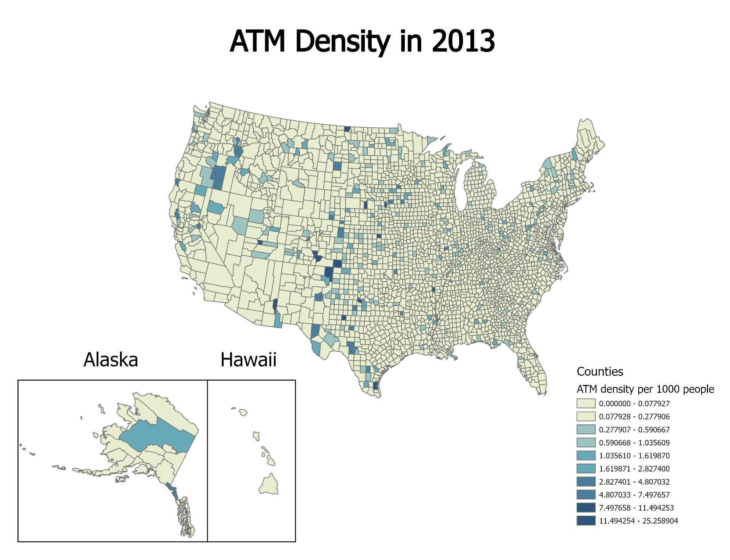
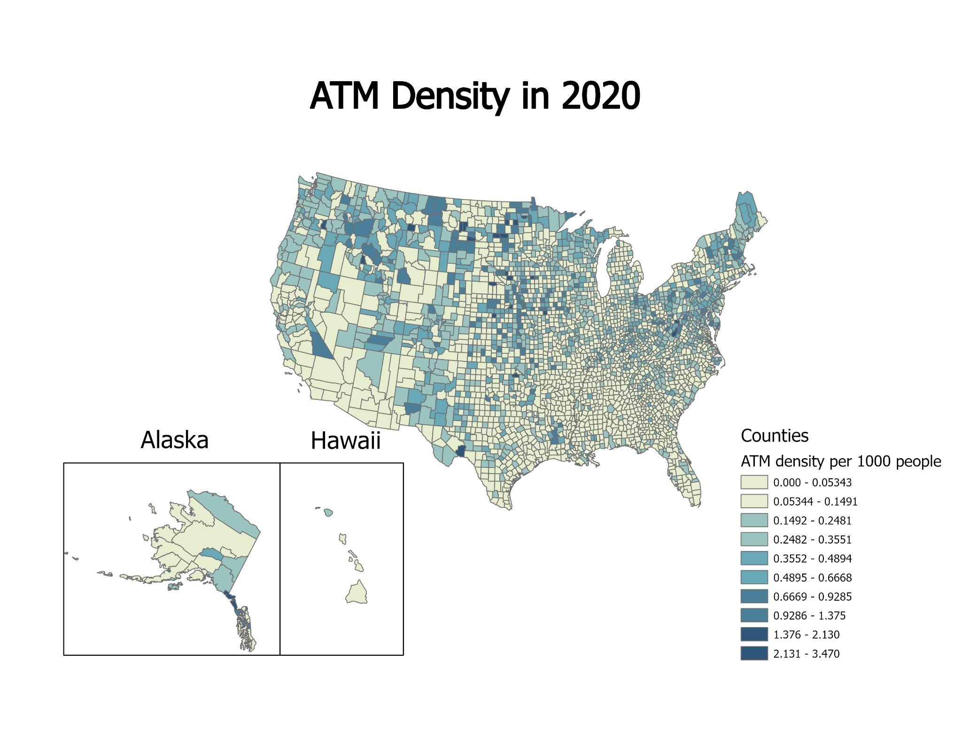

We present one of the result tables from the empirical strategy run in our research. Our analysis indicates that the ATM density impacts on the small business owners’ income proven in the following tables.

Table 1. General Regression for the real income of owners
 |  |  | Area
 | In general | Restaurant related businesses | Rural | Urban
 | (1) | (2) | (3) | (4)
ATM | 11.384*** | 25.526*** | -9.203 | 12.117***
 | (4.033) | (0.879) | (11.192) | (4.019)
N | 21690 | 852 | 368 | 21322
Notes: "* p<0.10 ** p<0.05 *** p<0.01
The validity of results can be determined by the parenthesis value which expresses the probability of errors. N illustrates the number of individuals.

The table presents the baseline results and Column 1 reports the result of variables we controlled. According to the baseline results, an additional ATM per 1000 people will increase the income of owners by $11,300 while it increases the income by $25,500 in column 2, where we limited a sample to the restaurant-related businesses. From these results, we can conclude that the businesses in the foodservice sector are highly affected by ATM density. The frequency of the purchases daily is relatively higher than other sectors, that food is ordered and paid by each customer/a group of customers. Most of the small businesses we collect are located in the urban area and the income of owners will increase by $12.1 with the increase of each ATM per 1000 people. All the results except, one with control in rural areas, are statistically significant at 1% significance level.

Although we find that the acceptance of cash leads to an increase in the owners income, adopting the digital payment methods can be inevitable in the near future. Given that smaller firms are more affected by the accessibility to cash, the relevant policies promoting digital payments can be implemented for those small business owners.
We thank Albion College’s Summer FURSCA Program and Vernon and Gladys B. Lawson Endowed Research Fellowship for funding this project.

