Name of applicant: Alexis Wilkerson
Date: August 5 2019
Graduation Year: 2021
Major: Biology & Religious Studies
Research Advisor: Ola Olapade
Advisor’s Department: Biology

This summer I explored the Comparison of Bacterial Occurrences and their Hydrolytic Enzyme Activities among Different Soil Types. My study was based on asking 3 different questions. The first one being what are the differences in the characteristics in different types of soil, in this case I explored 3 different soil types including loamy, sandy, and clayey. Soil is separated into classes or groups each having similar characteristics. These classifications are determined by water content, organic content, temperature and pH which are known to vary. I believed that if there were differences in their inherent characteristics, then there would be difference in biotic factors like bacteria. The second question I explored was “what are the differences in the abundance of bacteria in different soil types” I believed that if the bacteria numbers differed, the way they function on an enzymatic level would also vary. The third question was what are the differences in bacterial hydrolytic enzyme activity. The first question was addressed using organic matter content method or an organic matter analysis. The second question was addressed the viable count method, and a total count of all stained bacterial cells, the last question was addressed using a fluorescein diacetate analysis. By the end of the first week I created a standard curve to use for my results, I collected each type of soil in triplicate and sterilized all the materials I was planning to use. By the end of the second week I started my actual experiment as just a test run, there were a lot of errors that needed to be tweaked so I would be able to more forward. By the end of the third week I ran my first successful trial yielding results, since we wanted as much accuracy as possible we did the experiment in triplicates so the 4th and 5th week I ran trials 3 and 4.
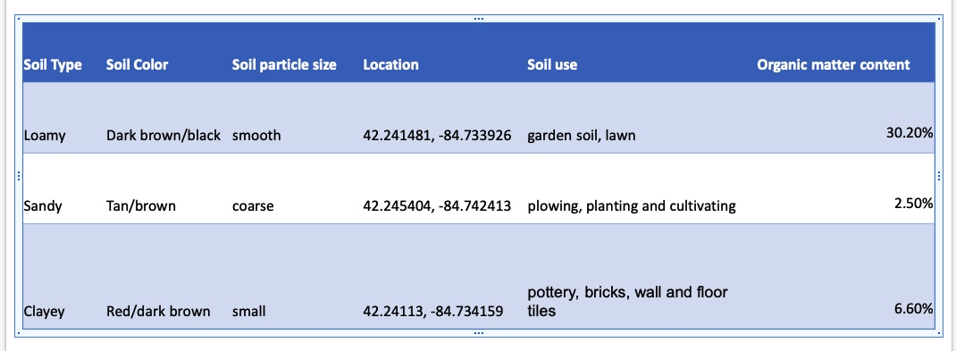

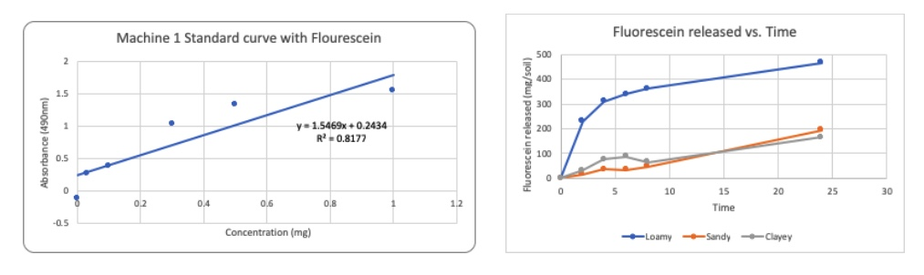
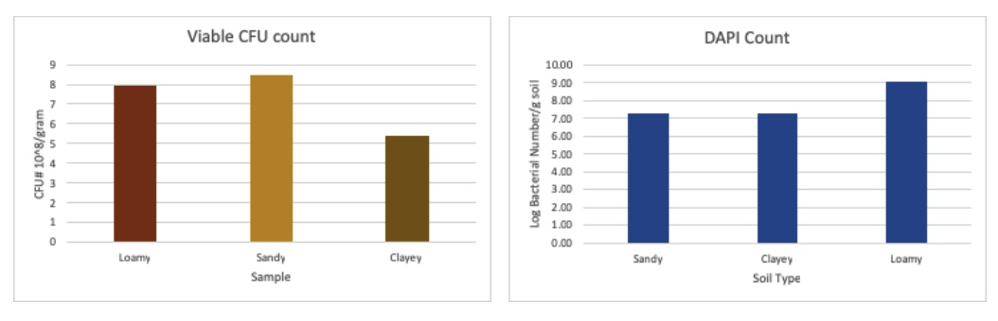

My final week on campus I presented my project and shared my findings, I found that Not all environments are the same in light of microbial populations, More activity in loamy soil compared to sandy and clayey soil, Organic matter content in soil is driving bacterial occurrences. I first got the opportunity to complete a FURSCA fellowship through Dr. O by taking a bio class with him when one day he asked me if I had anything planned for the summer and if I wanted to be on his research team, I quickly agreed and was very happy to try something new. Throughout the summer I learned to have a lot of patience when it comes to lab work. Things don't always go as expected and you don't always yield the results you need in the lab. I learned to work with others more fluently because I had to go into many different labs to use certain equipment, these labs were occupied with students working on their research. I would say the best part of the summer program was presenting my research to all the students and faculty involved in FURSCA. Being in the labs doing solo research was amazing and I learned so many new techniques that I will be able to use in future lab courses, I have learned new skills that I can take with me throughout my undergraduate and graduate careers.

I have always been a thinker but doing this research I had to come up with new ideas and new boundaries. Throughout my research I have gained a much larger understanding of what it means to actually create something and manage it effectively and efficiently. This research required me to spend long hours in the lab five days a week and yield results then share them with a group of people who were doing the same thing as me.
Now having done FURSCA I can say that I would be more than willing to do it again. As a biology major who wants to go on to graduate school learning lab skills and techniques is very important. My research through FURSCA has allowed me to gain so much more knowledge in the laboratory and has allowed me to think about how it will relate to everything I do in the future. I have learned to continuously ask “why?” on many different levels, I have expanded on so many levels, and I have been able to critically think and have results that I can say happened because of me. I am extremely proud of the work I did on campus this past summer and next summer, if given the opportunity, I challenge myself to dig deeper and explore more. I plan to write my senior thesis on the research I did, and to participate in the Elkin Isaac symposium in the spring of 2020.
I have always been a thinker but doing this research I had to come up with new ideas and new boundaries. Throughout my research I have gained a much larger understanding of what it means to actually create something and manage it effectively and efficiently. This research required me to spend long hours in the lab five days a week and yield results then share them with a group of people who were doing the same thing as me.

