July 23, 2021
Tanya Jagdish
Advisors: Dr. Yuming Zhang, Jason Raddatz
FURSCA - End of Summer Report
Identification of Plants in Aerial Images using Deep Learning
Introduction
Wild rice (Zizania spp.), also called manoomin in the Ojibwe language, is an annual plant that
grows in shallow water in small lakes and slow flowing rivers [1]. It is an ecologically important species that has a deep cultural significance to the Indigenous Odawa, Ojibwe, and Potawatomi Peoples. In the 18th century, wild rice was commonly found in most lakes and rivers east of the Mississippi River. Now it is restricted to areas in north Minnesota, Wisconsin, parts of Michigan and Canada [2]. We are fortunate to have one of the most historic wild rice beds in our own backyard at Albion College. These wild rice beds grow along Kalamazoo River running through the Whitehouse Nature Center. Unfortunately, these plants face many threats including loss of genetic diversity, habitat declines, competition from non-native species, warmer temperatures due to climate change, and pathogenic diseases like fungal brown spot [3].

Thus, environmental monitoring is essential to assess the state of an ecosystem, observe changes through time and space, and prevent irreversible damage. In the past, I have worked collaboratively with the members of the Match-e-be-nash-she-wish and the Nottawaseppi Huron Band of Potawatomi to monitor the growth of these wild rice beds manually. However, this is a long and cumbersome process. One needs to kayak along the length of the river to monitor and note the GPS locations of these beds. This typically takes an entire day and needs to be done on a weekly basis making it unfeasible in the long run.

This summer, I worked on automating wild rice monitoring using artificial intelligence technique. I used deep learning, a subset of artificial intelligence, to train a model to identify wild rice in aerial images. Specifically, I used U-Net, a state-of-the-art deep learning model for my project. Given both input and the expected output, it learns distinguishing features from the data, rather than these features being manually selected [4]. The deep learning models can accurately approximate the non-linear relationship between environmental parameters owing to multi-layer learning. Once the model is trained on selected data, it will learn to make predictions on unseen dataset.

The goals of my project were:

- To collect weekly aerial images of wild rice using a drone
- Create a training dataset for wild rice by creating masks for each image
- Become familiar with deep learning concepts and U-Net architecture
- Create a working model that identifies wild rice in an image
- Get FAA Drone Pilot certified

Results
Building my dataset
I collected more than 700 aerial images of the wild rice beds. I have completed annotating 70 images in total. I found the annotation process to be time consuming, taking about one hour to get through one image. An example of an image and accompanying mask can be found in Fig. 1. It was also difficult to recognize wild rice from the air during the initial growth stages. As the wild rice grows and approaches harvest season in September, it will become more prominent and easier to identify from air. Thus, I plan on continuing data collection until September, even after FURSCA ends.
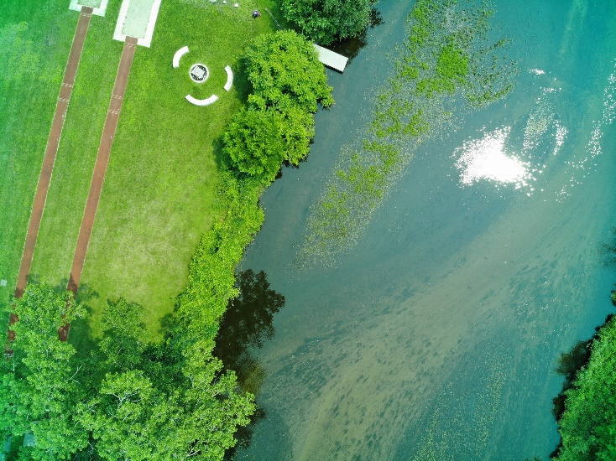 | 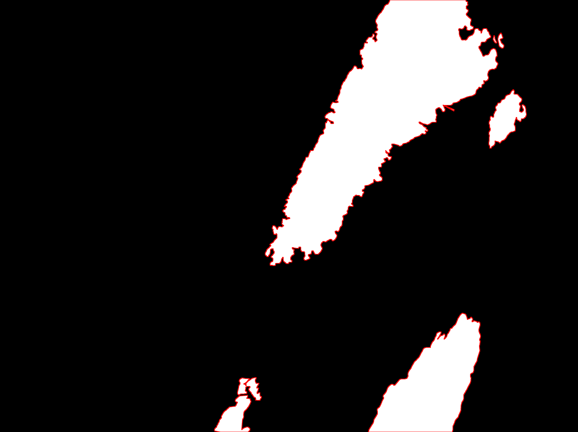
(a) |  | (b)
Figure 1. (a) Example of an aerial image of wild rice beds along Kalamazoo River; (b) true mask of image in (a).
Model
We ran both U-Net and Residual U-Net model on an open-source dataset of different breeds of cats and dogs from Oxford. We found the prediction accuracy of U-Net from training and validation data was around 96% and 88% respectively (Fig 2a). Whereas the prediction accuracy of Residual U-Net for training and validation data was around 94% and 89% respectively (Fig. 2b). Residual U-Net performed better on validation or unseen data and also reduced the overfitting problem.
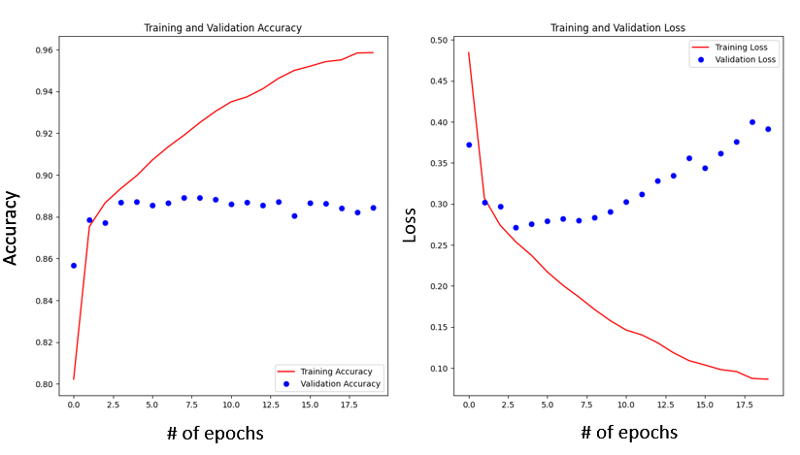
Figure 2. Accuracy and loss percentages of training and validation datasets in U-Net model.
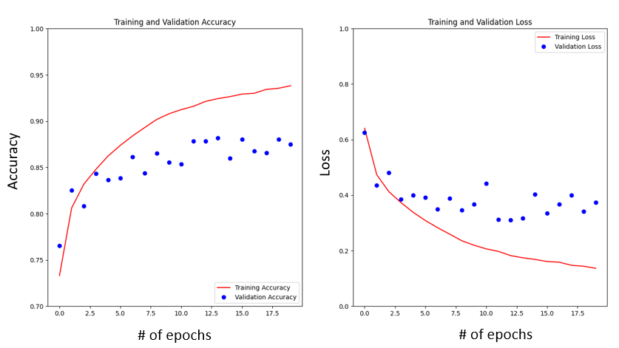Figure 3. Accuracy and loss percentages of training and validation datasets in Residual U-Net model.
Data Augmentation Techniques
Data augmentation is an important technique in machine learning used to increase the amount of training data by making changes to existing data. This is especially useful in small datasets such as the ones used in our project. We coded a few image augmentation techniques that randomly modified a certain percentage of our training dataset. A few techniques we used included random brightness, contrast, crop, rotation, flip, saturation, hue, and erase. Unfortunately, we did not see an increase in accuracy levels of our model. However, we made a key observation that augmentation techniques applied to a large proportion of the dataset increased our overfitting problem. This was an interesting finding that we hope to explore further next semester.
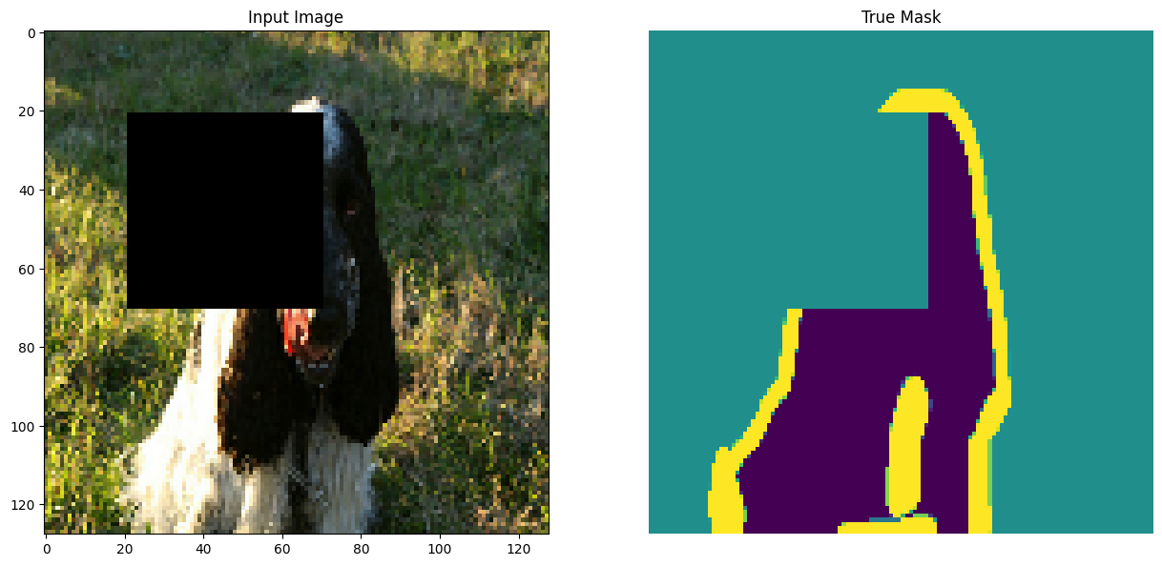
Figure 4. Example of Random Erase, a data augmentation technique that randomly erases a section of the image and mask. Notice that in the mask, this section becomes the background.
Conclusion
We were able to successfully run U-Net and Residual U-Net model on an open-source dataset of cats and dogs. We collected images of wild rice and have started to build our own dataset. I was also able to complete an online drone course, and will be taking my FAA Certification exam by the end of July 2021. My plan is to continue working on the project in the Fall as a directed study. Now that my advisor and I are comfortable working with the model, we hope to explore questions related to the architecture and data augmentation techniques in the future.
I am grateful to the Bruce A., '53 and Peggy Kresge, '53 Endowed Science Fellowship for funding my research. Over the last ten-weeks, I was able to immerse myself in coding and artificial intelligence concepts. As a non-computer science major, I wouldn’t have been able to complete this project in a regular semester. I found this project to be extremely challenging because I had to learn how to code in Python from scratch. With little prior knowledge about machine learning concepts, this project challenged me to go beyond my comfort zone. Now I can proudly claim that I am proficient in Python language. This is one of the first machine learning related research project at Albion College. As we launch a new data science program this Fall, I am hoping more students will be inspired to pursue research in machine learning and similar topics.

Bibliography

[1] R. Porter, “Wildrice (Zizania L.) in North America: Genetic Resources, Conservation, and Use,” in North American Crop Wild Relatives, Volume 2: Important Species, S. L. Greene, K. A. Williams, C. K. Khoury, M. B. Kantar, and L. F. Marek, Eds. Cham: Springer International Publishing, 2019, pp. 83–97. doi: 10.1007/978-3-319-97121-6_3.
[2] A. Zilberstein, “Inured to Empire: Wild Rice and Climate Change,” The William and Mary Quarterly, vol. 72, no. 1, pp. 127–158, 2015.
[3] D. D. Biesboer and D. D. Biesboer, “The Ecology and Conservation of Wild Rice, Zizania palustris L., in North America,” Acta Limnologica Brasiliensia, vol. 31, 2019, doi: 10.1590/s2179-975x2319.
[4] L. Zhang, L. Zhang, and B. Du, “Deep Learning for Remote Sensing Data: A Technical Tutorial on the State of the Art,” IEEE Geosci. Remote Sens. Mag., vol. 4, no. 2, pp. 22–40, Jun. 2016, doi: 10.1109/MGRS.2016.2540798.

