Antibiotics are a big part of medicine. It allows paper cuts and pneumonia to not become fatal. Despite the amount of antibiotics that are out there, there is an antibiotic apocalypse that will happen in 2050. This is because of antibiotic resistance. The rate at which bacteria can evolve and work around the antibiotics is a lot faster than the rate of new antibiotics that are produced. Therefore, a lot of the common bacteria our bodies experience when we get paper cuts or get a cold are now still living past the antibiotics our doctors hand us as the bacteria is used to it now. One of these antibiotics is called Vancomycin. It is a known antibiotic that has lasted a lot longer than most, however its ability to fight bacteria is wearing away.¹ That is why I decided to do FURSCA and synthesize the new version of bacteria against Vancomycin and find a new replacement.

A week into FURSCA, one of the major bumps in the road was that the necessary supplies to synthesize the bacteria was unavailable. With common materials that are easy to get were taking weeks to get delivered, my advisor and I realized we were not going to be able to get our materials we needed in time. However, in Dr. Streu’s lab, we are never working on just one thing so I resumed my project I had started this past spring semester.

Cancer is a disease that cost thousands of lives each year. With no cure as of now, improvement on treatments is imperative. Therefore, my goal changed to creating a cancer drug that has an on and off switch or photoswitchability. The purpose of this is to create a cancer treatment that is more effective than chemotherapy. Chemotherapy attacks the cancer cells as well as the healthy cells in patients. With a drug with photoswitchability, we would be able to turn it off when the patient takes it and then turn it on only in the area of the cancer. Thus only the cancer cells are only affected. I worked on producing more batches of it to do testing and other reactions with it to formulate a better drug.
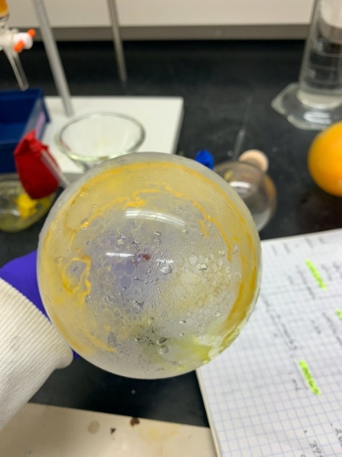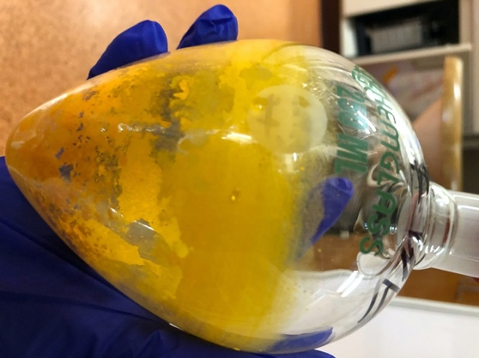

Not everyone has the chance to synthesize cancer drugs for 10 weeks in the summer. This project has had a profound effect on my fall plans in the lab and my interest in a career path. I came into Albion as someone who wants to go to medical school, however, now it has changed to graduate school. This experience is something I would like to share at the Elkin Isaac Symposium next year as well as the American Chemical Society Conference.

I would like to thank the Anna and Carl Weiskittel Endowed Chemistry Fellowship for giving me this opportunity and experience FURSCA. I would also like to thank Dave Carrey, the Albion College Chemistry and Biochemistry department, and FURSCA for this summer. I would not have been able to find my passion for biochemistry without you all.

References
_________________________________

¹ Orange Book: Approved Drug Products with Therapeutic Equivalence Evaluations Archived 2016-08-17 at the Wayback Machine

