End of Summer Report – Rebecca Wagener
Pre-Columbian Peruvian Artifacts in the Albion College Art Collection

Introduction
In 2019 twenty-seven Pre-Columbian Peruvian artifacts were donated to Albion College. The collection consists of 22 pottery pieces, two necklaces, a textile, needles with thread, and a reed and fabric doll. I selected nine of these artifacts to research this summer. The nine pieces are made of different materials and come from different Pre-Columbian cultures in Peru. The goal of my research was to learn more about the cultures from which these artifacts came and the role that these artifacts had in their societies, such as ritualistic, funerary, or every day purposes. When owning art from other cultures, especially from indigenous Pre-Columbian cultures, it is important to understand the cultural context and history. Through the information I brought to light, the College can better use these Peruvian objects to educate others. With mentoring from my advisor, Professor Bille Wickre, I conducted my research by reading books and articles about Pre-Columbian cultures of Peru, comparing the College’s artifacts to those in museum collections around the world visible online, and by interviewing the donor of these artifacts several times to hear about the history of the artifacts and her experiences living in Peru.

Results
This summer I was able to research and better understand the historical time periods and cultures that the artifacts come from. I will be continuing my research after the end of FURSCA and in the Fall semester. I have learned that the artifacts come from four Pre-Columbian cultures in Peru, the Chancay, Moche, Chimú/Inka, and the Wari and display over a thousand years of history in Peru. As I continue my research I will be focusing on the role of these artifacts in their cultures. This includes researching the methods used to create the artifacts and the significance of their stylistic characteristics. As FURSCA has come to an end, I have begun writing about my findings for each piece. One of the examples that I feel captures my goal of learning about cultural history, cultural significance, as well as knowledge of methodology and stylistic characteristics is the Inka-Chimú Paqcha. I included a short essay about this artifact below.

Ceramic Paqcha
Inka-Chimú Culture
1400-1500 A.D.
Approximately 8 7/8” L. 2 ½” w. 5” h. 8 3/8” c. at the head. 9 ¼” c. at the base.
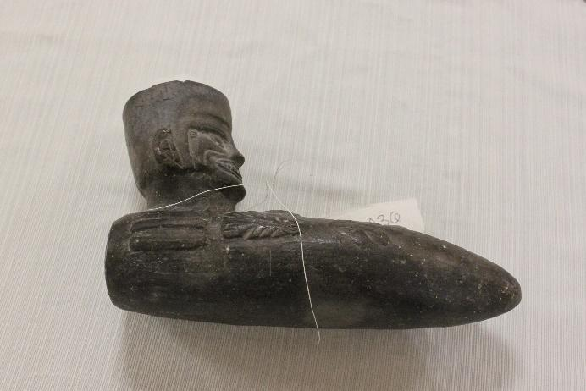
The Chimú were dominant in the Northern coast of Peru from approximately 850-1470 C.E. until being absorbed into the Inka Empire. The Paqcha is a wonderful example of how the Chimú and Inka culture came together in this time. The blending of culture is best displayed through the ceramics produced in this time period. Chimú ceramicists were prominent artists in the Inka Empire, and maintained traditional Chimú ceramic styles in their work. This includes using the reduction atmosphere firing methods to achieve the monochrome black color. The dark grey-black color of the ceramic is a distinctive style of the Chimú. The Paqcha is a ritual vessel associated with the Inka Empire. The Paqcha is shaped like an agricultural digging implement but would be used for fertility rituals. Chicha, a maize beer common in the Andes, would have been poured in where the head is on this example. There is a small hole at the pointed opposite end where the Chicha would flow out during the ritual. This Paqcha is decorated with reliefs depicting fishing on rafts made of totora reeds. This is an example of the blending of Chimú and Inka culture. The Inka Empire primarily based the economy on agriculture. However, being a coastal culture, the Chimú had a strong reliance on fishing. While the Paqcha is used for Inka agricultural rituals, in this example it combines agriculture and fishing. These are the two most important economic factors in this region of the Inka Empire. In addition, this Paqcha is created by a Chimú ceramicist who used the traditional Chimú ceramic style. Overall, this Paqcha is an excellent example of the blending of two Pre-Columbian cultures and traditions.

Conclusions
My project has been extremely important to my future. It has helped to reaffirm that in the future I want to continue archaeological and art historical research similar to my project. In the upcoming year, I plan to write a thesis about the Chancay culture and the artifacts from their culture. Due to the size and diversity of the collection, there are many opportunities for other students to continue research about the artifacts, and an array of topics to write about for other theses. I will be continuing my research after FURSCA and through the next semester. I also intend to present my project at the Elkin Isaac Student Research Symposium. The information gained from this project can also be used in future classes at Albion and to educate future students. In the upcoming semester I plan to create an online exhibition displaying the artifacts, now with the appropriate cultural context. Personally, I have improved my researching and interviewing skills, which will help me significantly in the future. I have also expanded my knowledge of the Pre-Columbian cultures of Peru. There is a complex history spanning thousands of years in Peru before the Inka and arrival of Spanish conquistadors. Pre-Inka cultures were often not as wealthy in gold and silver, not as populous, nor as militarily powerful, so they were not important or interesting to European conquerors and subsequent archaeologists. Nevertheless, they were civilizations with sophisticated fishing, farming and trading economies, complex religions, and rich cultural lives. It has been important to me to learn about the smaller Peruvian cultures that have been historically researched less, because unfortunately the histories of many Pre-Columbian cultures have not been taught to students and the general population. Because these cultures did not have a written language and European conquerors did not keep careful records of the cultures, the art sometimes offers the best look at the historically underrepresented cultures of the Ancient Andes. This project was a wonderful opportunity to work with the process of revealing the cultures of the lesser known Peruvian societies through art.
In addition to researching these artifacts, I have also explored the question of ownership of indigenous art and artifacts. It is important when owning artifacts like these to also question the ethics of doing so. This has played a big role in my research, as many large collections of Pre-Columbian Peruvian art I used for research exist outside of Peru. As owners of these artifacts, it is highly important that Albion College has an appreciation and understanding of the cultures and their impact on the world’s history.
I would like to thank Vanessa McCaffrey, Renee Kreger, and FURSCA for giving me the opportunity to pursue this research. I would also like to thank the Lawrence B., '72 and Frances Schook Research Fund in FURSCA for funding and supporting my project. In addition, I would like to thank Maureen O’Ryan, the donor of these artifacts, for making the generous gift of these items and then for allowing me to interview her on several occasions. Thank you very much to my advisor Bille Wickre for all of the support and guidance throughout this project and leading up to this summer. It has been an incredible opportunity and I have learned so much from my research, thank you all.

