Enisa Muhaxhiri
FURSCA Summer Report
07/23/2021

Electrocatalytic Decarboxylation of Amino Acids using Ruthenium of Activated Carbon Cloth (Ru/ACC)

Abstract: This research focuses on the development and the study of a heterogeneous catalyst, Ruthenium on Activated Carbon Cloth (Ru/ACC) to effectively decarboxylate several amino acids into amines. The process of decarboxylation is the removal of the carboxyl group from a compound, in this case, amino acids. Amines are used as solvents and also serve as building blocks in drugs and chemical synthesis. This project is designed to use water as a solvent and electricity as a chemical reagent. The process of decarboxylation happens as a result of the catalyst (Ru/ACC) removing electrons from the carboxyl group of the amino acid in a dilute phosphoric solution. The carboxyl group is then removed to form CO₂, which bubbles out of the solution. Samples of the reaction solution are collected and NMR is used for observational analysis.
Introduction:
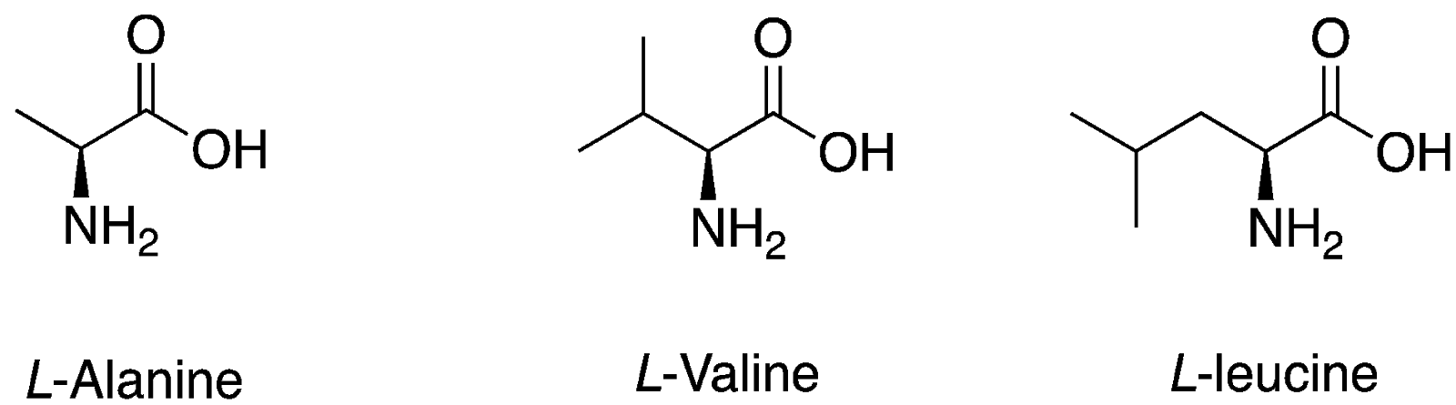
The preliminary work for this research entails the use of electricity in order to convert first, alanine to ethyl amine and later converting different amino acids such as valine to isopropylamine and leucine to 3-methylbutylamine (Fig.1). These amines are common amine chemicals that are used in chemistry labs and other industries for pharmaceutical drug development. Alanine is the second smallest amino acid, which is also followed by valine and leucine. These amino acids will be used for the experiment due to the simplicity of the structures.

Figure 1. Structures of the amino acids used in this research.

The first step was to prepare the Ruthenium on Activated Carbon Cloth. The Ru will be prepared by reducing Ru (III) to Ru (0), and then trapped/ deposited on the ACC. The ACC is a highly efficient material for absorption and electricity conductivity. This process initially includes soaking the cloth into a solution of ruthenium and ammonium hydroxide. The study of the decarboxylation process of these amino acids mentioned earlier, will be explored along with the stability of the catalyst. Variables such as temperature, voltage and amino acid concentration have been studied to develop effective and optimized conditions for the process of decarboxylation. Control experiments, such as temperature change, using ACC without Ruthenium instead of platinum wire, and changing the current have been studied.

Background Information:
Electrochemical decarboxylation is a more cost effective and eco-friendly method of decarboxylation when compared to other methods. Decarboxylation of amino acids can be achieved through various methods such as enzymatic and chemical decarboxylation (Figure 2).
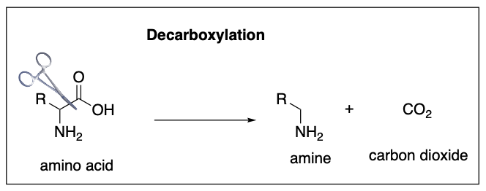

Figure 2. Decarboxylation Reaction.

Another well-known method for decarboxylation is also through fermentation which uses enzymes as catalysts. Although these different methods are effective, they are very costly because they require the use of expensive chemicals or enzymes to achieve decarboxylation. Thus, using electrochemistry is more eco-friendly since water is used as a solvent and electricity is pure. Amino acids are organic compounds, which are the main components of proteins. The decarboxylation of amino acids results in the formation of amines. Amine compounds consist of nitrogen, carbon and hydrogen atoms. They are traditionally derived from ammonia and hydrocarbons synthesis. They are also used as starting materials in drug development, solvent for chemical synthesis as well as the development of materials that have absorbent properties. Oxidative decarboxylation of amino acids is the process of oxidizing a carboxyl group of the amino acids to form CO₂ and an amine as a possible product (Figure 2).
Electrochemistry has been applied as a method for synthesis of organic compounds as early as the 19th century, but not a lot is known about the application of in the process of decarboxylation of amino acids.

Methodology:
The reaction was set up with an undivided electrochemical cell. In order to determine the reaction rates, samples were collected from 0 hour and repeated every 2 hours for a period of 8 hours, followed by a last 24 hour sample for each experiment. These samples were analyzed via proton NMR. The current was set at 70mA at 70℃ as the initial optimized conditions for the reaction. The current needed adjusting every 15 minutes but remained between 65-75mA. The samples collected were measured to be 0.5mL, and they were acidified using 3 drops of concentrated H-Cl, and allowed to dry under a drying system created by a tube connected to the air system in the hood. After the samples were dried to a salt, the solvent used for NMR analysis was D₂O containing 20 mM dioxane as interval standard was added to the vial, and the solution was transferred to NMR tubes, which were taken to the NMR machine to be analyzed.

Catalyst Preparation:
The catalyst was prepared by making a solution of Hexaammineruthenium(III) chloride. In an H-cell, 1600μL were added to the cathode side of the cell, as well as 0.2M HCl solution.Activated carbon cloth is also placed on the cathode side of the cell . The anode side contained platinum wire as well as a 0.2M carbonate buffer (Figure 3).

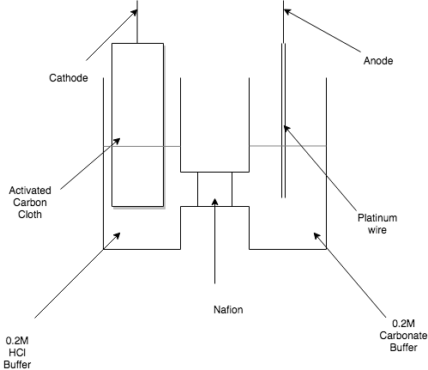
Figure 3. Preparation of the catalyst in a divided cell.

The HCl solution was prepared using 16.6 mL of concentrated HCl, and deionized water was added to the 1L mark of the volumetric flask, and the carbonate buffer was made by combining 2.10g of sodium bicarbonate (NaHCO₃) and 18.54g of sodium carbonate (Na₂CO₃). The solution was then filled with deionized water to the 1L mark of the volumetric flask. The reaction was run for 30-45 minutes, at 70℃ and 150mA, where visibly ruthenium went through the stages of reducing from salt to metal (Figure 4-7). When the reaction was finished, the carbon cloth had a grey, shiny coating on top of its usual black color.

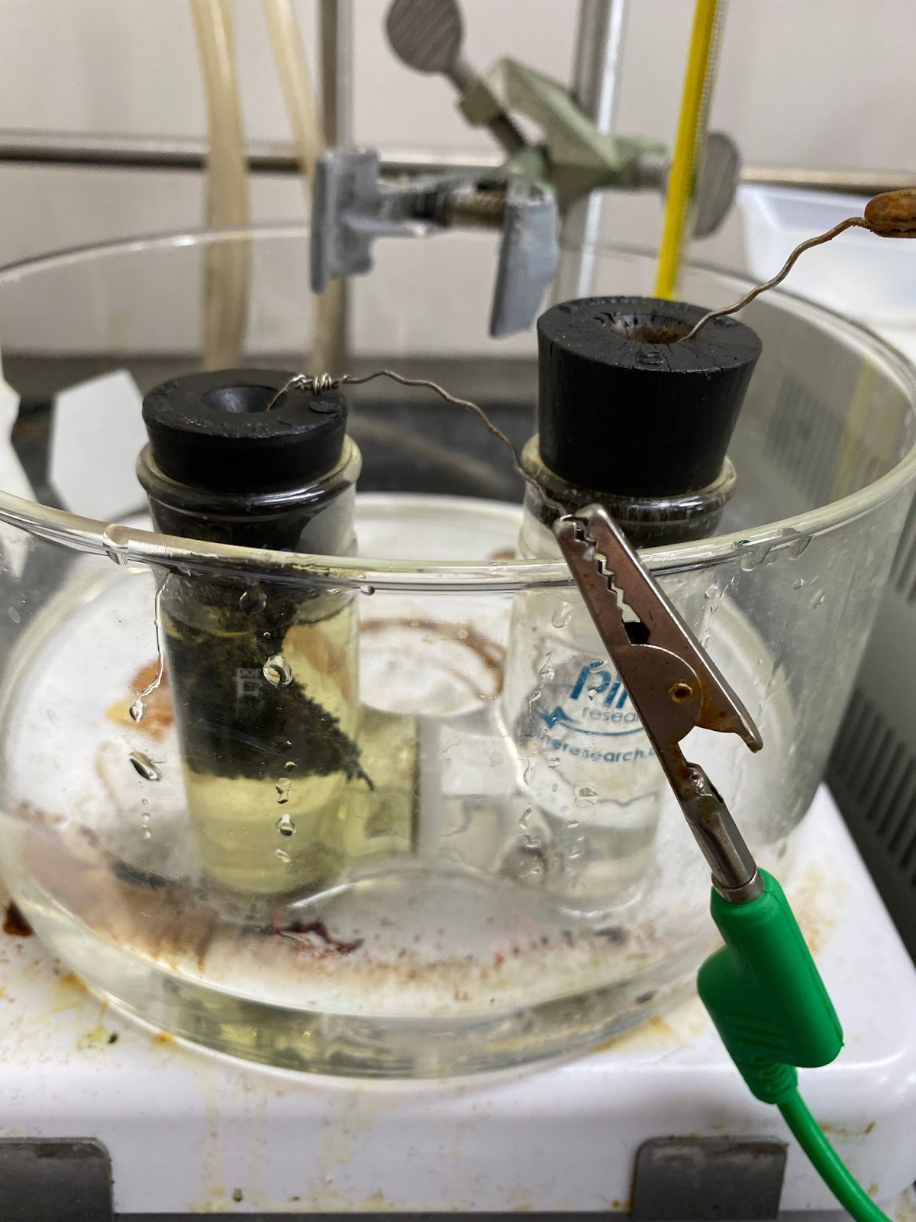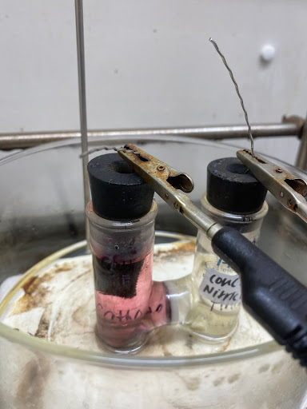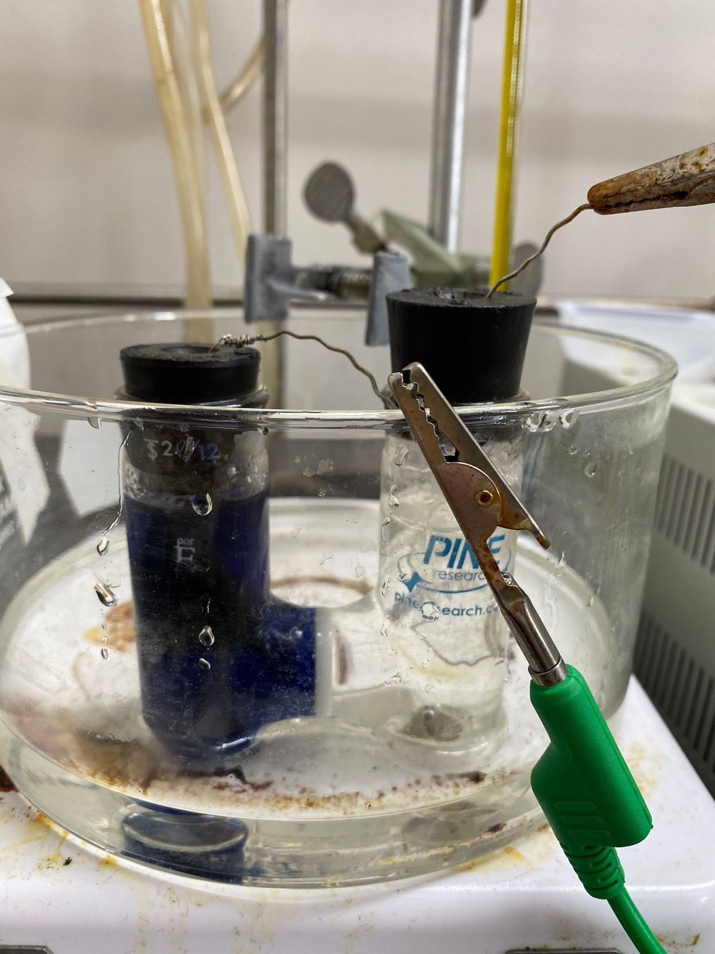
Figure 4. Ru (III). Figure 5. Ru (II). Figure 6. Ru (I).
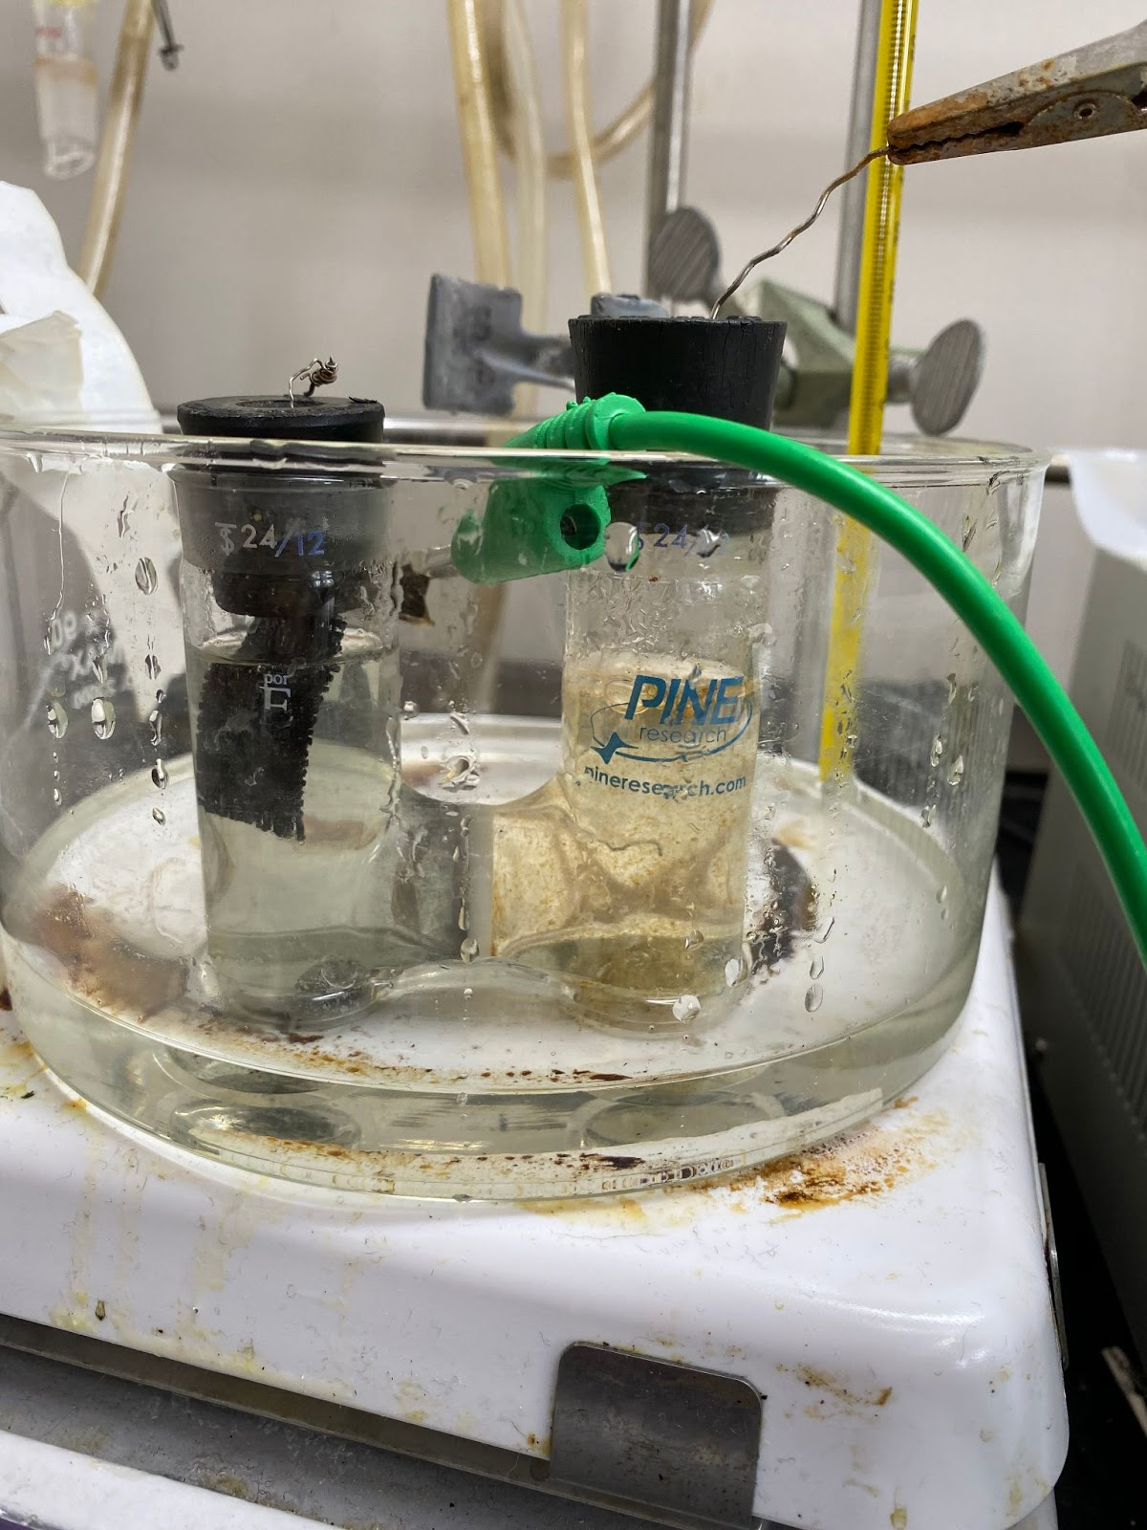
Figure 7. Ru (0).

Reaction Procedure:
- Supplies were set up in a fume hood. Those supplies included the electricity meter, a power supply, and a round bottom flask with two neck openings (Figure 8).
- A phosphoric acid solution was prepared to use for the reaction. This buffer has a concentration of 0.036M, and it was made by measuring out 0.243mL of concentrated phosphoric acid, and adding deionized water to the 1L mark. Following 30mL of this buffer were measured and added to the round bottom flask.
- 0.0534g of alanine or 0.0703g of valine (depending on the progression of the research), was added to the round bottom flask , and without electricity, after the amino acid is dissolved, a sample was collected and acidified, using the above procedure.
- The Ru impregnated ACC is connected to the anode wire, and the platinum wire was connected to the cathode wire.
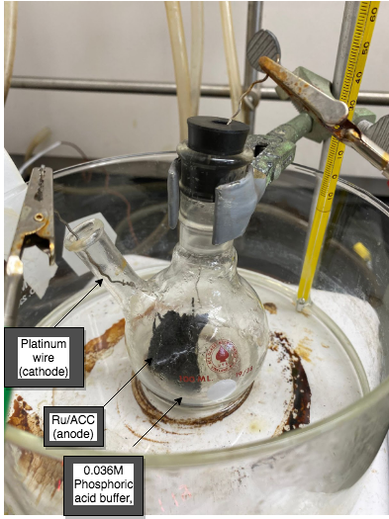
- Power supply was turned on, and the current was turned to 100mA, and samples were taken every 2 hours for an 8 hour period, and one last sample was collected at the 24 hour mark of the reaction. Those samples were acidified using concentrated HCl, and once dry they were prepared for the NMR by using a D2O solution for it. Samples were analyzed via proton NMR.

Figure 8. Set up for the Decarboxylation Reaction.

Results:
The NMR results of each reaction will be added once a software to open the files has been found. Experiments 1 through 16 were conducted. Experiments 1 through 7, were control experiments for the decarboxylation of alanine.Those procedures included condition changes such as temperature and current in order to conclude that the established conditions (at the start time being 70*C and 70mA) for our experiment, were the right for a successful decarboxylation.

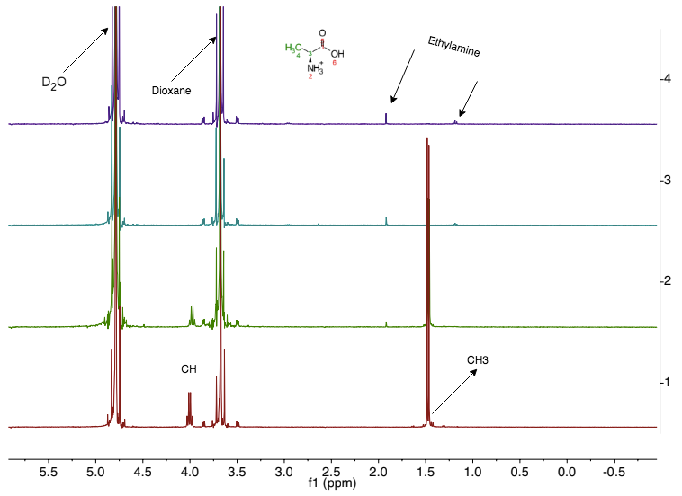
Figure 9. Example of NMR results from a successful decarboxylation of alanine (Reaction 1)

Experiment 1:
For this experiment, the conditions established were 70*C and using a current of 70mA to run the experiment. During this experiment samples A, B, C, D and E were taken. Samples 1 through D were taken approximately every two hours and sample E was taken at the 24 hour mark. The results of this experiment showed that decarboxylation had been completed by hour 18, but since samples were not taken consistently and exactly every two hours, it was not possible to establish exactly when decarboxylation was completed (Figure 9).
Experiment 2:
For this experiment, the same parameters and conditions were used as in Experiment 1 (70*C at 70mA). Samples A, B, C, D, E and F were collected. This time during the experiment samples were collected exactly every two hours (A-E) and sample F was collected at the 24 hour mark of the reaction. After analyzing the NMR results from our samples, it was concluded that yes there was amine product formation and decarboxylation was taking place, but the reaction was not fully completed. After thinking about reasons possible as to why this could happen, considering that Experiment 1, had completed decarboxylation by hour 18, it was concluded that one of the reasons that this could happen was because the surface amount of the ACC was soaked into the solution during the reaction.
Experiment 3:
The conditions used for this experiment were 70*C at 35mA. Just like the previous experiment, samples A, B, C, D, E and F were taken. Samples A-E were collected every 2 hours over an 8 hour period, and sample F was collected at the 24 hour mark of the experiment. The NMR results for this experiment showed that the rate of the reaction was slow. Decarboxylation did occur, but it was not completed after 24 hours, making 70mA still the ideal condition for decarboxylation within 24 hours.
Experiment 4:
For this experiment, it was decided to lower the current used even more. This time the established conditions for the experiment were 10mA at 70*C. Just like previous experiments samples A, B, C, D, E, and F were collected, where samples A-E were collected every two hours over an 8 hour period, and sample F was collected at the 24 hour mark of the experiment. The NMR results of this experiment showed that decarboxylation was taking place, but the rate of the reaction was even lower than Experiment 3, again showing us that higher current leads to a higher rate of reaction.
Experiment 5:
For reaction 5, a different road was taken. For this experiment the conditions for the reaction were 100mA at 70*C. Samples A, B, C, D, and E were collected, where samples A-D were collected every two hours, and sample E was collected at the 24 hour mark of the reaction. This experiment was what changed the optimal conditions for decarboxylation, since when analyzing the NMR data received, decarboxylation had been completed by hour 6, making 100mA the ideal condition for establishing a quick and successful decarboxylation.
Experiment 6:
For this experiment, the current was kept at 100mA and temperature was the parameter that was changed. No heat was applied during this experiment, so the temperature of the reaction was room temperature. During this experiment samples A, B, C, D, E and F were collected, where samples A-E were collected every two hours over an 8 hour period and sample F was collected at the 24 hour mark of the experiment. The NMR results showed that once again the reaction occurred, but the rate of the reaction was lower.
Experiment 7:
For this experiment the conditions were 100mA at 70*C, but the condition that changed was replacing the Platinum wire with plain ACC. Samples A, B and C were collected. This experiment was only run for 4 hours due to the fact that the plain ACC had absorbed the solution in the beaker.
Experiments 8 and 9:
Since the optimal conditions for alanine decarboxylation were established, these two experiments employ the use of valine to decarboxylate. The conditions for this experiment were 100mA at 70*C. Samples A, B, C, D, and E were taken for both experiments. These two experiments were only run for 8 hours. Samples from both these experiments were analyzed using Proton NMR, and the results showed that there was product formation, but decarboxylation was not completed.
Experiment 10:
For this experiment, valine was used for the purposes of decarboxylation once again, but since the first experiments were only run for 8 hours, this experiment was run for 24 hours. The optimized conditions, just as the previous experiments were 100 mA at a temperature of 70*C. Samples were collected every 2 hours, with one last sample at the 24 hour mark. The samples were analyzed using a Proton NMR, and the results showed that the reaction was occurring but the reaction was still not fully completed.
Experiment 11:
Experiment 11 employed all the same optimized conditions as the previous experiments (70*C at 100 mA as the current), but for this experiment, instead of using valine or alanine, leucine was used for decarboxylation. This reaction was run for 24 hours, while samples were collected every 2 hours, with the last sample being taken at the 24 hour mark. Those samples were analyzed using Proton NMR, and those results showed that once again the reaction was occurring, but even after the 24 hour mark it was not fully completed.
Experiment 12:
For Experiment 12, decarboxylation of valine was repeated one more time over the course of a 24 hour period. The optimized conditions for this reaction remained the same at 70*C with a current of 100 mA. Samples were once again collected every 2 hours, with the last sample being at the 24 hour mark. The Proton NMR results of this reaction showed once again that decarboxylation was occurring, but it was not fully completed.
Conclusion:
The goal for this research was to find a cost effective and green way to decarboxylate amino acids into amines using water as a solvent and electricity. Research started with the decarboxylation of alanine, and finding the perfect conditions for the reaction to occur. Throughout this process, we were able to successfully decarboxylate alanine under the conditions of 70*C with a current of 100 mA, with a solution of Phosphoric Acid. While alanine was successfully decarboxylated, other amino acids such as valine and leucine showed how different amino acids react under the same reaction conditions for decarboxylation. While alanine was able to completely decarboxylate, valine and leucine were going through the same process, under the same conditions, but instead took a longer time to complete the decarboxylation. These two amino acids also had a harder time dissolving in the Phosphoric acid solution when compared to alanine. The next step in this research is to see how the addition of other chemicals to the Phosphoric acid solution will affect the reaction. The chemicals we are planning to use are isopropyl, ethanol as well as formaldehyde.

References:
Appiagyei, B., Bhatia, S., Keeney, G. L., Dolmetsch, T., & Jackson, J. E. (2020). Electro Activated alkylation of amines with alcohols via both direct and indirect borrowing hydrogen mechanisms. Green Chemistry, 22(3), 860–869. doi:10.1039/c9gc03747k
2. Evan J. Horn, Brandon R. Rosen, and Phil S. Baran ACS Central Science 2016 2 (5), 302-308 DOI: 10.1021/acscentsci.6b00091
3. Pancaldi, Giuliano (2003). Volta, Science and Culture in the Age of Enlightenment. Princeton Univ. Press. ISBN 978-0-691-12226-7
4. Klüh, D.; Waldmüller, W.; Gaderer, M. Kolbe Electrolysis for the Conversion of Carboxylic Acids to Valuable Products—A Process Design Study. Clean Technol. 2021, 3, 1–18. https://doi.org/10.3390/cleantechnol 3010001
5. Bu, F., Lu, L., Wang, S., & Lei, A. (2020). Electrochemical oxidative decarboxylation and 1,2-aryl migration towards the synthesis of 1,2-diaryl ethers. Chemical Science, 11(36), 1000-1004. doi: https://doi.org/10.1039/D0SC03708G
6. Marangoni, D. G., Wylie, I. G. N. & Roscoe, S. G. Surface electrochemistry of the oxidation reactions of α- and β-alanine at a platinum electrode. Bioelectrochemistry Bioenerg. 25, 269–284 (1991).
7. Barton, D. H. R., Crich, D. & Motherwell, W. B. New and improved methods for the radical decarboxylation of acids. J. Chem. Soc. Chem. Commun. 939 (1983). doi:10.1039/c39830000939

