Phuong Anh Dinh
Supervisor: Dr. Saville
August 26th, 2019

END OF SUMMER REPORT

Introduction

For many years, Drosophila melanogaster has served as a standard model to study genes, their expressions, and regulations. It has several outstanding advantages such as short life-span, fecundity, small sizes, etc. Also, many of the genes of Drosophila have counterparts in mammals and humans. Surprisingly, D. melanogaster also exhibits some behaviors similar to that of drug addiction in human. For example, they have been found to consume ethanol voluntarily and increasingly over time, overcome unpleasant feelings such as bitterness to consume ethanol, or display relapse-like effect after ethanol deprivation¹. The study of genetic rationale behind alcohol sensitivity in Drosophila melanogaster, hence, may shed light on drug addiction study in human.
In their natural habitats, D. melanogaster uses alcohol from fermented fruits as an effective energy source. In order to extract energy from such source, an ethanol degradation pathway with several steps needs to be carried out. The alcohol dehydrogenase coded by Adh gene is the enzyme that catalyzes for the first reaction in that pathway. The Adh gene has its wild-type allele Adh⁺ coding for normal-functioning enzymes and different mutant forms such as Adh^{n1}, Adh^{n4}, Adh^{n7}, etc. Here, in this investigation, I will investigate the Adh^{n1} and Adh^{n4} forms. While Adh^{n1} is a missense mutation substituting a G for an A at the position 1120 of the Adh gene (G1120A) leading to the Gly93Glu amino acid replacement in the translated polypeptide, Adh^{n4} contains a nonsense mutation (C312T) that causes the absence of PvuII site in DNA region corresponding to exon 2 and the shortening of the translated polypeptide². This allows the detection of this mutation using molecular techniques. In both cases, the activity of alcohol dehydrogenase enzyme is affected. Consequently, it is expected that the alcohol sensitivity of genetically different flies are different.
My investigation comprises three main experiments, exploring differences in three different stages: genetic materials, enzymes’ activity, and expressed phenotypes. Specifically, I have used PCR combined with PvuII restriction enzyme and gel electrophoresis for genetic analysis, the ADH Enzyme Assay developed by Department of Biochemistry at the University of Buffalo for enzyme activity test and a climbing assay for examination of the alcohol sensitivity in 3 different strains of flies.

Methods and Results:
For genetic level experiment, three different fly strains were grown in different vials, and DNA from them were extracted separately. After specific primers for the Adh gene were added, PCR was performed. PCR products were added with PvuII enzyme and appropriate buffer, incubated for 1 hour, and finally used for gel electrophoresis. Because Adh⁺ and Adh^{n1} has the PvuII site, each of their PCR products will be cut into two smaller fragments which are very similar in size (about 20 base pairs in difference only). The Adh^{n4} does not have this site and thus, its gel electrophoresis should only have one big band. The result is shown below.
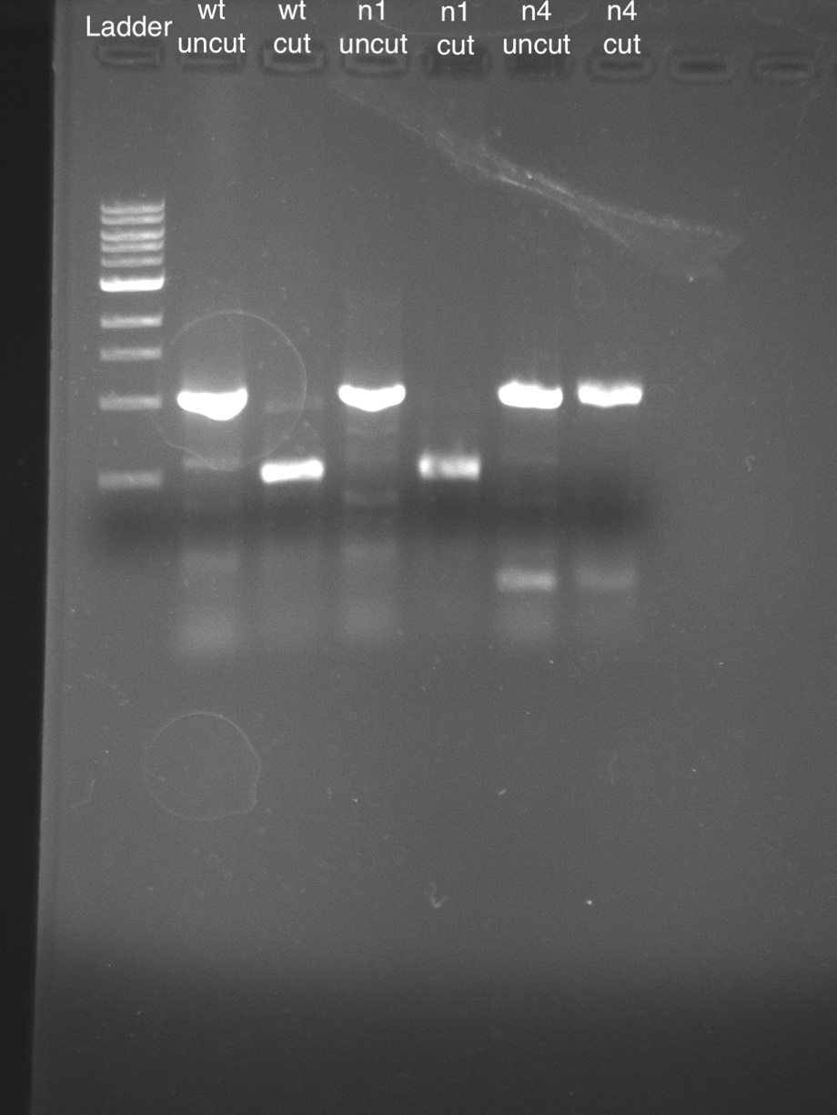
Figure 1: Gel electrophoresis result of Adh⁺ ,Adh^{n1} and Adh^{n4}.

Due to the characteristics of the 1% agarose gel used, two smaller fragments resulting from PvuII digestions of Adh⁺ and Adh^{n1} which were about 20 bps in difference cannot be seen as 2 distinguish bands. Indeed, they appeared as a single band with the relative size of about half of the uncut PCR products. With Adh^{n4}, there is no difference between the cut and uncut PCR products. This experiment examined the difference between Adh⁺ and Adh^{n4} but could not confirm the mutant form of Adh^{n1} flies.
For the protein level experiment, after protein were extracted from each type of fly, two assays were performed to measure the protein concentration and the Adh activity of the solution. Specific Adh activity was then obtained by taking the Adh activity divided by the protein concentration.

Figure 2: Specific Adh activity of Adh⁺ ,Adh^{n1} and Adh^{n4}.

The T-test showed that the difference between Adh⁺ and Adh^{n4} was significant but the difference between Adh⁺ and Adh^{n1} was not significant. This contradicted to the expectation that Adh⁺ should have the highest specific Adh activity while Adh^{n1} and Adh^{n4} should have about the same and are way lower than that of Adh⁺.
Lastly for the pheotype, flies of different strains were transferred to empty vials and knocked down to the bottom. While sober flies naturally start crawling up, those that are affected by ethanol will remain immobile at the bottom of vials. Hence, to measure ethanol sensitivity of flies, I added ethanol to the button on top, tapped vials to knock flies down, and counted number of flies that got knocked down over time. The result shown below showed that Adh^{n4} were more sensitive to ethanol whereas the Adh⁺ and Adh^{n1} were somewhat similar.

Figure 3: Number of flies that got knocked down over time of Adh⁺ ,Adh^{n1} and Adh^{n4} strains.

These results suggested that the Adh^{n1} flies that we are currently having in lab is not the mutant one. To further confirm this hypothesis, the cloning kit using pMiniT 2.0 vector has been used to clone the Adh gene of three different fly strains and the products was sent to be sequenced. After processing the returned sequences, we confirmed that the current Adh^{n1} flies in lab is not the mutant one.

Personally, I would like to express my deepest thank to the Hyde Fellows fund and donors for making this research opportunity available for me – an international freshman at Albion College. Not only have I had the chance to do research right at my first summer in college but also gotten the chance to work with my amazing supervisor – Dr. Saville – and learnt so many new things and lab techniques. This experience will be invaluable as it fortifies my application for future research programs and also graduate schools.

