FURSCA End of Summer Report
Joshua S. Luurtsema

The research I was conducting this summer was on fossil turtles from the Eocene Epoch of Wyoming. Specifically, I was working through specimens from the collections of Albion College, University of Michigan, and Duke University. The research of these specimens over the summer included mostly reading of literature on the identifying characteristics of the relevant groups of turtles, and the piecing together of their fragmented remains. The results at the conclusion of this research would include identification of the specimens, as well as providing information about the environments and niches these turtles were occupying over time through the Eocene Epoch.
Due to the large scope of this research (unlike recent preceding research, it did not focus on one group of turtles, but all turtles from the Eocene of Wyoming), the project has not yet reached its conclusion. What was accomplished this summer was the reconstruction and identification of specimens from three of the five families of turtles being researched.
The slow crawl through turtle literature took significantly longer than originally planned, with some of the papers and books being written in the early 1800s (before many words had their contemporary spellings). This was further complicated by disagreements between paleontologists on species-level identification and classification of certain turtles, making the entire process take longer than a simple read through. Ultimately, many of my classification decisions were grounded on the consistency of multiple characteristics appearing together on the specimens I was working on.
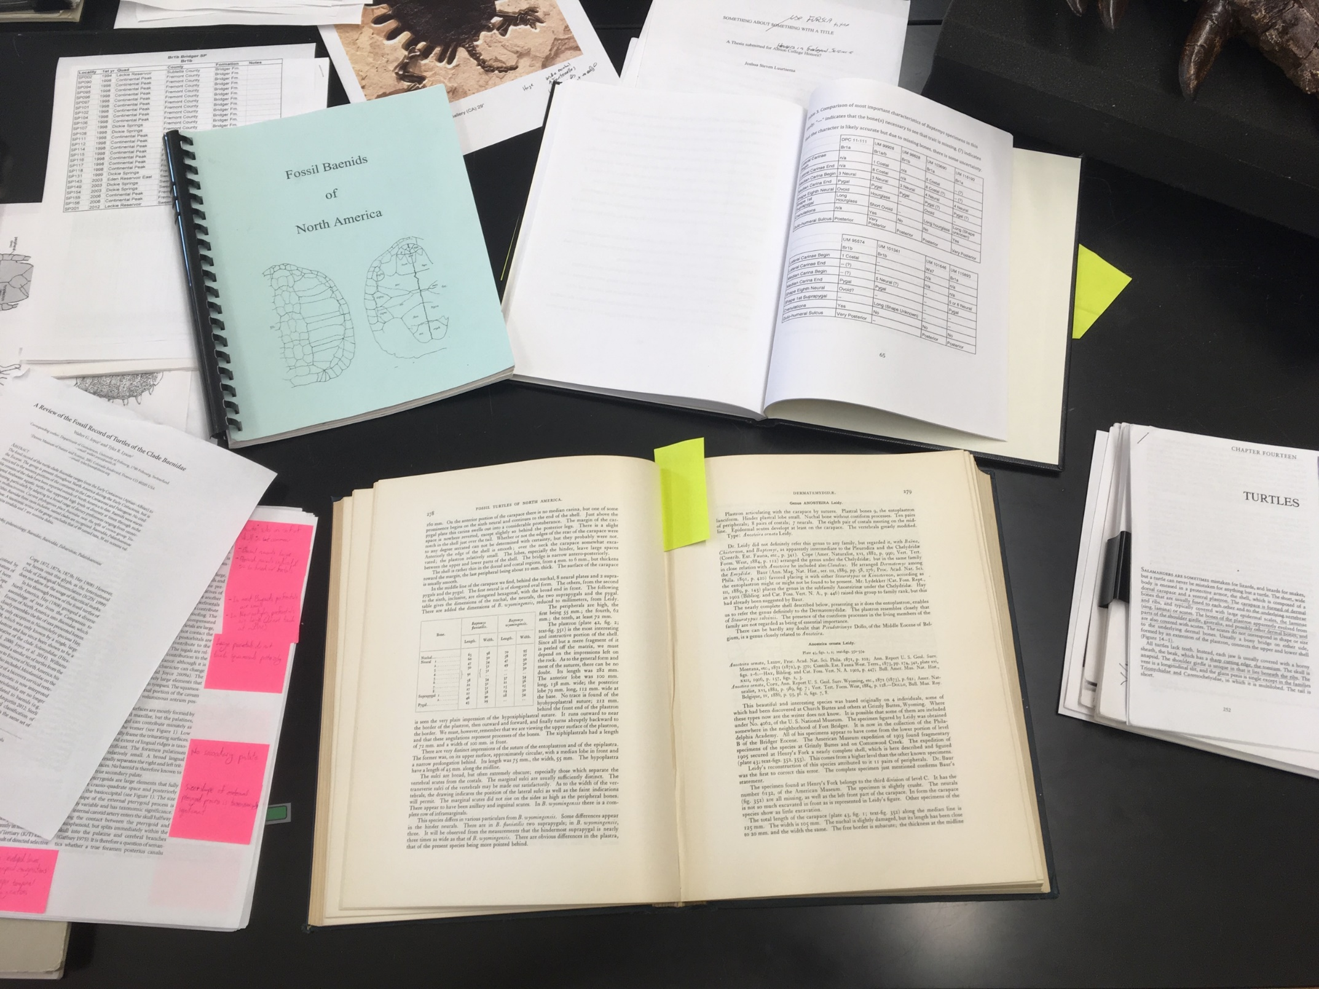

Reconstruction was familiar to me prior to this research, though the mixing of multiple fragmented specimens in boxes severely complicated the process. Once reconstructed, some specimens were simple to identify, but other had many peculiarities that suggested different identification than what they were originally catalogued as. There were some specimens that simply could not be reconstructed to a point where they could be accurately identified, so they were sent back to their original collections.

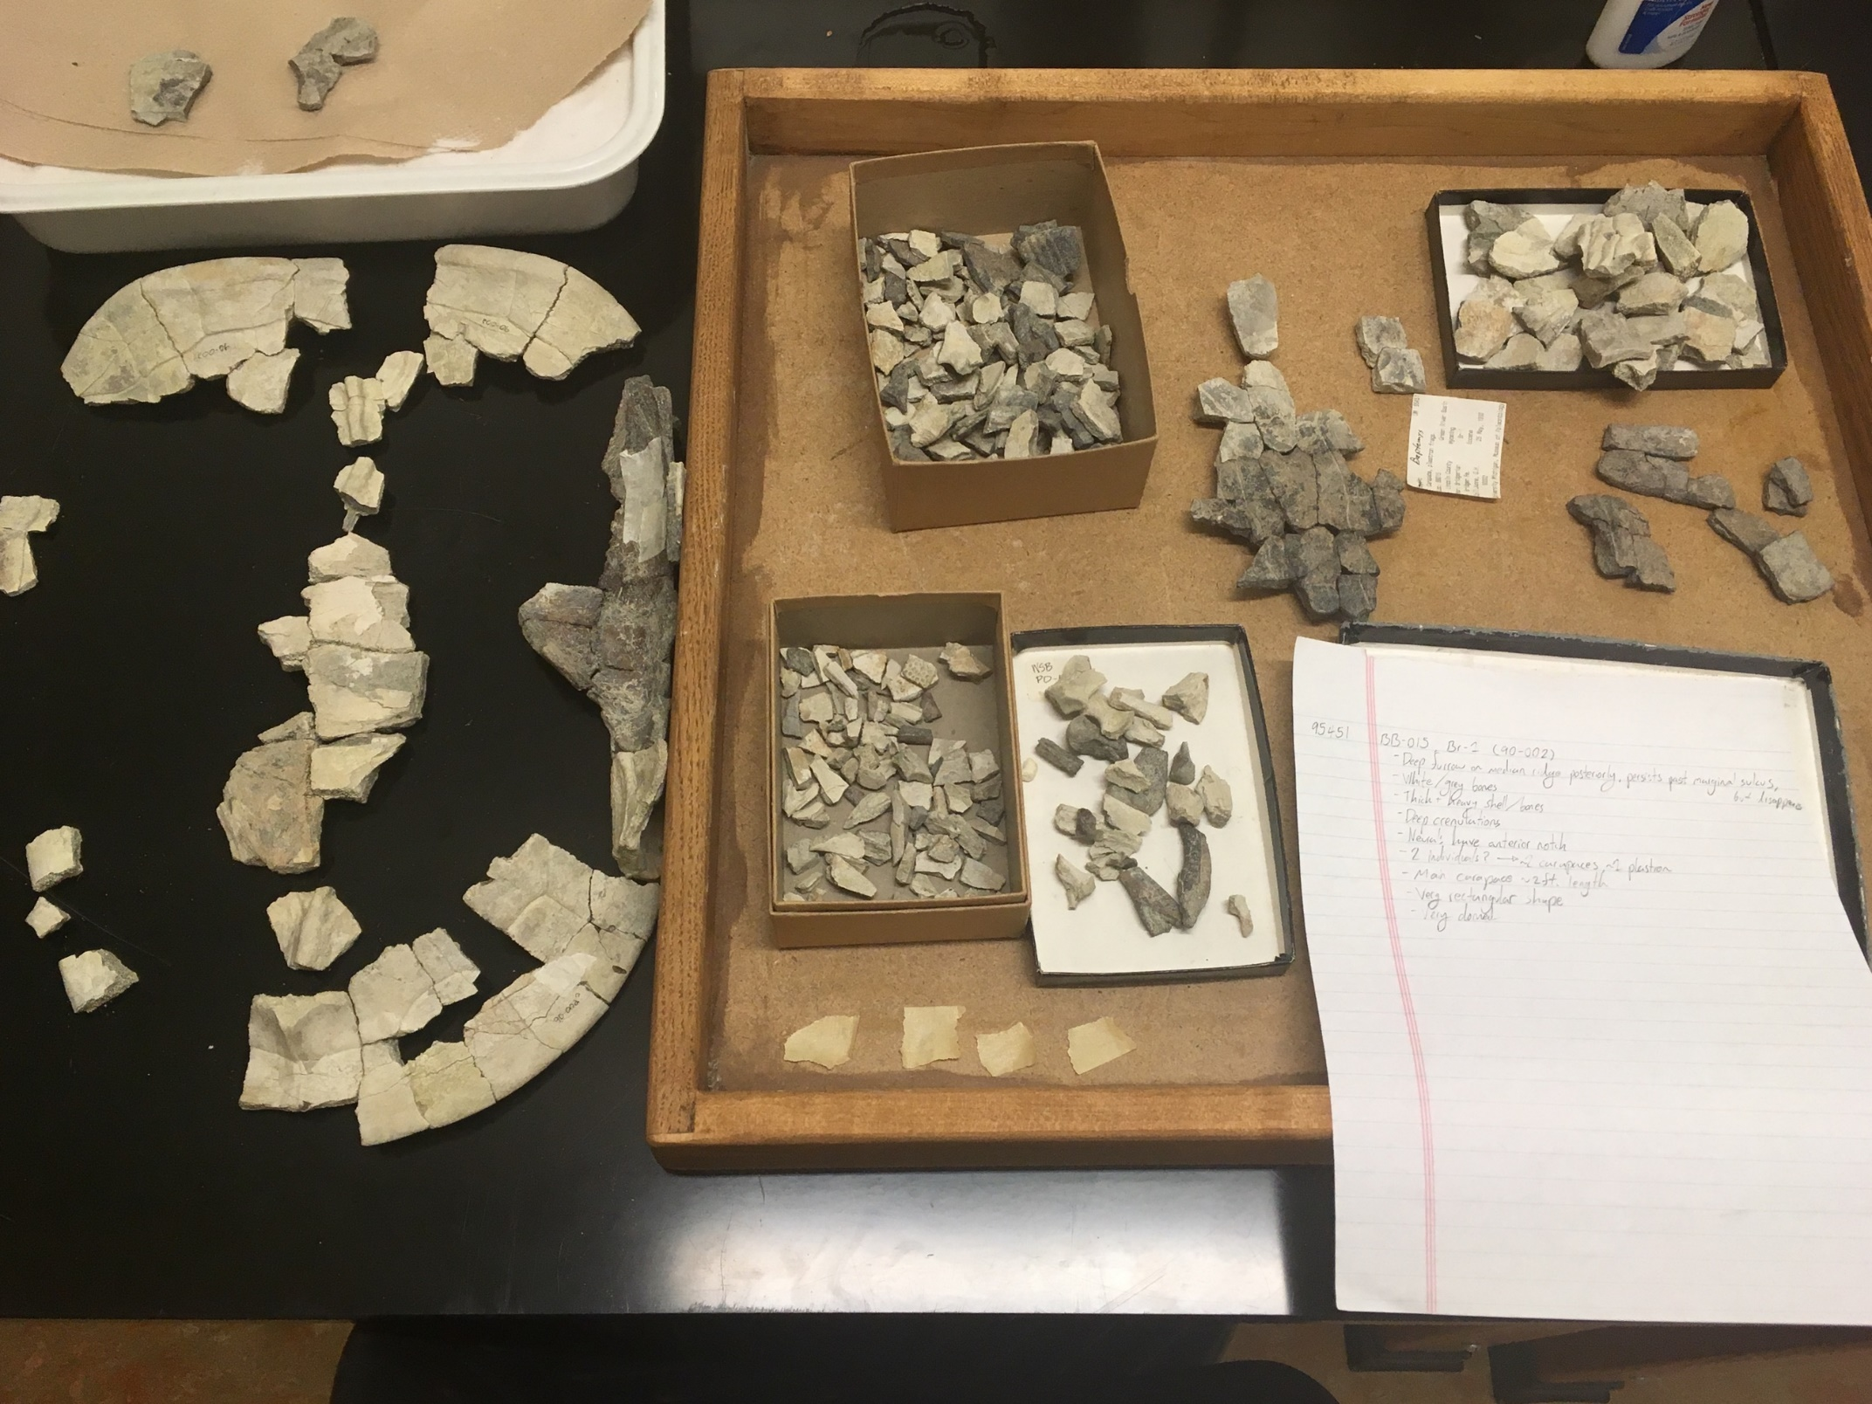

This research will continue into the fall 2019 semester, including the last couple families, and will culminate in a senior thesis to be finished before winter break. With its completion, it will hopefully help in my acceptance into graduate school, but more importantly, will give a foundation of knowledge for other paleontologists to understand the shifts in the roles of turtles in their ecosystems and in their populations through the Eocene of Wyoming. This research has humbled me and taught me many new skills, such as the involvement required to review literature, as well direct usage of previous research on a physical specimen. The FURSCA program has improved and prepared me for further research in grad school and beyond, so that I may improve and do better as I further my learning.

