Peter Filbrandt
Summer 2020
Albion College 23’

Development of a Pseudomonas Syringae Binding Nanobody
This past fall I began working at Albion College as a student research partner in Dr. Streu’s research lab. I have always been interested in science, but I did not know much about scientific research in academics and industry. Upon beginning to work in Dr. Streu’s lab, I was exposed to academic research and have since been interested in participating in research at Albion College. Last December, I sat down with Dr. Streu and Dr. Rohlman and we began to work on developing a research proposal for myself.
The project we developed was to find an antibody capable of binding to and neutralizing the plant pathogen Pseudomonas syringae which is known for infecting tomato plants. P. syringae is a gram-negative bacteria species that has a unique system of infecting host cells called the type three secretion system. The system is a protein complex composed of several subunits that we are attempting to disrupt the formation of using small proteins called nanobodies. To do this we will grow a large collection of yeast cells that have all been engineered to display proteins on their surface. The library of yeast cells will be as large as 2.5 billion cells and each cell will display a slightly different protein structure due to mutations. We will then select yeast cells from our library based on their affinity to a subunit protein called HrpW which is in the type three secretion system of P. syringae. Once these yeast cells are selected, we can sequence the DNA of the yeast cells to find the exact protein structure of the protein that the cells display. In the future, we can then reproduce these proteins to test them on tomato plants and see how well they work against P. syringae.
After the decision was made to move summer research online, we altered our plans for the summer to accommodate the progress of my project in a remote environment. This mostly meant that we would tackle parts of the project that would need to be done eventually but did not require working in the lab. Much of my summer was spent furthering my knowledge of the project, learning basics concepts of writing code, and learning how to make professional figures using Adobe Illustrator. I was quite knowledgeable on my project prior to this summer but there will still some parts of my project that I did not know everything about. To change this, Dr. Streu and some other lab members read and analyzed an abundance of academic articles that were related to our topics to fill the gaps in our understanding of our projects. Part of my project includes the analysis of DNA sequences after we isolate the DNA and send it off to be sequenced. When this is done, we will have to look through possibly thousands of DNA base pairs to determine the structure of our surface proteins. To even analyze all these base pairs in a single lifetime we would have to use computer programming. Therefore, part of my time this summer was spent teaching myself how to understand basic coding concepts in coding languages such as python and R. Eventually if I wish to present my findings on this project to others or at conferences I will have to create posters or presentations that will include figures to illustrate what we are doing on a molecular scale. Although PowerPoint and Google Drawings allows you to create decent figures for presentations, Adobe Illustrator allows you to create far more detailed figures and it is also the industry standard for creating academic figures. This summer I acquired a free trial of Adobe Illustrator and began learning how to use the software by creating figures for my future presentations. Although my figures are not perfect, I now know how to use the software and can easily make figures in the future when I need to.
As of now, I am not certain what I want to do after my time at Albion College. I do know that I either want to pursue a career in medicine or research and by participating in research with Dr. Streu, I get to see how research is done in academics and industry. Although I still do not know exactly what direction I wish to pursue after graduation, this summer has also facilitated a greater level of respect for academics and science which I now believe is essential to being a member of society. In the future, I would like to further the progress of my project and eventually present my project at conferences such as the Elkin Isaac Research Symposium and national conferences as well. I believe my project can yield important discoveries and new information and the sharing of my findings will also allow me to develop my professional skills in the science field.
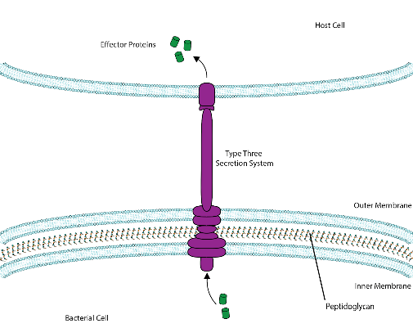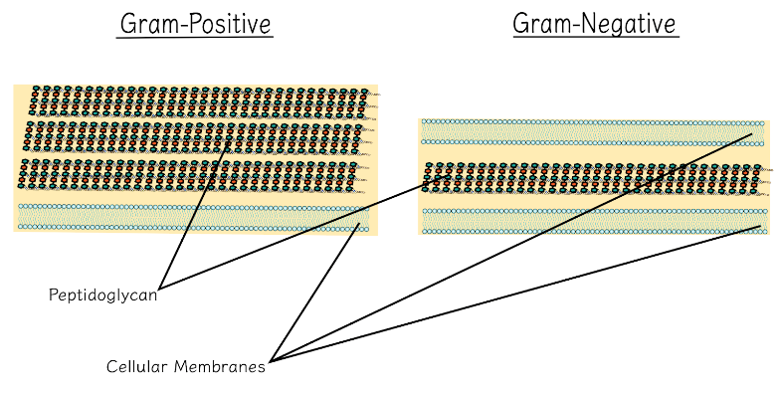
Here are some of the figures that I created this summer using Adobe Illustrator.
---------------------------------------------------------------------------------------------------------------------------------------
My research this summer was made possible by the Orpha Leiter Irwin Fellowship due to their funding. I am extremely grateful for their contribution to my research for this summer and with their funding I have been able to further my research project and continue to become a scientist. Thank you so much to the Orpha Leiter Irwin Fellowship for allowing me to continue my education in these summer months and permit me to continue my path to help and serve others through science.

