Survivability and Reproduction in Daphnia, Copepods, and Ostracods Under Changing Salinities

FURSCA SUMMER REPORT 2019

Christopher Breen

Dr. Cahill

Introduction
This summer I was continuing my research on Michigan’s salt marshes. I have been focusing on figuring out what kind of invertebrates that live there and creating a “catalogue”. This summer I focused mainly on Ostracods, Copepods and Daphnia. The main goal of the research is to see if animals that live in the salt marsh are adapted to the salty habitat, meaning that they survive and reproduce better in the salt marsh than the freshwater, and vice versa. I did this by running two experiments. The first tested how each Invertebrate survived in different salinities. The second tested how each invertebrate did in each water with the addition of another invertebrate and tested which one had the competitive edge.

Results/Summary

My goal was met, I now have a better understanding of how Daphnia, Ostracods, and Copepods handle two different environments one from the salt marsh and the other from the Kalamazoo river. It may not have been what I expected but it is still a better understanding. For the first experiment which tested a single type of invertebrate in the two varying salinities only Copepods had a significant difference of survival. However, it was not what we expected because the Copepods survived and reproduced more in the habitat that we thought would kill it. The Daphnia and ostracods didn’t show a significant difference in survivability and reproduction in the first experiment.
For the second experiment I wanted to see if having more than one type of invertebrate being in my controlled environment changed how one or both invertebrates reproduced and survived the two environments. This time there was a significant difference in integrated population density between Daphnia and ostracods, meaning that the Ostracods survived and reproduced significantly better than the Daphnia in both environments. I also found that there isn’t a difference when comparing how Daphnia and copepods survive and reproduce, which I found to be about the same. I also found that Copepods and Ostracods also do not show a difference. Below are the graphs from the first experiment showing the single type of invertebrate in two different environments.
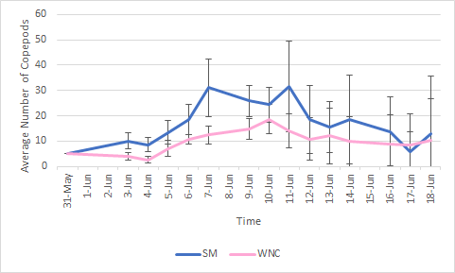
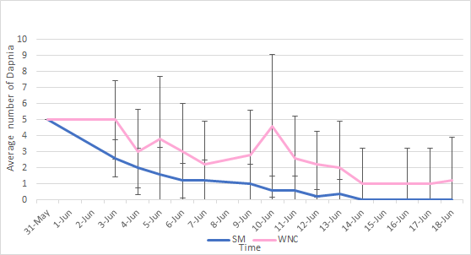
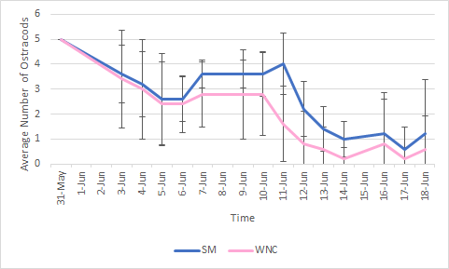

Conclusion
I have been working on getting a better understanding of the salt marshes in Michigan for a couple of semesters now so to continue my current work was very exciting. This project was important for me personally because I plan on writing my senior thesis on the work that I have done. I also will be using this data I gathered to present at the Elkin Isaac symposium. This summer’s experience really helped me solidify what I would like to go to graduate school. I had been doing research during the school year but only doing research and having journal discussions abut varying topics really tested to see if I could do this type of work for more than an hour or two. I am so thankful I was able to have this experience and would like to thank Jane Seymour Kilian for donating and making this research possible.

