Name of applicant: Alexis Wilkerson
Date: July 2 2020
Graduation Year: 2021
Major: Biology & Religious Studies
Research Advisor: Ola Olapade
Advisor’s Department: Biology

This summer I explored the Seasonal Comparison of Bacterial Occurrences and their Hydrolytic Enzymatic Activities Among Different Soil Types using Combinations of Standard Microbiological and Molecular Approaches. My study was based on asking 4 different questions. The first one being “What are the differences in the characteristics in different types of soil?” in this case I explored 3 different soil types including loamy, sandy, and clayey. Soil is separated into classes or groups each having similar characteristics. These classifications are determined by water content, organic content, temperature and pH which are known to vary. I believed that if there were differences in their inherent characteristics, then there would be differences in biotic factors like bacteria. The second question I explored was “What are the differences in the abundance of bacteria in different soil types” I believed that if the bacteria numbers differed, the way they function on an enzymatic level would also vary. The third question was “what are the differences in bacterial hydrolytic enzyme activity?” The final question was “What do all these variables look like in the summer and fall and additionally what they look like compared to each other?” In this study, it was hypothesized that the three soil types targeted will differ in their soil moisture, organic content and nutrient concentrations. Additionally, and more importantly to the study, it was expected based on the differences in properties of the soils that they will be harboring diverse bacterial populations with varied enzymatic capabilities and activity. Therefore, the main goal of the study was to examine, delineate and compare bacterial occurrences and their respective hydrolytic enzyme activities in different soil types using combinations of standard microbiological and molecular approaches during the study season and compare them to each other. The first question was addressed using organic matter content method or an organic matter analysis. The second question addressed the viable count method, and a total count of all stained bacterial cells, the third question was addressed using a fluorescein diacetate analysis, and the final question was addressed by compiling all data and running statistical comparison tests. The soils were examined for their organic matter content (% OM), while bacterial abundance was determined by combinations of viable counts and nucleic acid staining, and enzymatic activities measured using fluorescein diacetate (FDA) analysis. Comparatively, bacterial numbers (viable and total counts) were also higher in loamy soils than the other two soils. The same trend was observed for FDA analysis with higher fluorescein released in the loamy soil relative to the two soils. The results suggest that % OM strongly influences both bacterial abundance and hydrolytic enzyme activities in loamy soil and less so in both sandy and clayey soils examined in the study. Results obtained from summer and fall 2019 research activities revealed that the three soil types differ significantly in their physical features, moisture contents, as well as organic matter (OM) and nutrient concentrations. Additionally, all these variables were found to be different in fall compared to the previous summer season. This study was previously designed during the summer of 2019. The results obtained from this initial study revealed that the soils differed in their physical attributes, with the loamy soil having the highest % organic matter content at 31.5% as compared to 2.5% and 6.4% in sandy soil and clayey soils, respectively. When viable bacterial counts were examined, loamy soil had the highest with 8.6108CFU/g soil, sandy with was 8108CFU/g soil, and clayey 5.2105CFU g soil. Total bacterial counts based on DAPI staining showed loamy soil had the highest at 9.07 log bacterial number/g soil (sandy: 7.55 l and clayey at 7.13). Fluorescein (FDA) activity showed loamy soil had the highest enzymatic activity, releasing the most fluorescein per hour, with sandy and clayey soils releasing almost half the amount. All these variables were relatively lower when examined in the fall, with the exception of organic matter content being higher in the Fall season, this strongly indicated a seasonal trend. The results obtained from Fall 2019 revealed percent organic matter content at 46.4% as compared to 5.5% in sandy and 2.8% in clayey soils. When viable bacteria counts were examined, loamy had the highest with 8.48 108CFU/g soil, sandy with 8.27108CFU/g soil and clayey with 5.33105CFU g soil. Total bacteria counts based on DAPI staining showed loamy had the highest at 8.17 log bacterial number/g soil with sandy at 7.11 log bacterial number/g soil and clayey at 6.78 log bacterial number/g soil. FDA activity showed loamy soil had the highest enzymatic activity, releasing the most fluorescein per hour with clayey releasing about half and sandy releasing near the same amount of loamy over time. Relationship analysis for Fall data suggests that % OM strongly influences bacterial numbers both total and viable bacteria, it also influences enzymatic activity over time. Organic matter content in loamy soil strongly influenced both bacterial abundance and hydrolytic enzyme activity and less so in both sandy and clayey soils examined in the study. Loamy soil contained the highest percent of organic matter and had the highest numbers of bacterial counts and also had the most hydrolytic enzyme activity. T test analysis was used to determine seasonal differences in the variables among the soil types examined. A two tailed equal variance (type 2) T-test for DAPI counts between Summer and Fall seasons was not significantly different at (p = 0.50), while that for % OM (measured as LOI) between the two seasons was also not significantly different (p = 0.78). Also, the differences observed in bacterial CFU counts between the seasons was also very similar (p = 0.94). When bacterial hydrolytic enzyme activities was measured using FDA over time intervals were examined between the two seasons, no differences (p > 0.05) was found between the earlier time intervals at 4 hours (p = 0.50); 6 hours (p = 0.15); 8 hours (p = 0.096); and at 24 hours (p = 0.16). Relationship analysis for fall season showed again that % OM strongly influences both bacterial abundance and hydrolytic enzyme activities in loamy soil and less so in both sandy and clayey soils examined in the study.

Transitioning to remote research changed my plans significantly. Since All the above variables were relatively different when examined in the fall, compared to the summer months, this strongly indicated a seasonal trend and hence the need to examine a complete seasonal cycle as well as fully elucidate the bacterial community composition in each soil by targeting the 16S ribosomal RNA genes. If things have went according to plan, community DNA was to be extracted from the different soil types and subjected to polymerase chain reaction (PCR) using universal primer sets (i.e. 8F and 1492R) that targets the V3 region of the 16S ribosomal RNA gene. The applicon products generated would have been sent out for next generation sequencing using the illumina platform. Sequencing products would have been subjected to bioinformatic analysis including removing chimeras, BLAST searches and calculations of different diversity measures such as Shannon index, alpha and beta diversity, species richness and rarefaction analysis, among others. Since I was out of the lab, leading up to FURSCA 2020 consisted of literature review. The remote 6-week FURSCA 2020 period consisted of writing a senior thesis based on the research mentioned. I wrote a section of the thesis per week and also reviewed primary literature sources. At the end of each week a new copy of my work was sent in for review from my advisor. By the end of the 6 weeks I had a full copy of my thesis reaching about 60 pages long.

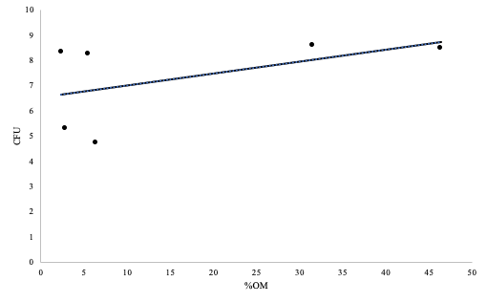
Figure 1. Relationship between %OM and CFU Counts in the Summer and Fall %OM (independent) vs CFU (dependent)
Y axis displays bacterial colony forming units versus the X axis which displays the percentage of organic matter. Upward trend is observed which indicates CFU is dependent on %OM which directly drives bacterial counts. Graph markers are indicative of soil samples.

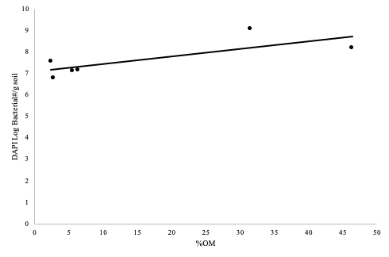
Figure 2. Relationship between %OM and DAPI Counts in the Summer and Fall %OM (independent) vs CFU (dependent)
Y axis displays bacterial colony forming units versus the X axis which displays the percentage of organic matter %OM (independent) vs DAPI (dependent). Upward trend is observed which indicates DAPI numbers are dependent on %OM which directly drives bacterial counts. Graph markers are indicative of soil samples.

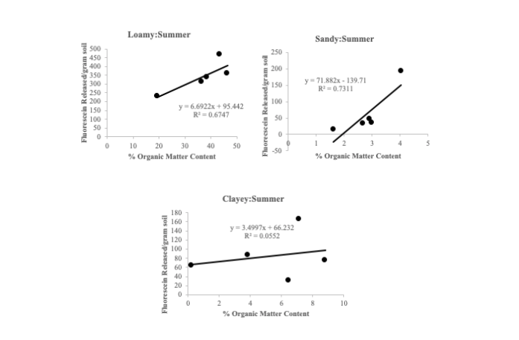
Figure 3. Relationship between %OM and FDA hydrolysis in the summer.
The Y axis displays the amount of fluorescein released versus the X axis which displays the percentage of organic matter %OM (independent) vs FDA (dependent). Soil samples shown to have an upward trend indicating organic matter is driving the amount of fluorescein released over time. Amount of enzyme activity is dependent on organic matter content in the soil. Loamy and sandy samples have a strong upward trend with clayey having a less steep slope. Slope and regression shown.

Figure 4. Relationship between %OM and FDA hydrolysis in the fall.
Y axis displays the amount of fluorescein released versus the X axis which displays the percentage of organic matter %OM (independent) vs FDA (dependent). Soil samples shown to have an upward trend indicating organic matter is driving the amount of fluorescein released over time. Amount of enzyme activity is dependent on organic matter content in the soil. Loamy and sandy samples have a strong upward trend with clayey having a slight downward slope. Slope and regression shown.

I first got the opportunity to complete a FURSCA fellowship through Dr. O by taking a bio class with him when one day he asked me if I had anything planned for the summer and if I wanted to be on his research team, I quickly agreed and was very happy to try something new. Throughout the summer I learned to have a lot of patience when it comes to remote lab work. Things don't always go as expected and you don't always yield the results you need in the lab as well as outside the lab. In writing my thesis I have learned many new science writing skills that go into a well-rounded thesis. I learned to work in unusual conditions, and I have learned new writing skills that I can take with me throughout my undergraduate and graduate careers.

Soil is the literal foundation of our ecosystem. Soil filters our water, provides essential nutrients to our forests and crops, and helps regulate the Earth's temperature as well as many of the important greenhouse gases. I think this research is important because it allows us to learn what's in our soil and how it can be useful to us in many disciplines. If for instance I did sequence the bacterial DNA this summer I would have found out exactly what was in the soil and what these bacterial populations could be useful for. They are useful to many obvious things like the foods we eat. Microbiology as a whole is important because it can be applied in every sub section of the sciences.

Now having done FURSCA twice, I can say that I would be more than happy to work in a laboratory setting in my future. As a biology major who wants to go on to graduate school, learning lab skills and techniques this experience is very important. My research through FURSCA has allowed me to gain so much more knowledge in the laboratory and has allowed me to think about how it will relate to everything I do in the future. I have learned to continuously ask “why?” on many different levels, I have expanded on so many levels, and I have been able to critically think and have results that I can say happened because of me. I also have learned how to take something in one form and completely transition to a different remote form. I am extremely proud of the work I did on campus last summer and very proud of all the remote work I've done off campus this summer. As a rising senior, I challenge myself to dig deeper and explore more. FURSCA has allowed me to participate in really cool things like microbiology conferences and has even allowed me the opportunity to begin publishing the work in a microbiology journal. I plan to participate in the Elkin Isaac symposium in the spring of 2020 and publish my thesis on this research.

I have always been a thinker but doing this research I had to come up with new ideas and new boundaries. Throughout my research I have gained a much larger understanding of what it means to actually create something and manage it effectively and efficiently. Last summer, this research required me to spend long hours in the lab five days a week and yield results then share them with a group of people who were doing the same thing as me. This summer my research took a shift but allowed me a head start on my undergraduate thesis. I am thankful for every opportunity supplied by FURSCA and its donors. I would especially like to thank Kenneth Ballou, '47 Research Endowment for Biology. Without generous donations and support like these, the opportunities given to students like me would not be possible. Your significant contributions to FURSCA are much appreciated, and I am extremely grateful.

