Aura Ware
During my project, I wanted to see how different views and aspects of masculinity combined will affect the way men, especially Black men, view help seeking because help seeking is something that is historically and socially seen as uncommon in men. More importantly, I wanted to reach into the minds of Black men and understand how they felt about mental health issues when faced with societal pressures of being resilient even when there is not an even playing field for Black men. I wanted to understand what options Black men think they have in terms of help seeking, and how I could have broadened those options. For instance, many Black men feel as though they can not talk to many people, if anyone at all, about their mental health issues and over all problems unless they have known them for an extended amount of time. Black men especially do not trust systems and being that the mental healthcare institution is a part of a system, it is safe to say Black men do not trust it. I wanted to know how my research could help bridge the gap between Black men and the healthcare institution. I was hoping my research would be able to point out where the disconnect between Black men and help seeking is in further detail and help future researchers attack this disconnect head on.
Fortunately, I did achieve most of my goals, but there were some goals that I was unable to achieve such as being able to only focus on Black men. Because it was such a small sample size of Black men, I had to compare the experiences of Black men with masculinity, John Henryism, gender role conflict, and attitudes toward help seeking with the experiences of the larger sample size of white men in order to get some more concrete results. Other than that, the goal was to understand the gap between Black men and the mental health care system and I did . 2/3 of my hypotheses were fully supported, and many men messaged me telling me about how the survey impacted the way they viewed their masculinity and how it affected their mental health. They let me know that they started to reflect on the mistrust that they have with systems including the mental health care system and how it affects their ability to have resilience against the challenges that life throws at them.
Below is the graph that shows the results of each correlation and the typed out version of my hypotheses.

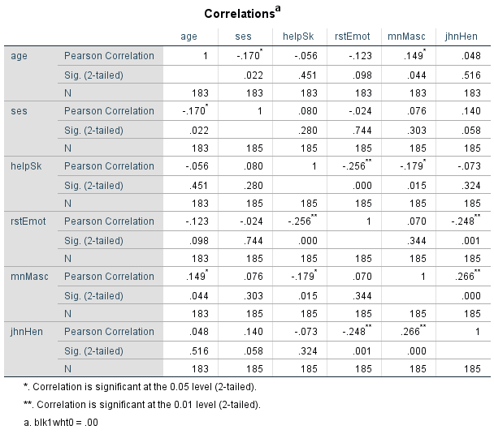

Restrictive emotionality will be negatively correlated with help-seeking--Supported
Among white Ps -- r (183) = -.26, p < .001
Among Black Ps -- r (63) = -.34, p = .01

Mainstream masculinity will be negatively correlated with help-seeking--Supported
Among white Ps -- r (183) = -.18, p = .02
Among Black Ps -- r (63) = -.11, p = .38

John Henryism will be negatively correlated with help-seeking--partially supported
Among white Ps -- r (183) = -.07, p = .32
Among Black Ps -- r (63) = -.17, p = .18
This project is important for the future of Albion College because we as a campus need to make sure we are prepared to support the mental health of all students not just the white women or occasionally the white man. Therefore, the results from my study should turn into a plan of action to ensure all students feel valued in the eyes of the mental health care institution on campus. I plan on turning this project into a thesis and presenting it at Elkin Isaac. I still have more theories to dive into, and it would be a shame if I just let this project sit in a volt because this project has made a difference in my life by showing me that if I see something that is lacking in the system, I can do something about it academically.

